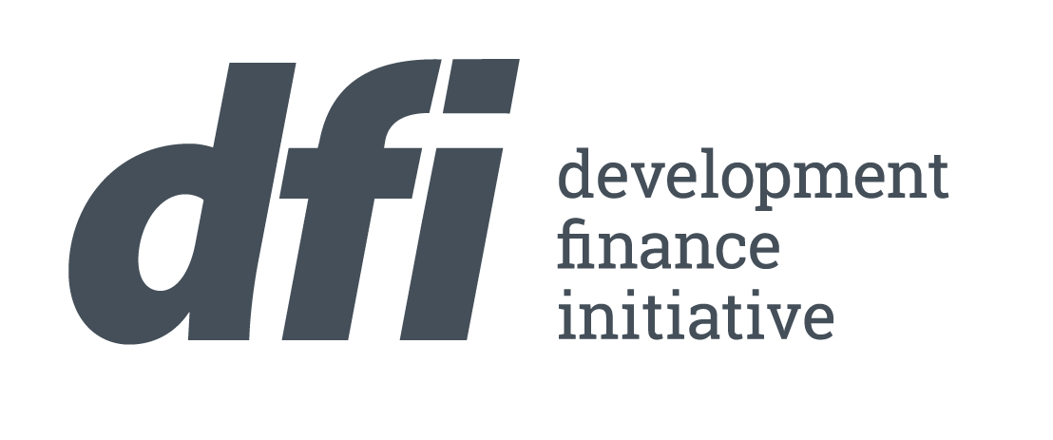
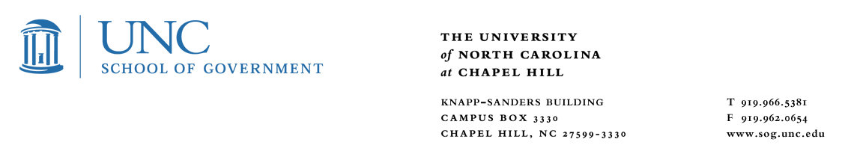
Development Finance Initiative – Graduate Student Fellowship
The Development Finance Initiative (DFI) at the UNC School of Government is seeking
Summer 2022 Student Fellows

DFI partners with local governments in North Carolina to attract private investment for transformative projects by providing specialized finance and development expertise. DFI partners with communities on projects including master-planned developments, urban infill redevelopment, downtown revitalization, and neighborhood redevelopment. Examples of our active projects include:
- Site control and master development to create a town center in a fast-growing community
- Pre-development of a large urban riverfront mixed-use project on City-owned land
- Fund design and development for acquisition and adaptive reuse of historic commercial corridor
To support our work, DFI offers graduate student fellowships in real estate and community economic development. Applicants should have an interest and experience in real estate development, finance, community economic development, and/or downtown revitalization. Fellows will join multi-disciplinary teams that work with faculty, staff, and local government clients on development projects in North Carolina communities.
Under the guidance and supervision of staff, Student Fellows will develop revitalization plans for distressed buildings, neighborhoods, or targeted redevelopment sites from work that includes touring local projects; meeting stakeholders; conducting market research; researching and performing due diligence on projects; developing strategies, plans, pro formas; researching best practices; writing blog posts and preparing presentations. Fellows may have the opportunity to present findings to local officials, faculty, staff, private developers and other stakeholders. Travel, including occasional overnight trips, may be required pending current University guidance as related to Covid-19.
Qualifications: Graduate students in planning, business, public administration and/or related disciplines. Experience in real estate development, finance, and/or community economic development preferred. GIS skills helpful.
Compensation: A generous stipend and health insurance.
Intangibles: Mentorship from private real estate development experts, practical project-based experience, exposure to real challenges and opportunities in real communities, opportunity to make a difference.
Term: 12 week internship averaging 40 hours per week. Successful applicants hired for the summer may have an opportunity to work with DFI during the school year.
Hiring Timeline: Please send a resume and cover letter to Sara Cockerham at dfi_deputy@sog.unc.edu by Friday, January 28, 2022.
The University of North Carolina at Chapel Hill is an Equal Opportunity Employer

