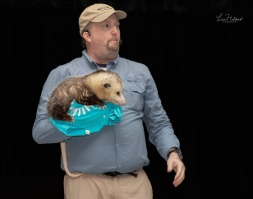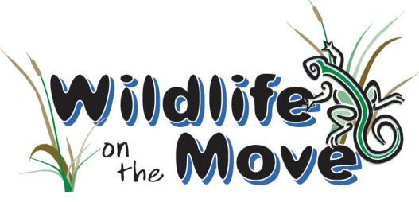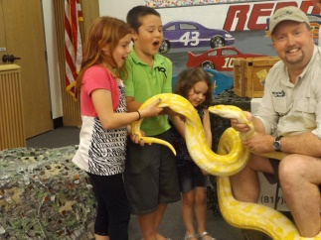

SPECIAL DISCOUNT PROMO CODE
You can “Bring Science to Life” at a SSSSuper Discounted Rate; Wildlife On The Move would like to provide you with our
Last Chance to SSSSave Spooktacular Special Offer
15% OFF OUR PRESENTATION FEES for ANY & ALL Events* you Book with us by 10/31/2020!

Simply Call or Email us by October 31st and provide us with Promo Code: LCTS20WOTM15 when booking to reduce your presentation fees for your Upcoming Special Events. This Promo Code can be used an UNLIMITED AMOUNT of TIMES from NOW through 9/1/2021! Special Discount Offer Expires: 10/31/2020 at 11:59PM
*Discount is NOT VALID for LIVE Boas vs. Pythons Presentations or WILD Birthday Parties*

PRESENTATION AVAILABILITY
We currently have availability to help KICK OFF the school year LIVE or VIRTUALLY this Fall, provide CREEPY CRITTER ENCOUNTERS in October, present AMAZING ANIMAL SHOWS for Fall/Winter Breaks, Spring Break, & even offer LIVE ANIMAL INTERACTION STATIONS for festivals & special events! Our Programming Calendar has Limited Spots & fills very quickly for Fall/Spring, so DON’T MISSSS OUT on your WILD Educational & Entertaining Experience!

DISCOUNTED PRESENTATION FEES (if Booked By 10/31/2020 with PROMO CODE)
**Additional Travel/Mileage Fees Apply to All LIVE and In Person Appearances Based Upon Venue Address**
$276 for GOIN WILD VideoVenture Series featuring Amazing Adaptations or Boas vs. Pythons
$255 for an "auditorium" program** (>35 people) / $225 for a 2nd back-to-back auditorium program**
$225 for a "classroom" program** (<35 people) / $204 for a 2nd back-to-back classroom program**
$315 for Boas vs. Pythons*; $208 for Festival Booth** (1st Hour) & $187 (Each Additional Hour)

- FOR MORE INFORMATION or TO BOOK YOUR EVENT -
Contact 817-239-2345 / Email: hiss@wildlifeonthemove.com
www.wildlifeonthemove.com or @wildlifeonthemove on Facebook

BECOME A MOVEr and SSSShaker – Support Our Animal Care Fund
Please consider SSSSupporting Wildlife On The Move Educational and Animal Care Programming In 2021:
https://www.NorthTexasGivingDay.org/wildlife-on-the-move

Please consider further financial SSSSupport of Wildlife On The Move Educational and Animal Care Programming:
www.paypal.me/WildlifeOnTheMove

Amazon Shoppers – Please Use This Link for Amazon to Donate a Portion of Your Purchase to Wildlife On The Move:
https://smile.amazon.com/ch/20-2127123

Donate Other Supplies Needed: Aspen shavings, Repti-Bark, Repti-Sand, Crushed Walnut Bedding ("sand"), Zoo Med Eco-Earth Compressed Substrate Bricks, Purina Cat Chow, 15 gallon kitchen trash bags, 55 gallon size lawn/garden trash bags, paper towels, paper towel tubes, oatmeal (oats), duct tape, newspaper, hand sanitizer, sponges/scrubbing pads, bleach, dish soap, hand soap, 40W and 60W incandescent light bulbs – No LED’s please, household timers, discarded
t-shirts, discarded wash cloths & towels, brooms, leaf rakes, big scoop shovels, and Provent A Mite from Pro Products;
SHIP TO: Wildlife On The Move Animal Care Program at 5236 Kiwanis Road Dallas, Texas 75236

-Thank You for Your Support of our 501(c)(3) Non-Profit Animal Outreach Organization-

