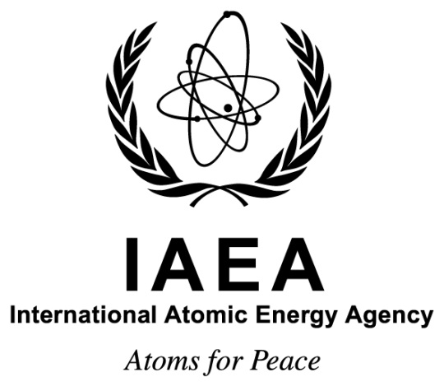

Technical Meeting on Global Progress in Developing Geological Disposal Solutions using Underground Research Facilities
Dunhuang City of Genzu Province, Peoples’ Republic of China
9-13 September 2019
Ref. No.: EVT1804482

Information Sheet

Background
The Underground Research Facilities Network for Geological Disposal (URF Network) establishes a community of practice and learning for geological disposal. The URF Network’s goal is to encourage the development of safe, sustainable and effective geological disposal programmes around the world through demonstrations of technology, improved training and enhanced communications between participating organizations.

To achieve this goal, the URF Network provides its members with a platform to assess and share best practices in developing, evaluating and implementing geological disposal solutions for intermediate level waste, high level waste and spent nuclear fuel. Emphasis is placed on the role and use of URFs to support the development and implementation of successful disposal programmes.

Best practices should be based on an understanding of high-level requirements (safety, security, safeguards, intergenerational equity and sustainability) and of the resulting governance needs in order to achieve successful disposal. The URF Network’s activities focus on methods and technologies to site, design, and license a disposal facility that meets these high-level requirements, as well as prepare for its implementation. This includes consideration of viable approaches in establishing national policies, strategies, and securing and maintaining acceptance of the project by relevant stakeholders. Relevant information on construction and operation becomes increasingly important as some Network members progress towards commissioning their first disposal facilities.

In order to achieve its goal and objectives, the URF Network relies on the active involvement of all Network members and, significantly, on resource contributions from all those members that own or manage URFs and other research facilities and that have agreed to host training and demonstration activities.

The 2019 Technical Meeting of the URF Network, on the theme of “Global Progress in Developing Geological Disposal Solutions”, will be hosted by the Peoples’ Republic of China organization Beijing Research Institute for Uranium Geology and held in Dunhuang, China, from 9 to 13 September 2019.

This meeting is the 18th in the series and all URF Network members are cordially invited to participate; in addition, several Member States with advanced programmes to incorporate nuclear power into their energy mix are also invited to participate.

Purpose
The purpose of the event is to review information from the IAEA Underground Research Facilities (URF) Network for Geological Disposal on recent developments relevant to geological disposal around the world and to review siting criteria as they are used in various national programmes.

It will provide an opportunity to review recent Network activities and discuss the future strategic orientation of the programme of work, as well as to propose and agree on specific activities and topics to be addressed by the Network in 2019 and beyond, as well as a session focused on the draft global Compendium of RD&D activities conducted insides URFs. This will be aligned with the focus of specific recent developments achieved in the national programme in the People’s Republic of China, as may be related to the construction of a new URF and the associated RD&D planning.

Working Language
The working language of the meeting will be English with no interpretation provided. All communications, abstracts and papers must be submitted in this language.

Venue
The meeting will commence on Monday, 9 September 2019, in Dunhuang City of Genzu Province, the Peoples’ Republic of China. The specific meeting venue will be confirmed in due course.

Target Audience
The meeting is targeted to representatives of organizations with specific responsibilities related to establishing, developing, providing the scientific and technical basis for, and implementing deep geological disposal projects for radioactive waste. Their expertise in associated scientific, technical or management functions should allow them to openly engage with their peers representing other waste disposal programmes.

Visas
Participants who need a visa for entering China should submit the necessary application to the nearest diplomatic or consular representative of the Peoples’ Republic of China as early as possible.

Organization
Official correspondence with regard to the technical aspects of the meeting should be addressed to the Scientific Secretary:
Mr Stefan Mayer
Waste Technology Section
Division of Nuclear Fuel Cycle and Waste Technology
Department of Nuclear Energy
Vienna International Centre
PO Box 100
1400 VIENNA
AUSTRIA
Tel.: +43 1 2600 22672
Fax: +43 1 26007
Email: S.J.Mayer@iaea.org

Official correspondence with regard to administrative issues should be addressed to the Administrative Secretary:
Mr Shelby Elamkunnam
Waste Technology Section
Division of Nuclear Fuel Cycle and Waste Technology
Department of Nuclear Energy
Vienna International Centre
PO Box 100
1400 VIENNA
AUSTRIA
Tel.: +43 1 2600 26492
Fax: +43 1 26007
Email: S.T.Elamkunnam@iaea.org

