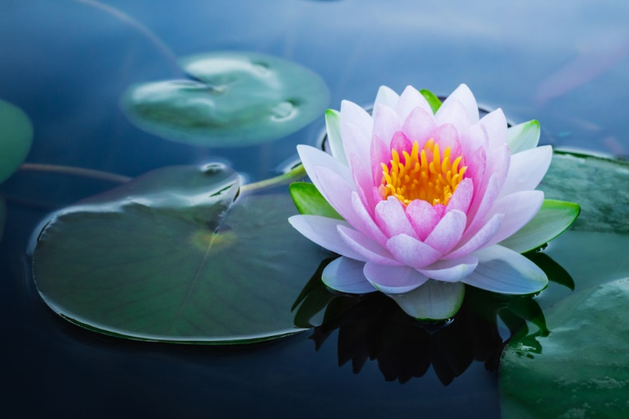
Peaceful Harbor Sangha
Sundays | 6:30-8:00 pm | online
Peaceful Harbor Sangha meets weekly for shared Buddhist practice. Meetings include sitting meditation, walking meditation, dharma reading and discussion. Come experience the calm in the storm! Meetings are now held on Zoom, and all are welcome; donations are gratefully accepted but not required. To receive the Zoom link, email Peter Eglinton.

