The Pastoral Center
Pastoral ministers serving pastoral ministers

Revival Happens Here
Exactly one year from today, 80,000 Catholics from all over the U.S. will gather in Indianapolis for a transformative encounter with the Real Presence of Jesus. As an official collaborator with the National Eucharistic Revival, we invite you to explore being a part of this in-person experience. Learn more at EucharisticRevival.org.
Just as importantly, consider how you can bring the Revival to your own local community. Take advantage of this process to welcome people back to the Eucharist and deepen their experience of it. We have many new tools to help you connect the Eucharist and Mass to our mission:
- Consider your approach with our free planning guide.
- Use the Christ Present in the Eucharist four-session parish process.
- Engage families in the Revival.
- Give away copies of the bulk-priced book The Mass is Never Ended!
- Offer a teaching Mass to make a real impression.
—Paul and the Pastoral Center team
Questions? Need some coaching?
Call toll-free 9am-5pm CT weekdays at 844-727-8672.

QUICK LINKS
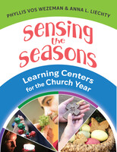
Creative Activity-Based Lessons

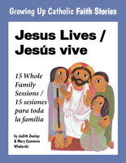
Flexible Family Catechesis (Home / Parish / Remote)

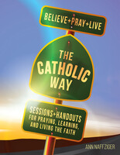
RCIA & Adult Formation

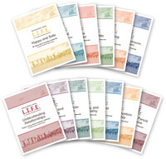
Family Catechesis for Loving Relationships

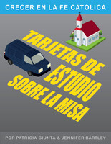
Weekly Lectionary Resources

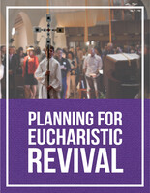
Planning for Eucharistic Revival
FREE Downloadable Pastoral Toolkit
This practical guide by Paul Canavese will guide you step-by-step through what the Revival is and how to best respond. It offers eight suggested objectives and is organized into short handouts and worksheets, perfect for use with parish leadership teams. • FREE!
Purchase / Learn More

CONNECT MASS TO MISSION
Examining the Mass through the lens of the dismissal—and how each part of the liturgy prepares us to be sent out again—will offer your people a profound and practical perspective on Eucharist.

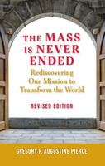
The Mass is Never Ended
Rediscovering Our Mission to Transform the World
A Perfect Giveaway for Eucharistic Revival
Revised especially for the National Eucharistic Revival, this book will renew appreciation for the beauty and wisdom of the Mass for Catholics everywhere. • Paperback • As low as $4/copy
Preview Purchase / Learn More

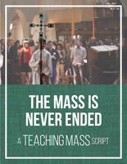
The Mass Is Never Ended
Teaching Mass Script for Euch. Revival
Succinct, powerful insights to proclaim at Mass
Utilizes the role of commentator as intended. Short enough that is can be used in your regular services. Great for regular Sunday Masses, RCIA/OCIA, Confirmation, and First Communion Preparation
$18/parish • Downloadable & editable
Preview Purchase / Learn More

REVIVAL FOR KIDS & FAMILIES
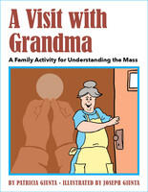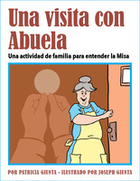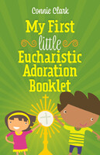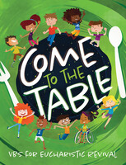
VIEW ALL

SESSIONS FOR EUCHARISTIC REVIVAL

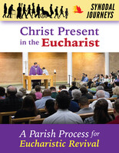
Christ Present in the Eucharist
A Synodal Parish Process for Eucharistic Revival
Lead your people to better understand and respond to the Eucharist! This dynamic 4-session parish process modeled after synod listening sessions includes:
- Slides & talking points
- Small group discussion guides
- Personal notes page, resource list, and tent cards for participants
- Tools for promotion & facilitation
Only $40/parish • Downloadable & reproducible
Preview

Purchase / Learn More

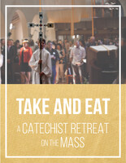
Take and Eat
A Catechist Retreat on the Mass
Preview Buy / Learn More

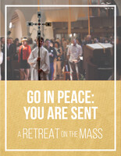
Go in Peace: You Are Sent
A Parish Retreat on the Mass
Preview Buy / Learn More

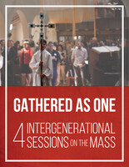
Gathered As One
4 Intergenerational Sessions on the Mass
Preview Buy / Learn More

TOP BOOKS FOR REVIVAL
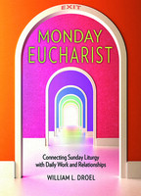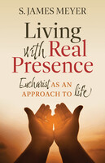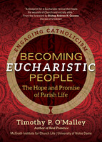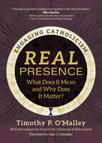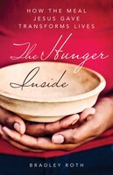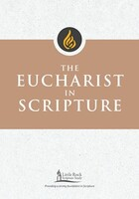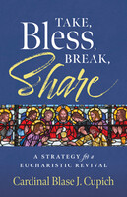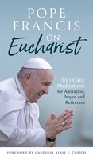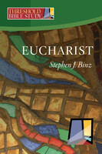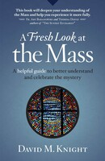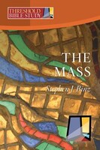
VIEW ALL

ALL RESOURCES FOR REVIVAL

The Pastoral Center • Growing Up Catholic • Fashioning Faith
Call toll-free 9am-5pm Central Time weekdays at 844-727-8672
1212 Versailles Ave, Alameda CA 94501 • resources@pastoralcenter.com
Manage subscriptions • Unsubscribe from all emails
Email not displaying correctly? View it in your browser

