A: Priesthood Sunday Bulletin Announcement for the 3rd week of September:

Next Sunday September 27, 2020 is Priesthood Sunday.

The fourth Sunday of September is a special day set aside to honor priesthood in the United States. It is a day to reflect upon and affirm the role of the priest as central to the life of the Church. The lay faithful of all parishes develop their own special way of marking the day and honoring their parish priest(s) at Mass the weekend Masses. This event offers an opportunity for priests and parishioners to build a stronger working relationship with our pastor, Fr. __________ and express to him our support and appreciation for his service to the Church, and in particular our parish.
There are many ways to celebrate this event, some ideas include letting him know you enjoyed his homily, either in person or by giving him a card with a note of appreciation. In a way this is another “Father’s Day," our spiritual father. Parishioners are invited you to leave a card (basket in the gathering space of Church) with words of gratitude and tribute for our priest. A special blessing will also be given to them at the weekend Masses.
(Optional Text :)
This nationwide event is coordinated and sponsored by the US Council of Serra International, an organization of lay men and women whose mission is to foster and affirm vocations to the ministerial priesthood and vowed religious life in the USA. The Serra Club of Southeast KC,MO collaborates with Bishop Johnston and Vocation Director Fr. Adam Johnson to fulfill its mission. Through this ministry, Serrans work to further their Catholic faith.

Priesthood Sunday Bulletin Announcement for the 4th week of September, Priesthood Sunday:

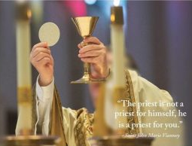
We are celebrating Priesthood Sunday this weekend at all Masses. A special blessing will be given to them at end of each weekend Masses.
Thank God for our Holy Priests!

B: Priesthood Sunday Bulletin Announcement for the 3rd week of September:
What is Priesthood Sunday?
Priesthood Sunday is a special day set aside to honor the priesthood in the United States. It is a day to reflect upon and affirm the role of the priesthood in the life of the Church. We are all encouraged to celebrate Priesthood Sunday on September 27th.
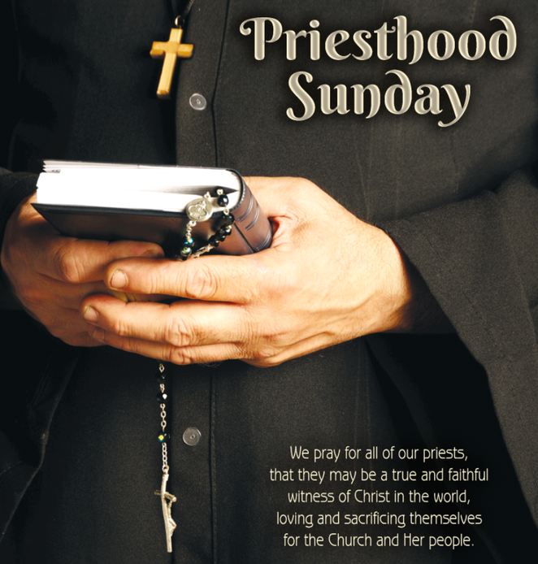
This is a good opportunity to show your appreciation and support to our priest/s. Consider bringing a Card or Note of appreciation next weekend. Place your Card or Note in the basket in the Gathering Space before Mass. Before the closing of each Mass there will be a Blessing Prayer for our pastor and the basket of Cards/Notes will be presented.

