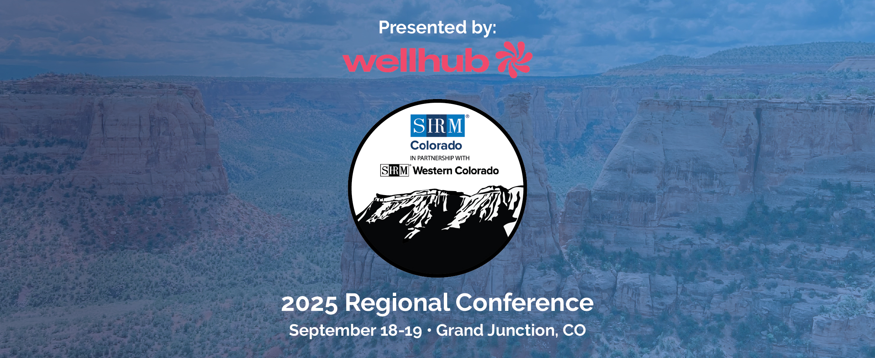

Agenda

Thursday, September 18, 2025
Time | Session | Speaker | Location
2:00–2:50 PM | Registration Open, Refreshments and Business Showcase |  | Foyer
3:00–4:30 PM | Keynote: Create A Culture Of Belonging: Unlocking Human Potential | Curtis Hill, Culture of Belonging Global | Grand Ballroom
4:30-7:30 PM | 50th Celebration  50 Years of Excellence: Celebrating SHRM Western Colorado’s Legacy and Future | Get ready to join the fun as we celebrate 50 years with a bold, 1970s-inspired party—dress up, hit the dance floor, enjoy great food and drinks, and show off your best moves and trivia skills! | Foyer/Grand Ballroom

Friday, September 19, 2025
Time | Session | Speaker | Location
7:00–8:00 AM | Registration Open & Breakfast |  | Foyer/Grand Ballroom
7:50-8:00 AM | Welcome and Opening Remarks |  | Grand Ballroom
8:00–9:30 AM | Keynote: The Great Knowledge Acceleration: Bridging Generations in the AI Era | Luke Goetting, LTG Strategy | Grand Ballroom
Concurrent Sessions
9:40–10:40 AM | Beyond Balance: Future of Work-Life Blend with AI | Dan Bruder, Blendification | Centennial
9:40–10:40 AM | Collaboration vs. Replacement: Empowering HR Professionals to Build Deeper, Human-Centered Approaches to AI | - Gunner Rigsby, GROWL Agency  - John Walden, MothLabs  - Tim Wenger, Matador Network | Bookcliff
10:40-11:00 AM | Exhibitor Break and Networking |  | Foyer
Concurrent Sessions
11:00 AM–12:00 PM | Thriving through Change: Build Agility and Resilience to Lead the AI Revolution | Tracy Graf, Fuse - Igniting Communication | Colorado
11:00 AM–12:00 PM | Build Your Own HR AI Toolkit (No Tech Skills Required) | Renaya Demarest, Colorado Mesa University | Centennial
11:00 AM–12:00 PM | AI for HR: Clarity, Not Chaos | - John Walden, MothLabs  - Tim Wenger, Matador Network | Bookcliff
12:00-1:00 PM | Lunch and Exhibitor Break |  | Grand Ballroom
1:00–2:30 PM | How HR, eLearning, and AI Will Save the World | Dan Streeter, Mission Fuel | Grand Ballroom
2:30-2:45 PM | Break
2:45–3:15 PM | Colorado’s Artificial Intelligence Act: What Employers Need to Know Now | Michael Santo, Bechtel & Santo Employment Law | Grand Ballroom
3:15-4:15 PM | SHRM: The Human + AI Imperative | Jenny Locanthi, SHRM | Grand Ballroom
4:15-4:30 PM | Closing Remarks

