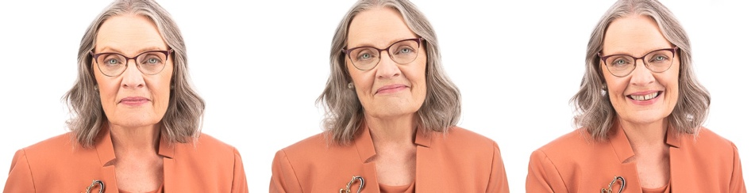

Breakout Speaker, Coach Faculty, Mentor Frederick, Maryland//Washington, D.C. Metro Area

The five most frequent pain points I hear from coaches are directly addressed during my five accredited CCE breakout sessions, now available to your coach organization.

Hi there, I’m Anne Kelly. Thank you for learning about my oﬀerings for your coach organization. As a 10+ year active ICF volunteer and presenter, speaking to coaches is a service I am passionate about.

I hear your pain, and teach to it!

Over the years I’ve listened as mentoring client after mentoring client has struggled with what I call the “frequent five” pain points. In 2020 I designed an accredited training program targeting and exploring these “frequent five” challenges. I’d be pleased to share this learning with your coaches’ group!

My training style for ICF Professionals makes
Core Competencies understandable, applicable, and fun.

My expertise as a coach trainer/speaker is a result of having:

- Served for one year on the Ethics Education Team that successfully updated the ICF’s 3-hour on-line course to reflect the new code of ethics and new core competencies
- Graduated from the ICF’s original (2020) and updated (2022) PCC Marker Assessor trainings, earning 68 CCE hrs of PCC Markers Training since 2018
- Taught multiple CCE courses throughout each year since 2014

Coached continuously since 2003, first internal, and now external coach of individuals and groups
- Served for ten years as a volunteer for ICF Metro DC Chapter, including three years as the Chapter’s volunteer Group Mentor Coach
- Created my 20-hour ICF accredited CCEase coach training program
- 30+ years experience as a certified Trainer and Facilitator of adult learning

Testimonials:

Galina Knopman, PCC, Fortune 500 Coach, Author, Speaker, Educator
  - “I went to a session that Anne led and got more out of it than I ever expected. I laughed and had fun, met new people and quickly moved into a high-energy zone. The team I was a part of surprised ourselves with our abundant productivity, collaboration, and new insights about ourselves and others. This was not my average experience when taking a workshop, but is Anne’s standard of delivery.”

Deborah Jane Wells, Board Certified Coach

  - “Anne C. Kelly is a gifted coach, facilitator and trainer. I have had the joy and honor to participate in the Metro DC ICF Facilitation and Training Community of Practice that she organizes and leads. She is wise, kind, compassionate and genuine. She listens deeply, asks insightful questions, demonstrates flexibility in her approach and infuses joy in every session. I am so happy to have found Anne and the meaningful group she facilitates to support other ICF professional coaches in continuing education and deep connection.”

Barb Girson, Registered Corporate Coach(TM), Trainer, Strategist

  - “Anne demonstrated excellent and high-level facilitation skills during our small group training, coaching and professional development program. She used a variety of techniques and methods which kept the program interesting. She successfully got all participants involved and added her expertise and experience when the discussion lended itself for more input. She was encouraging, positive, creative, caring, and showed up as a learner as well as a facilitator. I found her to demonstrate a deep level of competence and confidence especially with the ICF core competencies. I would highly recommend Anne as a mentor, facilitator, coach and trainer based on my experience.”

Deb Waterstone, Learning Consultant, Certified Coach

  - “I had the great pleasure of meeting Anne in 2007 during her certification as an Inspired Learning facilitator. What really stood out for me was her range of expertise, passion for learning, and ability to deliver a rich, well-designed, experiential session. And this was just in the first months of knowing her!
She understands what it takes to design a session with purpose, practical application, inspiration, and sensitivity to different learning styles. Combine this with her ease in front of a room, excellent coaching skills, and generous spirit….well I just find this to be a powerful package.”

Jamee Tenzer, MCC, BCC

- “Anne, you have been such a wonderful co-facilitator with Jean Francois. You
bring sparkle, creativity and humor to everything you do and that has been such a wonderful contribution to the Deeper Conversations Coach CCE Program class. Thank you for your commitment to the class participants and to your role as facilitator.”

Sheri Boone, MCC, BCC, MCC Mentor Coach

- “Thank you, Anne!! I echo exactly what Jamee said :-) We are so fortunate to have you and your many gifts with us for the Deeper Conversations CCE Program, and the participants equally so!!”

Anthony Stamilio, ACC, Founder/CEO, First Step Coaching & Consulting, LLC

- "If you want to be a better coach, you need Anne Kelly! Anne is a superb mentor coach who has just the right touch. Her approach is based upon learning in a safe environment, and establishes trust early. From there, she challenged me to really examine my approach and invited me to dig deep. There is no doubt, I am a better coach after her mentorship—and I am having more fun. Anne is a winner!"

