SSCS Event Descriptions

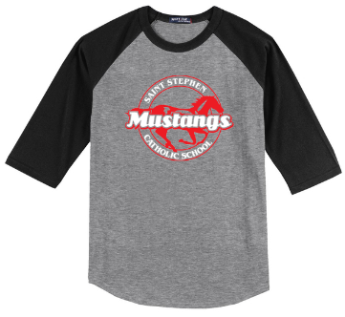
Spirit Shop- Show your Mustang Spirit! Saint Stephen Catholic School is excited to offer friends and families the opportunity to shop our new Online Mustang Spirit Store. All orders must be placed online by Sunday, October 4th. https://ststephenspiritstore.itemorder.com/
Items will be delivered directly to your home approximately 2-3 weeks after the store closes. Spirit Wear cannot be worn in place of any uniform. Thank you for supporting SSCS!
Please contact Nicki Gallagher, ngallagher@sscsfl.org, PTCO School Liaison, or Catherine Craig, catcraig@me.com, PTCO Spirit Wear Coordinator, if you have any questions, suggestions, or concerns.
Spirit Night- Local restaurants partner with SSCS to offer a specific time when our school will receive a percentage of the receipts from business given to the restaurant by school friends and families. When visiting the restaurant during this time, please be sure your server or the manager knows you are there representing SSCS so the school can get credit for your visit.
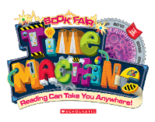
Virtual Book Fair- Our Book Fair is online! The theme for this year’s event is Time Machine. Support our school and help your child discover new books, favorite characters, value packs, and more! Orders are delivered right to your home and you can take advantage of FREE shipping on book-only purchases over $25. https://bookfairs.scholastic.com/bookfairs/cptoolkit/homepage.do?method=homepage&url=ststephencatholicschool2
Move Together to Care for Creation- Children experience outdoor fun and exercise. Parents and friends pledge a donation to encourage students to use their time to enjoy the outdoors and the planned activities. More details regarding the event will be sent to families closer to the event date. Each family will be requested to get donations totaling $100 from family and friends to encourage their student(s) to complete the stations. The school goal is for 100% participation.

Angels Among Us Valentine Gala- February 13, 2021
Angels Among Us is in its 21st year supporting our school. Historically, the Gala raises approximately $70,000 through sponsorships, donations, auctions, etc. The Gala is attended by school families and friends of the SSCS community. Seat Reservations are $120 per person and include an open bar, dinner, and dancing at The Palmetto Club. Parents and friends of the school enjoy attending the event and donating to the event in various ways. Each grade makes a class craft that is raffled. Details regarding the Valentine Gala will be available in December. If you would like info about donations or sponsorships before December, please contact ngallagher@sscsfl.org.

