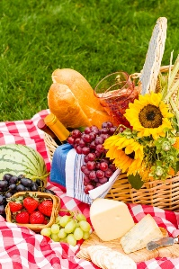
UNITY OF NORTH KITSAP ANNUAL PICNIC
Sunday, August 9th, 2026
Nelson Park, 20296 3rd Ave NW, Poulsbo, WA
Please arrive by 11:15 a.m. Service starts at 11:30!
Linda Moehring will be our speaker and we will make some music.
Bring your own “personal picnic” or a potluck dish to share (salads, main dish, or dessert) and your own beverage. Seating is at picnic tables, so bring a chair if you prefer.
DIRECTIONS:
Nelson Park is near the corner of Finn Hill and Viking Way – behind the Viking statue and across the Lindvig Way from Fish Park. The address is 20296 3rd Ave NW, Poulsbo. Type Nelson Park if using Google Maps.
From the church, you would go to Highway 305 and turn RIGHT. Proceed to the first signal at Bond Road & turn LEFT.
Proceed to the next signal at Lindvig Way and turn RIGHT.
Then you turn LEFT into the parking lot access road for Aroydy Thai Cuisine and other businesses. Nelson Park is tucked away behind various businesses and across from Fish Park.

3

305
Finn Hill

Lindvig Way

Viking Way
Nelson Park
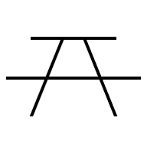
Fish Park
Bond Road


Faith Episcopal

