2020 Blueberry
Fund Raiser

Sponsored by Hershey-Hummelstown Kiwanis Club

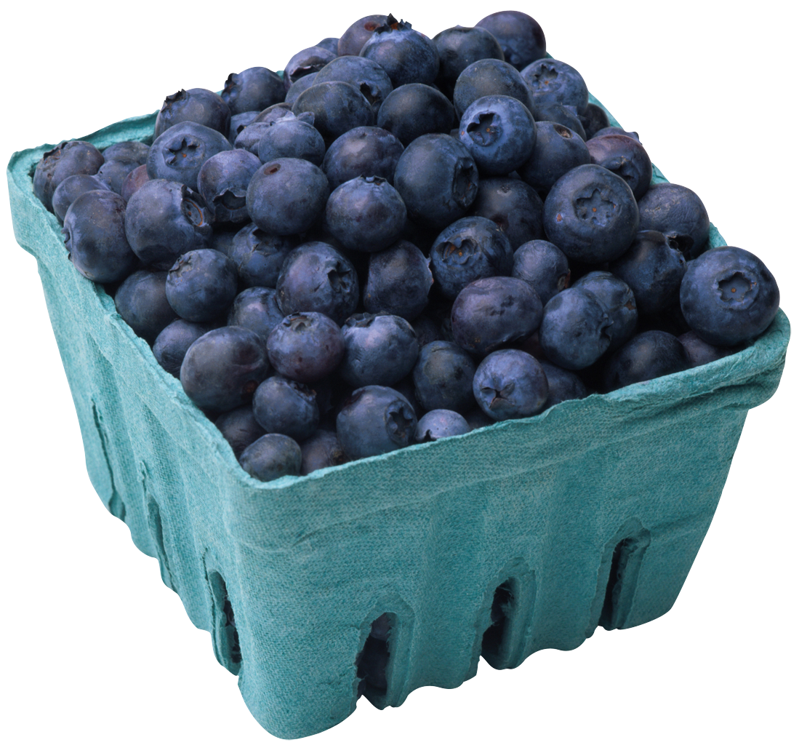

$32 for 10 Pound Box!
(10 pound box = 13.5 pints = about $2.37 per pint)

The New Jersey blueberries arrive within 24 hours of picking!

If you are interested, please call 717-533-3307 and you will be asked to provide your name, phone number, email address, and number of boxes. All orders must be prepaid.
Checks made out to Kiwanis Club of Hershey/Hummelstown

Last date for orders is Thursday, June 25, 2020.
Blueberries must be picked up Wednesday, July 1, 2020 from 12 NOON to 6PM at
21 Tice Avenue, Hershey, Pa 17033

Name:______________________________________________________

Phone Number:______________________________________________

Email Address:______________________________________________

Number of Boxes:____________________________________________

