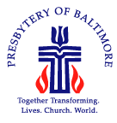
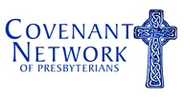

The Covenant Network of Presbyterians
&
Presbytery of Baltimore

Invite you to a one-day training
for individuals, pastors and congregations

Introduction to Systemic Racism
Presented by Crossroads Anti-Racism Training

Wednesday, November 8, 1:00 p.m. to 8:00 p.m.
First & Franklin Presbyterian Church, 210 W Madison St., Baltimore

This workshop equips people to understand, talk about, and analyze the ways systemic racism operates in U.S. society and within organizations—including the church. This workshop can serve as a starting place for conversations about how to live in—and challenge—the status quo and build a more inclusive, equal, just community.

Cost (incl. dinner): $25, Baltimore Presbytery participants
$50, for all others
$75, when combined with Friday morning Baltimore mission tour

This is a pre-conference event for the 2017 Covenant Conference,
the national gathering of the Covenant Network of Presbyterians
November 9-10, 2017, First & Franklin Presbyterian Church

Register, starting Monday, September 25, at www.covnetpres.org/oursharedhumanity

