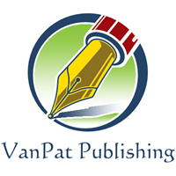

Order Form

Name:

Address:

Phone: Email:

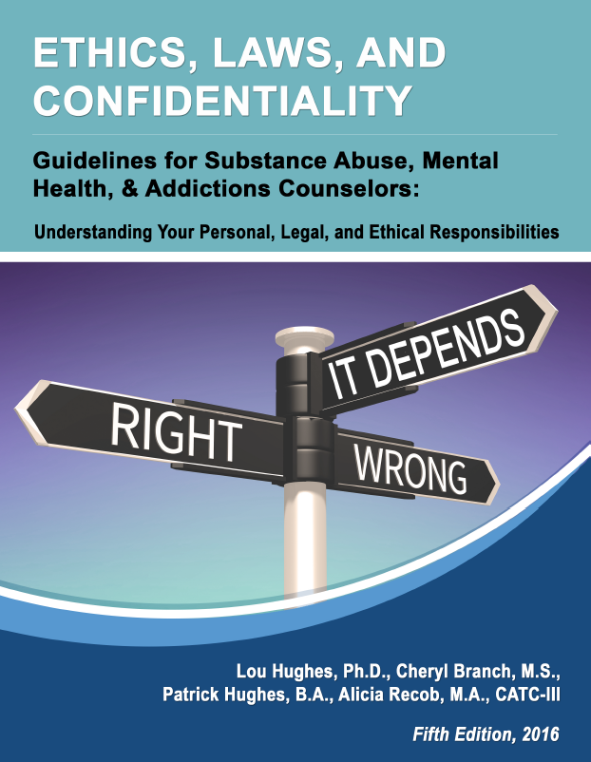
Select books and quantities:

- Ethics, Laws, and Confidentiality: Guidelines for Substance Abuse Counselors; Understanding your Personal, Legal, and Ethical Responsibilities
ISBN: 978-1-933408-38-5
Authors: C-TAP - Lou Hughes, Ph.D., Cheryl Branch, M.S., Alicia Recob, M.A., Patrick Hughes, B.A. (Fifth Edition, 2016)
Price: $29.95 Qty: ________

- Poor Health is beating Good Health: Trying to stop the Runaway Train. Is the battle over? ISBN: 978-1-933408-31-6
Authors: C-TAP - Lou Hughes, Ph.D., Alicia Recob, M.A., Vanessa Lathrop, B.A., (First Edition, 2016)
Price: $29.95 Qty: ________

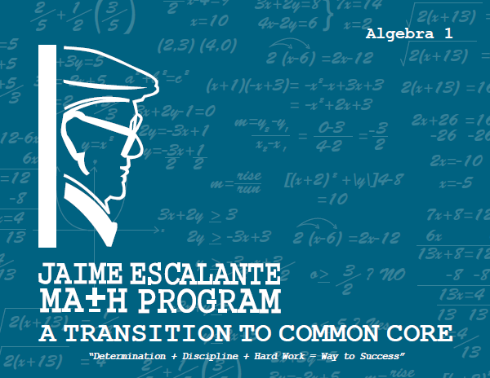
- Jaime Escalante Math Program: Algebra 1: A Transition to Common Core.
Author: Jaime Escalante, Editor: Fernando Fernandez
Price: $34.95 Qty: ________

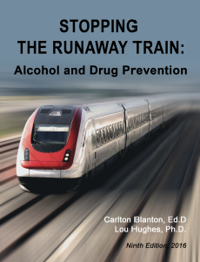
- Stopping the Runaway Train: Alcohol and Drug Prevention
ISBN: 978-1-933408-39-2
Authors: C-TAP - Carlton Blanton Ed.D., Lou Hughes, Ph.D., Alicia Recob, M.A., Patrick Hughes, B.A. (Sixth Edition, 2016)
Price: $29.95 Qty: ________

Order Form
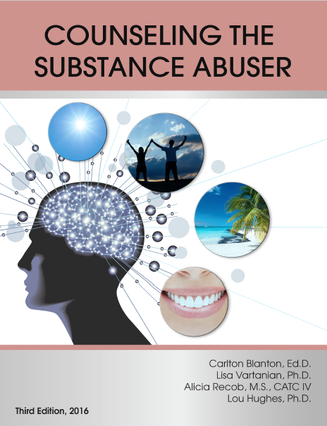

- Counseling the Substance Abuser ISBN: 978-1-933408-37-8
Authors: Carlton Blanton, Ed.D., Lisa Vartanian, Ph.D., Alicia Recob, M.S., CATC-IV, Lou Hughes, Ph.D.
Price: $29.95 Qty: ________


- Community Prevention for Parents, Children, and Youth
Authors: Luis Agredano, CATC-I; Laura Ochoa, BSW; Lou Hughes, Ph.D;
Carlton Blanton, Ed.D.
Price: $24.95 Qty: ________

Please make check payable to VanPat Publishing. Thank you!
VanPat Publishing
115 West California Blvd., Suite 250
Pasadena, CA 91105
(626) 644-5829

