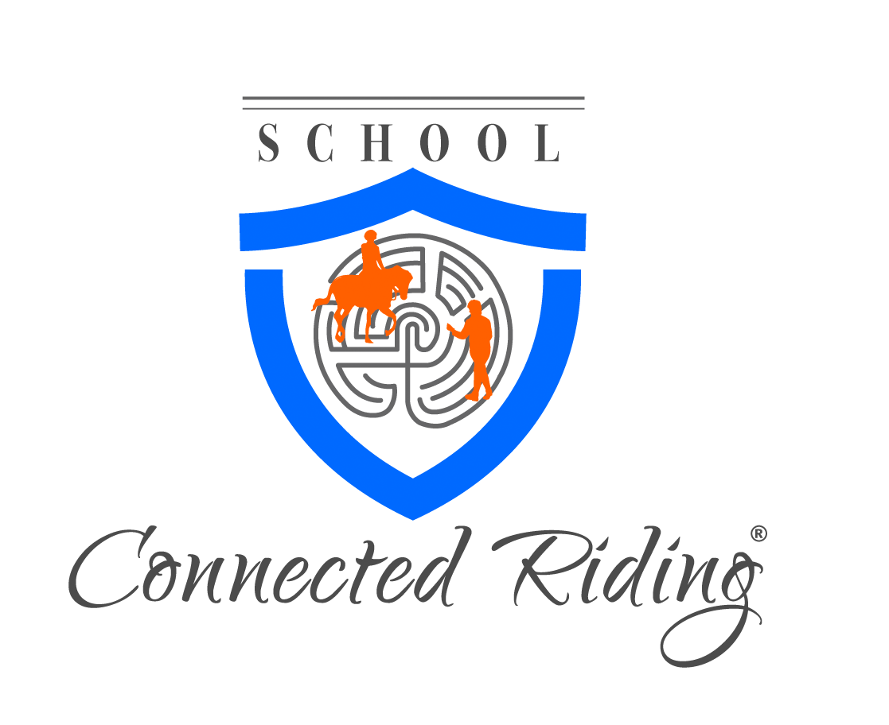

Dear Rider,

Thank you for your interest in our upcoming 5 Day SCRT Course, in Wiltshire January 31-February 4, 2019.

Please fill out the below application in full and return to Stephanie as soon as possible via email at:
accountsmanager@connectedriding.com
The application will be your sign up, so send asap!

Please complete your name exactly how you want to see it on your 101 certificate, we will not be able to make changes once we have generated your certificate.

We ask that you arrive the day before the event to get settled, courses start at 9:00 am with a lunch and will go till 5:00 p.m. give or take each day. Times will vary slightly depending on group, but will be close to times listed.

If you are not in the area we ask that you lodge in a VRBO situation with your fellow riders, or stay at the same hotel, we ask that someone please helps head this for us; Finding a reasonable location, setting up the details and working together as a group. We find that when a group lodges and dines with each other that bonds take place and a support team is created.

Breakfast will be on your own or with your group before the start of the course. Sack lunches are to be brought, and dinners are generally potluck and worked as a group effort.

Costs:
$1,350.00 USD
$350.00 is due via paypal by November 31 – non refundable
$1,0000.00 is due by wire December 23rd.
70.00 pounds for arena/horse/class fee – brought to course

Peggy will book her plane fare once we receive deposits. Cancellations effect the whole group as a whole, as this is a short notice course, and those on the waiting list might not be able to attend.

More information will follow once we approve your application.

Please answer all questions on the application.

God Unlimited Outdoor Therapy,
Elston Lane,
Shrewton,
Wiltshire
SP3 4HL
Contact Information only for directions and limited questions, they are only providing facilities..
Phone: 01980 621712
Email: office@god-unlimited.org

Please contact Stephanie for any additional information, concerns or questions you may have.

Application for Connected Riding - Training Course SCRT 101

Name:
(Name NEEDS to read how you want to see it on the course certificate!)
Address:
Email address
Website:
Telephone numbers:

- What are your needs and interests in pursuing this training?

- Who recommended you to this course?
3. How did you hear about Connected Riding?

4. Once your coursework is completed, how would you like to utilize your skills in Connected Riding ie. teaching friends and family, having a deeper understanding of the work for yourself, teaching your own students, becoming a representative of the work for the Connected Riding organization.

5. List all previous Connected Riding and Groundwork experience.

6. List all other of your horse-related life experience, bodywork experience or other information that you believe pertains to your interest in pursuing this course.

7. Have you read:
Connected Riding: An Introduction
Connect with your horse from the ground up
Connect with your horse from the saddle
Articles by and about Peggy and Connected Riding in our online library?

8. Are you staying home, booking a hotel or would you like to share a room/rental house as a group?

9. Are you willing to coordinate lodging, finding a feasible option?

Once you have completed this application return ASAP to:
Stephanie Jacobson ~ accountsmanager@connectedriding.com

