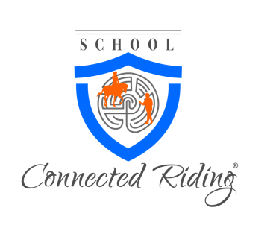
Below please find information on our upcoming Five Day SCRT 101 course.
Location: 49610 Quakenbrück, Germany
This course is designed for people who wish to incorporate Connected Riding into their own riding or teaching program, or who wish to take the initial steps to becoming certified CR practitioner.
SCRT 101 Course scope:
This course addresses the rationale and fundamentals for the "Connected" method: Biomechanics of movement in horse and rider including body awareness for riders, Connected Riding postures for horse and human, equipment use, and introduction to to Connected Riding from the “inside out.” The key application taught in this course learning how and why to balance the human body in neutral position, which is essential to Connected riding and groundwork.
Course outcomes:
• Receive a certificate of completion for SCRT 101
• Take home practice applications for position, riding, and groundwork.
• Contact group for support, and a plan for progressive learning.
Course instructors:
Peggy Cummings(or another Connected Riding Instructor) will teach SCRT 101 with assistance of other Connected Riding certified practitioners who may be assisting Peggy or other course instructor.
Tuition: $1,350.00 USD
The course will have classroom discussions and hands-on work as well as work with horses 3 of the 4 days. It is not necessary to bring your own horse to this course.
Please bring riding boots, helmet and gloves to each course day.
By submitting your application, you agree to Connected Riding Policy and release Connected Riding of all liability.

Commitment & Payment:
Commitment is required immediately, so that Peggy can secure an airline ticket. Payment is due February 1, 2019 to book the ticket. We prefer wiring as method due to fees from Paypal. Please make sure payment is received in full at our end, please account for your own fees and exchange rate. $1,350.00 USD should be sent in full.

Refund Policy:
No refunds will be made on your deposit if cancellation is less than 45 days of the course date. If we are able to fill your spot, we will refund a portion of your deposit less administration fees of $50.00. We hold courses on the commitments made by all riders and any last minute drop outs can effect everyone if we do not have enough riders.

Payment Info:
PayPal and reference our account: info@connectedriding.com
Wire Information: (Preferred method)
Bank of America
19255 Jensen Way, Poulsbo, WA 98370
(360) 697-3733
Swift No. BofAUS3N
Account No. 138115569764
ACH/ABA/Routing No. 026009593
Ref: School of Connected Riding
P.O. Box 1627, Poulsbo, WA 98370

Other Costs:
Please bring this in cash to the Course:
- 75 Euros Kurbeitrag in Bar, einmalig für diesen Lehrgang
- 12 Euros pro Tag für Mittagessen
- 20 Euros Gastbox
- 20 Euros Leihpferd
Other:
If you are attending the course from out of the area, we suggest you arrive the afternoon prior and leave the day after the course. Contact your course host for information regarding ground transportation, meals, and housing, this is not included in the tuition fee.
**Riding Group should consider renting a flat/house together.** Dinners as a group. Please specify where you are staying on your application and/or if you would like to join a group for a flat.
Venue:
Veranstaltungsort:
Marlies Wernsing
Forstgartenweg 1
49610 Quakenbrück
Telefon: 05431 / 93 12 6
Telefax: 05431 / 93 12 7
Mobil: 0171 / 9 37 96 38
Webseite: www.tteam-reiten.de

