Working in Connection through ground driving (with donkeys)

The concepts of Connected Riding® in the context of working with horses from the ground or from the saddle will be familiar to those of you working using the Connected Riding method with your horses.

My passion though is working with donkeys and carriage driving with those donkeys so taking all of the skills learnt from the work with horses into working with donkeys and carriage driving is for me a delight and something that I feel humbled in being able to do.

I am owned by 4 donkeys ranging in age from two, rising 2-year-olds, a novice 5 year old driving donkey and a more experienced 9 year old driving donkey. My donkeys are no more than 11hh (44”) so too small for ridden work but I can use all those ‘connected’ tools from the Connected Riding® toolbox in my ground driving and carriage driving together with the Tellington TTouch Training Method that I also use.

The size of a donkeys’ head means that they are experts in “forehanditis”, are incredibly strong for their size and specialise in “brace” if given a pulling human to work with! I want to work their brains to move their bodies and enable them to find self-carriage.

Donkeys seem to work best through short, non-repetitive and varied sessions. I find working with them through connection really enables me to help them be the best they can in a relatively short time by showing them a more balanced way of being in self carriage. Using the Tellington TTouch Training and Connected riding® toolkits, ground driving becomes an active reciprocating process rather than passive correction with the donkeys just walking along in front of me.

As in riding, maintaining neutral pelvis is key. Rotation, combing the lines, finding the rhythm of the walk with elastic dynamic connection and stretchy elbows all enable my donkeys to change their way of going.

Toby is my 5 year old donkey that came to me as a rising 3 year old youngster as a project due to his reactive behaviours. He presents as a ‘forward’ going donkey, rushes, becomes unbalanced and has some concerns about things around his hind quarters, perhaps understandable as he has had clicking stifles and has weakness in his hind quarters. Ground driving has enabled Toby to find self-carriage, and to start to use his hind legs more effectively.

In the photo below Toby is wearing a Tellington TTouch Training figure 8 wrap under his driving saddle pad to help him release at the base of his neck and give him a connection to his hind quarters.
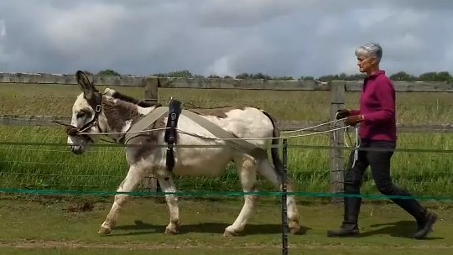
In this photo, Toby has started to brace, his head has come up slightly and his stride shorted behind. I use slight rotation of my body in neutral pelvis and “meet and melt” on the outside rein to help him release through the base of his neck and poll.

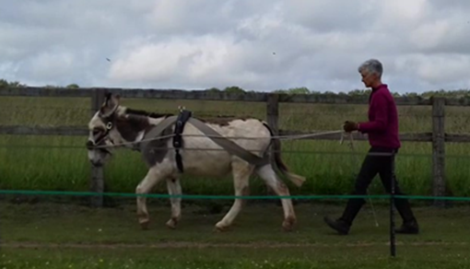
Toby responds by releasing at the base of his neck and poll, lengthening through his topline and bringing his left hind more underneath him

Winston is my 9 year old driving donkey that I was recently ground driving out on a walk with other donkeys and their people when the path became a very narrow with a steep slope downhill. I have a knee that has to be ‘looked after’ and the only way I was going to get down the path was carefully stepping sideways a few steps at a time. Sending Winston on ahead of me, using tiny rotation of my body in neutral pelvis I was able to ask Winston to do a few steady steps down the hill, halt and wait for me. This he did with ease and his level of self-carriage was just amazing. After the walk, someone approached me and asked how I was able to do that with a large donkey when they had been attached to a much smaller animal that had dragged them down the slope!

I love the connection that I have with my donkeys and am so grateful to Connected Riding® for giving me the means of achieving that connection. Thank you Peggy Cummings.

