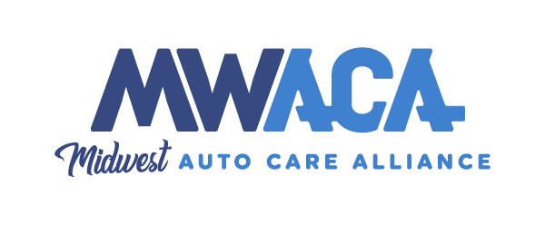
Today’s Date, 2025
Re: OPPOSISTION to HCS HB247 and HCS HB799 MOTOR VEHICLE SAFETY
INSPECTION PROGRAM
Dear Honorable Senators,
Our company, (insert company name) is with the Midwest Auto Care Alliance (MWACA) as one of its 522 Automotive Service and Repair business members. We are opposed to any legislation that would change or weaken the Missouri State Vehicle Safety Program.
The effectiveness of the program is well documented. The data confirms that states with Safety Inspection Programs show that the fatality due to mechanical failure is half compared to the states that do not require vehicle safety inspections.
Currently, safety inspections are not required for registration of a motor vehicle having less than 150,000 miles for the 10-year period following the model year of manufacture. It should not be changed to 150,000 miles or 2012 or newer. This would eliminate thousands of vehicles from the inspections. We will be compromising the safety of the motoring public on the roads and highways of Missouri.
Did you know that 51 percent of Missouri’s fleet is 10 years old or older?
The average failure for a vehicle safety defect is 18 percent. This number increases with the age of vehicles. Vehicles 11-15 years old = 20.8 percent defective rate, vehicles age 16-20 = 25.4 percent defective rate.
The Missouri State Safety Inspection Program and GVIP Federally Mandated Emission Inspections are two separate inspections that are tied together.
Another element of the program includes the School Bus Safety Inspections that are funded through the Safety Inspection Program. St. Louis, St. Charles, and Franklin Counties will STILL BE REQUIRED to obtain an Emissions Inspection.
Here are a couple of things we have heard about the program from legislators in the past:
• It’s inconvenient. We do many things every day that are inconvenient. Once every two years is hardly inconvenient. Saving lives has now become inconvenient?
• People always get things repaired when there is a problem. They take care of what is needed. If you watch while you are driving you will see vehicles with headlights, taillights and brake lights out on a consistent basis. This is a simple and obvious failure that goes unrepaired. How can you expect drivers to find serious defects under their car? If they did do what they are responsible for we wouldn’t need laws for mandatory car insurance and mandatory seatbelt laws to name a few.
• Cars are so advanced today we don’t need safety inspections. This is true from the collision aspect of newer vehicles but does not do anything for safety items such as steering and suspension, brakes and exhaust just to mention a few items.
• When I get my oil changed, they inspect my car. The inspection you receive from getting an oil change is not even in the same ballpark. Missouri’s Safety Inspection is one of the most comprehensive in the industry, not a quick 30-point glance to see what you can find.
This bill is bad for Missouri, and UNFAIR to lower income citizens who must drive older vehicles because of their economic situation.
Respectfully,
[Your Name]
[Your Title/Company]
[Your Phone Number and Email Address]

