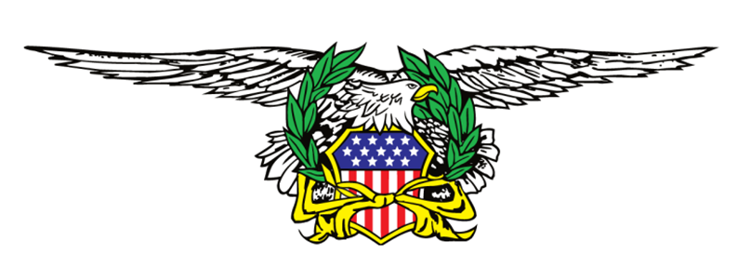
ABATE of WASHINGTON
2026 Motorcycle Rides/Events
January 2026
Jan 1st 5th Annual Polar Bear Run, South King County Chapter. Reg 11 am KSU 12 noon. $20 ea. 2up $30. @ Draft Choice Sports Bar & Grill 32201 Kent Black Diamond Rd. SE Auburn, WA 98092.
Jan 5th Spanaway Chapter meeting 6:30 pm.
January 10 & 11th Spokane Chapter, Road Guardian Accident Scene Management Scene Basic & Advanced classes. $50 each class! See flyer to register.
Jan 13th Spokane Chapter meeting 5:30 pm. potluck/social. 6:30 meeting 2405 N. Dick Rd. Spk Vly.
Jan 17th Spanaway Chapter Chili Cook Off
January 30th Black Friday, ABATE of Washington at the Capital. Ride in, see your legislators. Stand Up, Step Up and Be Heard!
Jan 31st Abate of WA BOD, VFW #318 2902 Martin Wy. W, Olympia. WA 98506

February 2026
Feb 2nd Spanaway Chapter meeting 6:30 pm.
Feb 10th Spokane Chapter meeting 5:30 pm. potluck/social. 6:30 meeting 2405 N. Dick Rd. Spk Vly.
February 21st The Original Sauce OFF. Spokane Chapter. $20 a person. Enter your sauce for the challenge. 1st, 2nd, & 3rd place winners. Show us your talents! 5pm all Sauce entries, 5:30 pasta dinner - put your favorite sauce on your pasta. Winner announced 6:30 pm. @ 2405 N. Dick Rd. Spokane Valley, Combat Vets Outreach Center.
Feb 28th Spanaway Chapter Spaghetti/Bingo

March 2026
Mar 2nd Spanaway Chapter meeting 6:30 pm.
Mar 8th Abate of WA Ecom meeting, 11 a.m. – Buckley Eagles
Mar 10th Spokane Chapter meeting 5:30 pm. potluck/social. 6:30 meeting 2405 N. Dick Rd. Spk Vly.
Mar 13-15th Spokane Motorcycle Show & Sale, Spokane Chapter Abate, Spokane County Fairgrounds.
March 22nd 11-3pm. ABATE of Washington Motorcycle Swap Meet, Evergreen State Fairgrounds, (Hwy 522 & Hwy 2) $5 ABATE members, non-members $10. See flyer for details.
Mar 21st Spanaway Chapter Wing-Ding

April 2026
Apr 6th Spanaway Chapter meeting 6:30pm
Apr 14th Spokane Chapter meeting 5:30 pm. potluck/social. 6:30 meeting 2405 N. Dick Rd. Spk Vly.
Apr 18th Abate of WA BOD, North Kitsap 11am. Cloverleaf – 6430 6th Ave. Tacoma, WA 98406
April 26th Motorcycle Awareness Ride, Spokane Chapter. Promoting Motorcycle Awareness Month (May). Ride. More details to follow.

May 2026 Motorcycle Awareness Month
May 4th Spanaway Chapter meeting 6:30 pm
May 12th Spokane Chapter meeting 5:30 pm. potluck/social. 6:30 meeting 2405 N. Dick Rd. Spk Vly.
May 30th Spanaway Chapter Fallen Riders Run

June 2026
Jun 1st Spanaway Chapter meeting 6:30 pm
Jun 7th Abate of WA Ecom meeting, 11 a.m. – Buckley Eagles
Jun 9th Spokane Chapter meeting 5:30 pm. potluck/social. 6:30 meeting 2405 N. Dick Rd. Spk Vly.
Jun 25 - 28 Spring Opener, ABATE of Washington, Randall. More details to follow.

July 2026
Jul 13th Spanaway Chapter meeting 6:30 pm
Jul 14th Spokane Chapter meeting 5:30 pm. potluck/social. 6:30 meeting 2405 N. Dick Rd. Spk Vly.
Jul 18th Abate of WA BOD, Spanaway/Foothills 11am. TBD

August 2026
Aug 3rd Spanaway Chapter meeting 6:30 pm
Aug 11th Spokane Chapter meeting 5:30 pm. potluck/social. 6:30 meeting 2405 N. Dick Rd. Spk Vly.

September 2026
Sept 6th Abate of WA Ecom, 11 a.m. – Buckley Eagles
Sept 8th Spokane Chapter meeting 5:30 pm. potluck/social. 6:30 meeting 2405 N. Dick Rd. Spk Vly.
Sept 12th Spanaway Chapter Soup Challenge
Sept 14th Spanaway Chapter meeting 6:30 pm
Sept 27th Oyster Run

October 2026
Oct 5th Spanaway Chapter meeting 6:30 pm
Oct 13th Spokane Chapter meeting 5:30 pm. potluck/social. 6:30 meeting 2405 N. Dick Rd. Spk Vly.
October 17th STEAM, ABATE of Washington. More details to follow
Oct 18th Abate of WA BOD, 10 am. Location TBD
BASH Turkey RUN

November 2026
Nov 2nd Spanaway Chapter meeting6:30 pm
Nov 10th Spokane Chapter meeting 5:30 pm. potluck/social. 6:30 meeting 2405 N. Dick Rd. Spk Vly.
Nov 15th Abate of WA Ecom, 11 a.m. – Buckley Eagles
Nov 20th Spanaway Chapter Toy Box Kick Off
Nov 20th BASH Prep Turkey boxes

December 2026
Dec 5th Olympia Toy Run
Dec 7th Spanaway Chapter meeting 6:30 pm.
Dec 8th Spokane Chapter Christmas Party & gift exchange ($10 value) 5:30 pm. 2405 N. Dick Rd. Spk Vly.
Dec 12th Wreaths Across America
Dec 12th Spanaway Chapter Christmas Party
Dec 19th Marymount/Orchard Park Christmas

