For Immediate Release

June 4, 2022

International Motorcycling Advocate Deb Butitta Killed in Arizona Crash

It is with a heavy heart and a great sense of loss that the Motorcycle Riders Foundation (MRF) shares the passing of Deborah Butitta. Deb had been committed to serving and protecting motorcyclists’ rights at the state, federal and international levels during the last four decades. Deb was taken from us due to internal injuries suffered in a motorcycle crash after a truck turned left in front of her on June 3, 2022.

Deb was particularly active with ABATE of Arizona, holding many different offices through the years, and in 2001 was selected as the first designated lobbyist for the Arizona Confederation of Motorcycle Clubs (AZCMC). Deb was a member of many state motorcyclists’ rights organizations, including the MMA of Arizona. She also served on the MRF Board of Directors for many years and was instrumental in the formation of MRF A&E (Awareness and Education), a 501(c)(3) charitable, non-profit organization created to assist the MRF in providing resources to promote motorcycle awareness and ‘share the road’ programs, along with all aspects of motorcycle safety education including rider training. A highly successful businesswoman in her own right, Deb was extremely well connected, not only in the motorcycling community and industry, but legislatively and in some very influential social circles as well. These relationships were of incredible value to the bikers of Arizona and the entire country.

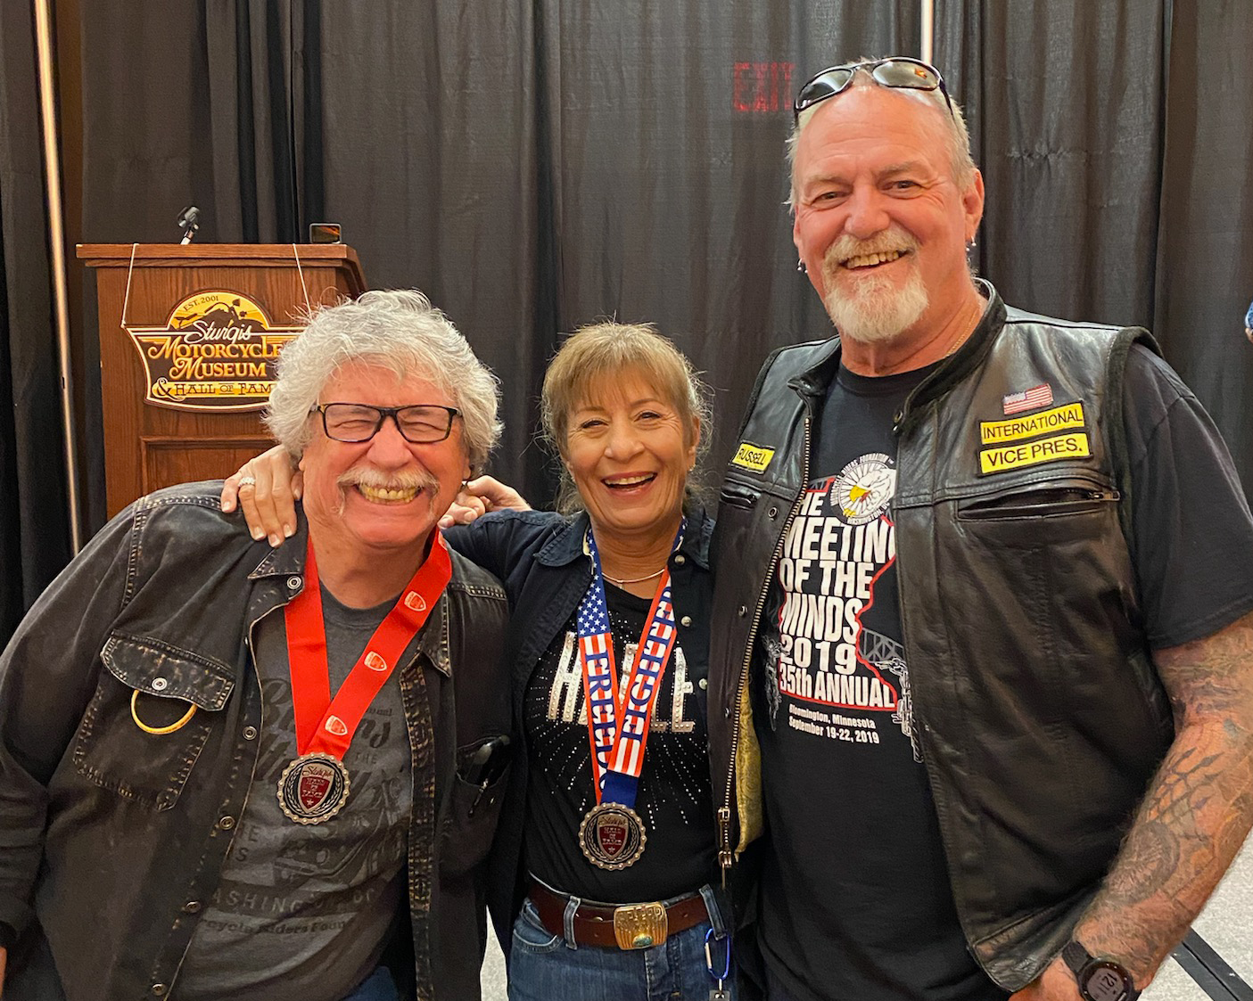

Deb’s accolades and awards are many, including being inducted into the MRF Hall of Fame in 2020 and the Sturgis Hall of Fame and Museum in 2021. Deb is a past winner of the MRF President’s Cup (2003), the MRF Founder’s Award (2017), and the MRF Lifetime Achievement Award (2020). Among her many other duties, Deb served as the MRF’s State Representative for Arizona for 14 years. For several years now, the MRF has given the ‘Deborah Butitta Award’ to it’s highest performing State Representative in her honor.

A true leader, Deb had a profound influence on many of her fellow activists. Few people have dedicated so much of their life or contributed as much to motorcycling as Deb Butitta. Personally and professionally, her passing leaves a tremendous void in our “family”.

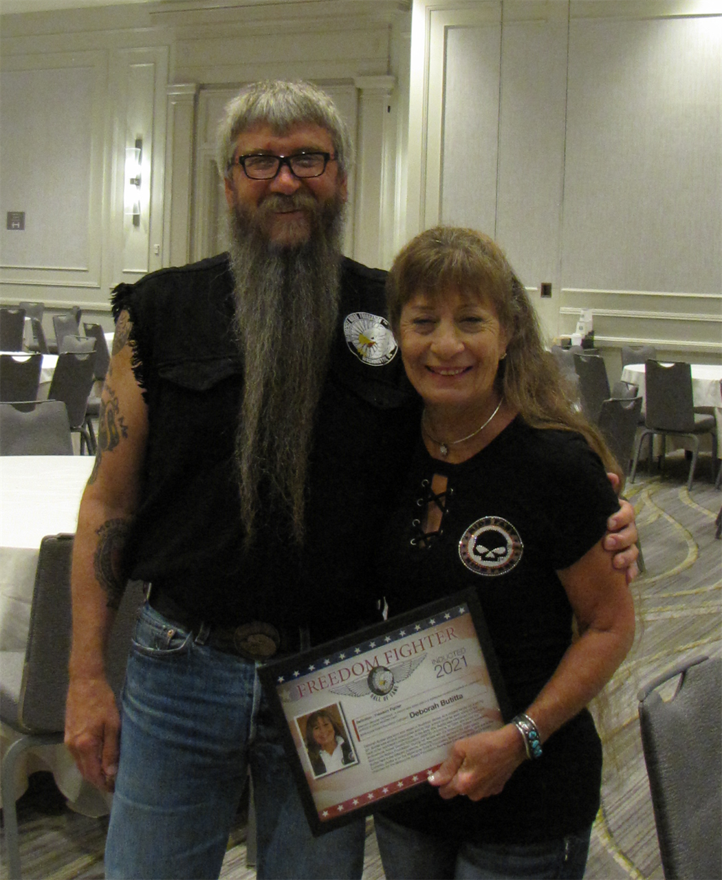

About Motorcycle Riders Foundation

The Motorcycle Riders Foundation (MRF) provides leadership at the federal level for states’ motorcyclists’ rights organizations as well as motorcycle clubs and individual riders. The MRF is chiefly concerned with issues at the national and international levels that impact the freedom and safety of American street motorcyclists. The MRF is committed to being a national advocate for the advancement of motorcycling and its associated lifestyle and works in conjunction with its partners to help educate elected officials and policymakers in Washington and beyond.

