St. Mary’s RE is hosting VACATION BIBLE SCHOOL
June 22nd - 25th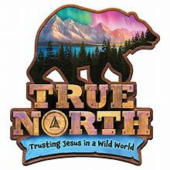
9am to noon $75.00
Come join us for a trip to the True North! All registration in first come first serve and spots are limited.

Each participant will receive a "limited edition" t-shirt, crafts, snacks, games, friendship and much more!
The whole week for $75.00

We welcome all children going into kindergarten in the fall of 2026 to all children going into 4th in 2026.
Children going into 5th grade through college are welcome to sign up as leaders/co-leaders and peer mentors. A spectacular way to earn service hours as well.
Adults helpers are urged to be part of the True North Team!
Questions: jadreani@stmarybg.org Julie Adreani


VBS K-4th grade student sign up
Teen volunteer sign up  Adult sign up 

