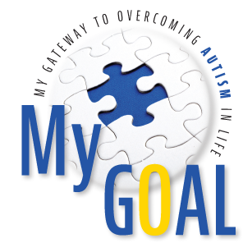
2018 GALA SPONSORSHIP AND BENEFITS

GOLD: $1500 SILVER: $1000 BRONZE: $500 TABLE: $800

AD JOURNAL RATES

Back Cover... $500
Front Inside Cover... $400 Back Inside Cover... $400
Full Gold Page... $400 Full White Page... $300
Half Page... $150 Quarter Page... $75

SPONSORSHIP DETAILS

- Gold Sponsor - $1,500
As a Gold Sponsor, you will receive the following:
  - Your ad on the inside front or back cover of the Program Book
  - Ten tickets to the Gala
  - Your logo on MyGOAL’s website and acknowledgement at the Gala

- Silver Sponsor - $1,000
As a Silver Sponsor, you will receive the following:
  - A full-page ad in the Gala Program Book
  - Five tickets to the Gala
  - Your logo on MyGOAL’s website and acknowledgement at the Gala

- Bronze Sponsor - $500
Bronze level sponsors will receive:
  - A half-page ad in the Gala Program Book
  - Two tickets to the Gala
  - Your logo on MyGOAL’s website and acknowledgement at the Gala

- Table Sponsor - $900
As a Table Sponsor, you will receive the following:
  - Ten tickets to the Gala
  - Acknowledgement at the Gala

Your support enables MyGOAL to enhance lives today and accelerate
a spectrum of solutions for tomorrow. Thank you for caring about MyGOAL Autism

To sponsor please visit our website at www.mygoalautism.org or info@mygoalutism.org

