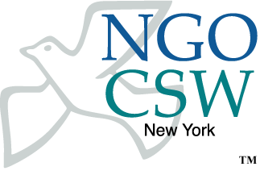
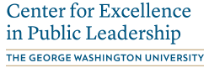
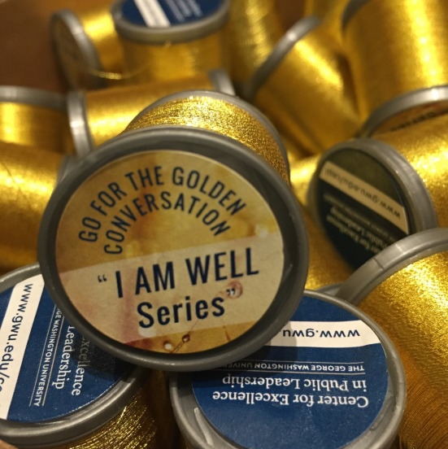
Our organizing symbol for the panel event is the “Golden Thread” of conversations, reminding us to develop deeper, more enriching connections for a truly powerful impact.
Panel Event: “What Women Leaders Must Do to be More Visible in the Media”
Time: 10:30 A.M. – noon (90 min total)
Date: 15 March, 2018
Venue: 4W 43rd Street (Aqua Room)
Format: Moderated panel discussion
Panelists:

- ROBERTA BASKIN, Investigative Reporter; Prize-Winning Journalist; Executive Director of AIM2Flourish
- CARY BROUSSARD, President, Broussard Global; Adjunct Professor, New York University; Author, From Cinderella to CEO (Wiley); President, Press Club of Dallas; former CEO, Alliance for Women in Media
- SARAH GLOVER, President, National Association of Black Journalists; Social Media Editor for NBC Television-owned stations
- LESLIE GROSSMAN, Confidence Curator; Leadership Executive Coach & Trainer; author, Link Out: How to Turn Your Network into a Chain of Lasting Connections (Wiley); Senior Fellow, Center for Excellence in Public Leadership, The George Washington University
- LIZ KAPLOW, CEO Kaplow Communications; former President, New York Women in Communications; Board of Trustees, Public Relations Society of America - Mission of Diversity & Inclusion
- Moderator: INA GJIKONDI-CECCHETTO, Director, Executive Education & Leadership Coaching Services, Center for Excellence in Public Leadership
The George Washington University

Academic Sponsor:
The George Washington University’s Center for Excellence in Public Leadership (GW-CEPL)

For more information, visit our website: www.gwu.edu/cepl or call: 202-994-5390

Panel Discussion and Guiding Questions: Role models play a critical part in influencing young girls to aspire to leadership roles. Visibility of role models in the media not only impacts aspiration of the young, but also garners acceptance and respect of women's leadership capabilities by both genders in business, government, and the highest levels of power.

This panel discussion will explore why women don't have significant visibility in the media, what stops women from being media-savvy role models, and what actions women must do to enable equal gender representation in traditional, digital and social media. The panel will also address issues that impact women's unwillingness to raise their hands in a media-centric society.

Finally, the speakers will share their recommendations on the actions women can take to build self-confidence, leadership presence and good communication skills, while eradicating modesty, perfectionism and childhood 'good girl' habits that create roadblocks for success.

About the Panel:

ROBERTA BASKIN
Investigative Reporter; Prize-Winning Journalist; Executive Director of AIM2Flourish
Roberta Baskin is a veteran investigative journalist on a radical new career path. She founded AIM2Flourish.com at the Fowler Center for Business as an Agent of World Benefit at Case Western Reserve University to find and showcase “good companies” across the globe. The initiative invites business school students to write about scalable innovations aligned with the UN’s Sustainable Development Goals. The 17 best global innovations are honored with Flourish Prizes. For 2018, Roberta has been honored among “100 Visionary Leaders” by Real Leaders Magazine.

Roberta’s storied career has earned her more than 75 journalism awards, including prestigious Peabodys, duPont Columbia Awards, and multiple Emmys. As a result of her investigations, she’s made beer healthier, exposed sweatshops in the shoe and soccer industries, uncovered pediatric dental abuses, and succeeded in banning dangerous products.

Roberta served as Executive Director of the Center for Public Integrity, Senior Washington Correspondent for “NOW with Bill Moyers,” Senior Investigative Producer for ABC News “20/20,” and Chief Investigative Correspondent for the CBS News magazine “48 Hours.” Her proudest journalistic achievements have been righting wrongs, especially transforming the way companies do business.

Roberta was named a Nieman Fellow at Harvard University and an Ethics Fellow at the Poynter Institute. She taught a graduate school course on investigative reporting at Georgetown University. She’s actively served on many boards of directors, including the Fund for Investigative Journalism, Investigative Reporters and Editors, the Journalism and Women Symposium, the Center for Public Integrity, the Robert F. Kennedy Memorial Journalism Committee, the Nieman Foundation’s Executive Committee, Images & Voices of Hope, the FoolProof Foundation, and the Fowler Center’s Advisory Board.

She has been a guest lecturer internationally from Baku to Budapest, and from Bilbao to Borneo. Roberta’s an avid scuba diver and likes to Baskin' the sun anywhere near warm water. She’s currently at work on a memoir.

CARY BROUSARD:
President, Broussard Global; Adjunct Professor, New York University; Author, From Cinderella to CEO (Wiley); President, Press Club of Dallas; former CEO, Alliance for Women in Media
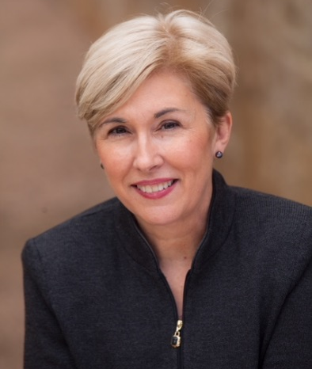
Missing Bio

SARAH GLOVER
President, National Association of Black Journalists; Social Media Editor for NBC Television-owned stations

Missing Photo and Bio

LESLIE GROSSMAN
Confidence Curator; Leadership Executive Coach & Trainer; author, Link Out: How to Turn Your Network into a Chain of Lasting Connections (Wiley); Senior Fellow, Center for Excellence in Public Leadership, The George Washington University

Would need abridged bio

LIZ KAPLOW
CEO Kaplow Communications; former President, New York Women in Communications; Board of Trustees, Public Relations Society of America - Mission of Diversity & Inclusion

Liz Kaplow is a visionary entrepreneur, a trusted advisor to the C-suite, and a champion for the advancement of women in the workplace.

As Founder & CEO of Kaplow Communications, Liz reinvented the practice of public relations in the 1990s with her visionary focus on storytelling – an idea that drives the industry today. Today, she is leading Kaplow Communications to break new ground again: with a redefined focus on storytelling for today’s social/digital world, the agency is integrating emerging technologies with best-in-class public relations.

Liz is a passionate advocate for diversity and inclusion in the workplace. During her tenure as President of New York Women in Communications, she focused on the advancement of women at all levels of their careers and continues to mentor young professionals. Her commitment to advancement for all employees has earned her agency a Top Places to Work in PR award.

Recognized throughout the industry for her leadership and insights, Liz has been honored by New York Women in Communications with its coveted Matrix Award, and by PR News with a Top Women in PR Award. She is a regular on the New York Observer’s PR Power List.

Moderator: INA GJIKONDI-CECCHETTO
Director, Executive Education & Leadership Coaching Services, Center for Excellence in Public Leadership, The George Washington University
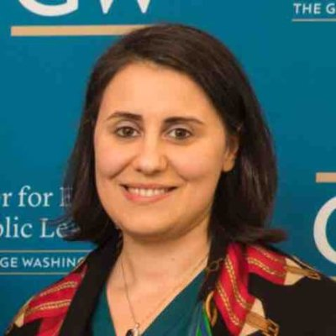
Ina Gjikondi is a passionate educator and ICF-certified coach committed in helping to elevate people and organizations to the next level of consciousness.

Ina serves as the Director of Executive Education and Coaching Programs at the George Washington University's Center for Excellence in Public Leadership. In this capacity she runs the day-to-day operations for the open enrollment, coaching programs, as well as customized offerings for a suite of government clients, supporting their leadership development training and coaching needs.

Ina’s work integrates a variety of approaches and nuances in leadership development, training design and delivery, inspired and grounded by different schools of thought and wisdom in the world. She has experience working in multicultural environments, and believes in the power of the language as an orientation to life, change, and growth.

Ina believes in the whole-person leadership development as a way of building more presence, intention and grounded choice to our actions and commitments. As we navigate this complex and uncertain world we must pay attention and be more intentionally aware to the integral environment that shapes who we are and is shaped by what we do. Balancing the internal and external world is a fine art, a dance of inner and outer technologies. The more we become aware of this polarity, the more we integrate and grow into the greatness that is here to make a difference. These technologies need articulation at all levels, cognitive, somatic, emotional, relational and spiritual, the clarity of which brings purpose and impact in our life, our organization and our planet.

Ina holds an MA in Human Resources Development and an MPS in Political Management, both from the George Washington University. Ina did her BA in Law at the University of Tirana, Albania.

----------------------------------------------------------------------------------------------------------------------------------

About the CSW NGO Forum: The NGO Committee on the Status of Women, NY (NGO CSW/NY) organizes the NGO CSW Forum that includes a day of consultation, a reception, conversation circles, and a series of parallel events during the annual UN Commission on the Status of Women (CSW) meeting in New York. The Forum will be held from 11-23 March 2018, and are organized around the following themes:

- Priority theme: Challenges and opportunities in achieving gender equality and the empowerment of rural women and girls;
- Review theme: Participation in and access of women to the media, and information and communications technologies and their impact on and use as an instrument for the advancement and empowerment of women.

About The George Washington University’s Center for Excellence in Public Leadership (GW-CEPL): The Center was founded in 1997 with a mission to develop public leaders who make a positive difference in their organizations and for the people they serve. The Center achieves its mission by weaving together a combination of academic and practitioner resources to provide rigorous executive education training and coaching, grounded in the realities of public sector leadership and management.

For more information about GW-CEPL, please visit: www.gwu.edu/cepl or call 202-994-5309.

