Lent
PASSPORT

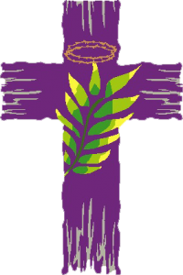

Bring this with you every time you come
to church during Lent!
You’ll receive a sticker to add to the book each time you are here.

Name of Lenten Traveler

First name: ______________________________

Last name: ______________________________

Lent 2019

Put sticker here

if you attend
the Pancake Supper!

Pancake Supper

What is it?
Sometimes called Shrove Tuesday, Fat Tuesday, Mardi Gras (that’s French for Fat Tuesday), or Pancake Day. But whatever you call it, it’s a time to get together right before Lent starts to celebrate the end of one holy and blessed season and the beginning of another.

What does it mean?
All those different names mean the same thing: time to eat delicious food, especially foods made with butter and eggs, like pancakes!

What can I expect?
Lots of family fun, with yummy food, fun games, crafts, and prizes!

What else?
Tonight we burn the palms from last year’s Palm Sunday, to make ashes. Ashes are an important part of Ash Wednesday, which is the next day. Come outside to help!

Pancake Supper: Tuesday, March 5, 5:30pm, Great Hall
Hosted by Christ Church Youth
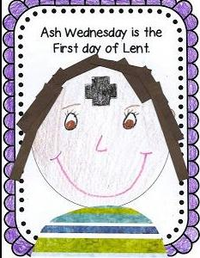

Put sticker here

if you attend
Ash Wednesday!

Ash Wednesday

What is it?
The season of Lent begins on Ash Wednesday. Lent lasts 40 days and is the season of preparation for Easter.

What does it mean?
The message of Ash Wednesday is that we are not God. We were created from dust, and someday, we will return to dust. We are only part of the world, not the ones in charge.

What can I expect?
During worship, you will be invited to come forward to receive a cross on your forehead, made of ashes. The ashes symbolize the dust that we are all made from, and to which we will return. The rest of worship will be like what we do on Sunday mornings, with prayers, singing and Communion.

Where do the ashes come from?
These ashes come from a company that makes them in a special way so that they will stick to people’s foreheads. Our Altar Guild orders the ashes and puts them in the proper bowl to be distributed.

Ash Wednesday services
7:00am
5:30pm, especially for children (others, please come too!)
7:30pm, with full choir
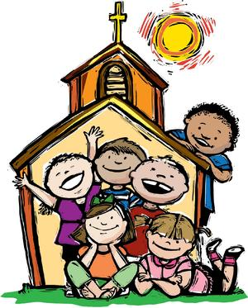

Put a sticker on the Sunday services you attend during Lent!

Sun. Mar. 24
Sun.
Mar. 10
Sun. Mar.17

Sun.
Mar. 31

Sun.
Apr. 7

Sunday Worship

What is it?
There are five Sundays in Lent. We come to church each Sunday morning to observe the holy season of Lent.

What does it mean?
Sunday worship is always a celebration of Jesus’s resurrection—kind of a mini-Easter! During Lent, you will see lots of the color purple, because that is the color for Lent.

What is most important?
Worship consists of Word and Sacrament. We hear from the Bible and we celebrate the sacrament of Communion with bread and wine, just as Jesus asked us to do, so that we can remember him.
There are lots of prayers and lots of music and we always celebrate worship together as a community!

What else?
Notice that we do not say or sing “Alleluia” during Lent! Because this is a word of joyful celebration, we save it for Easter, and that’s when you will hear it again.

Sundays in Lent
March 10, March 17, March 24, March 31, April 7
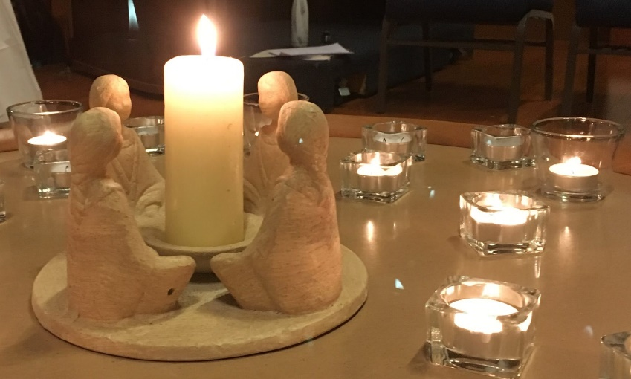

Put stickers here

[Grab your reader’s attention with a great quote from the document or use this space to emphasize a key point. To place this text box anywhere on the page, just drag it.]

Sun.
Apr. 14
Sun.
Mar. 10

if you attend
Taizé!

Taizé

What is it?
Taizé is a candlelight worship service in the church.

What does it mean?
Actually, Taizé is the name of a town in France where these special services started many years ago. Since that time, Taizé services have spread throughout the world! We are so lucky to have Taizé right here at Christ Church!

What can I expect?
Lots of candles at the front of the church, and everyone who comes holds a candle too. We sing special songs which are called chants, and there are readings from the Bible and prayers. There is no sermon. Taizé services last 45 minutes.

What else?
We have Taizé services on the second Sunday of every month. We will have one during Lent and one during Holy Week on Palm Sunday.

Taizé during Lent and Holy Week
Sunday, March 10 and Sunday, April 14, 5:30-6:15 pm

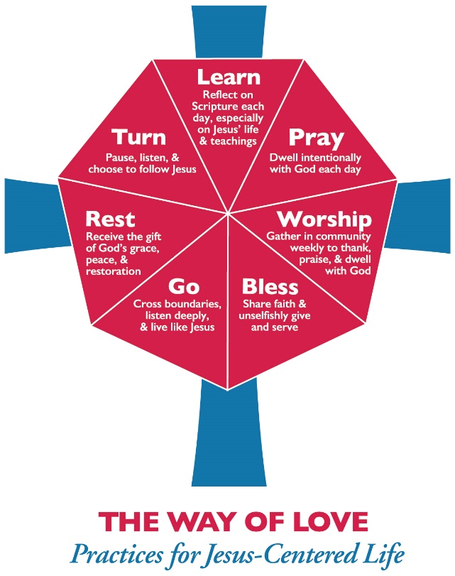

Put a sticker on the Thursday dates you attend!

Thurs.
Mar. 21
Thurs.
Mar. 28
Thurs.
Apr. 11
Thurs.
Apr. 4
Thurs.
Mar. 14

Thursday Worship

What is it?
During Lent, Christ Church offers worship services on Thursday evenings and a program in addition to our regular Sunday services. This gives people an extra way to grow their faith during Lent.

What can I expect?
There is a Compline service in the church, where we thank God for the day we have had and ask for protection through the night. Then we eat a delicious dinner together and then there is a program for adults and one for children and youth.

What else?
Our theme this year is “The Way of Love” from the head of the Episcopal Church in the U.S., Presiding Bishop Michael Curry. We will be making lots of artwork to go along with this theme, come and join us!

Thursdays in Lent
March 14, 21 and 28 and April 4 and 11, 6:00-7:45pm

Put sticker here

if you attend
St. Patrick’s Day Evensong!

St. Patrick’s Day Evensong

What is it?
Evensong is a choral worship service held in the evening, with prayers, psalms, and canticles. Canticles are songs of praise from Bible verses other than the psalms.

Why St. Patrick?
St. Patrick is a saint beloved by many, whose saint’s day is celebrated on March 17, which always falls during Lent. Long ago, in ancient times, St. Patrick brought Christianity to Ireland, which was really important to the spreading of our faith!

What can I expect?
Lots of candles, and lots of singing. The singing is for YOU to join in on! Because this Evensong is in honor of St. Patrick, there will be lots of Celtic prayers and music. The Celtic people lived in Ireland in ancient times and the Celtic culture is still very alive there today.

What else?
Please stay for dinner! Tonight it’s a special Irish-themed dinner with lots of delicious foods inspired by Irish cuisine.

St. Patrick’s Day Evensong
Sunday, March 17
5:30pm

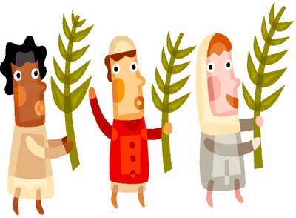

Put sticker here

if you attend
a Palm Sunday service!

Holy Week: Palm Sunday

What is it?
Palm Sunday is the first day of Holy Week, when we remember the last few days of Jesus’s life. Palm Sunday is the celebration of Jesus entering Jerusalem, when people welcomed him like a king!

What does it mean?
Jesus entered Jerusalem on a donkey and was cheered by people waving palm branches and spreading their cloaks on the road for him to ride on. All these things meant that the people thought Jesus was a very important person, and they were glad to have him there!

What can I expect?
At the beginning of worship, we go out into the churchyard and we form a procession. We go into the church singing. This is a way to remember Jesus’s entry into Jerusalem.
The entire Passion story will be read this morning too (the story of the very last days of Jesus.) We will also hear those Bible stories at other services during this week.

What about the palms?
In the part of the world where Jesus lived, there were lots of palm trees and that’s why the people waved branches from palm trees to welcome Jesus. All these years later we still use palm branches on this day!

Palm Sunday: April 14, 8:00 and 9:30am
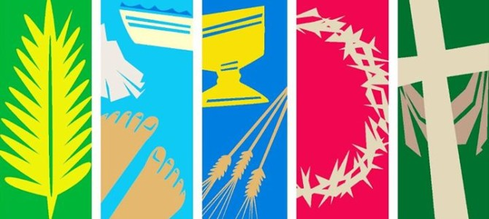

Put sticker here

if you attend
Holy Week Journey with Jesus!

Holy Week Journey with Jesus

What is it?
On Monday evening of Holy Week, we get together at the church to walk with Jesus on his last week. This is especially for children but lots of others will come too!

What does it mean?
Learning these stories together gives us a chance to grow in our love for Jesus and our intention to follow in his ways.

What can I expect?
We will use our imaginations a lot this evening! We will travel around different areas in the church that are set up like places Jesus went during his last week. We will visit the temple, we will have a meal together, we will celebrate Communion, and we will go to the Garden of Gethsemane, just like Jesus did with his disciples so long ago!

What else?
Something really unusual: we will have the opportunity to wash each other’s feet! Do you have to? No! But this is another thing that Jesus did with his disciples that week. A lot of children really enjoy this part of the evening. Come and see!

Holy Week Journey with Jesus
Monday, April 15, 5:00-6:30pm
Especially for children but really for anyone!
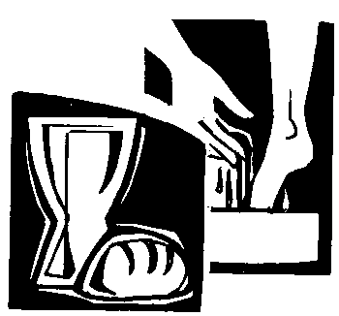

Put sticker here

if you attend
Maundy Thursday!

Maundy Thursday

What is it?
On Maundy Thursday we remember the last evening that Jesus and his disciples were together.

What can I expect?
First we will share a delicious Agapé meal. The word Agapé is pronounced Ah-GAH-pay and means loving-kindness. This meal is similar to our Eucharist. Then we will go into the church for a candle-lit service with prayers, singing and again, foot-washing (if you wish.) We will hear stories about that evening so long ago.

Hmm, this sounds familiar?
Yes! We have already learned about these things earlier in Holy Week. But come to Maundy Thursday too to experience all this again in a different way. All of this helps us remember to follow in the ways of Jesus!

Why is there foot washing?
Jesus washed his disciples’ feet as an act of humble service to them. Jesus did not come to be powerful but to serve people in the simplest ways.

What does “Maundy” mean?
It means “commandment.” When they were eating together on Jesus’s last night, Jesus gave his disciples a new commandment: ”Just as I loved you, you also should love one another.” (John 13:34.)

Maundy Thursday: 7:00pm

Put sticker here

if you attend
Good Friday.

Good Friday

What is it?
This is the day we remember Jesus’s death. After sharing a meal with his disciples and going to a garden to pray, Jesus was arrested by the Roman authorities. He was put on trial by both the religious authorities and the political authorities. He was sentenced to death and executed that same day. Jesus was nailed to a cross, where he hung until he died. Then a friend of Jesus, Joseph of Arimathea, took his body and put it in his own tomb. That’s where the Good Friday story ends.

What can I expect?
Once again we will hear the reading of the Passion, or the last hours of Jesus. There will be music and prayers. There is no Communion at this service. At the end of worship, the lights will be turned off and we will depart in silence.

Why do we call it “Good” Friday?
This was a terrible and sad day for Jesus and everyone who loved and followed him. But we call it “Good” because that helps us remember that Jesus defeated death when he rose again on Easter, to live in our hearts forever.

Good Friday: April 19, 12:00 noon
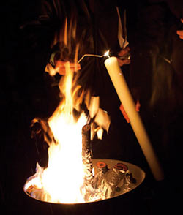

Put sticker here

if you attend
the Easter Vigil!

Easter Vigil

What is it?
This is the first celebration of Jesus’s resurrection which we celebrate the night before Easter Sunday!

What does it mean?
The word “Vigil” means the eve of a festival or holy day and a time of devotional watching and keeping awake, especially during the evening or nighttime hours.

What can I expect?
At the beginning of the service, we start outside in the churchyard to light the new Paschal candle. Look for the date of 2019 on the candle!
Then we come inside and hear wonderful stories about the history of God’s people.
Easter Vigil is a traditional time that the church offers the sacrament of baptism and we do have a baptism this year! All children are invited forward during baptisms so they can see what is going on and get a good look at the baby!

What else?
Stay for a party after the Easter Vigil service, to celebrate Easter!

Easter Vigil: Saturday, April 20, 7:30pm

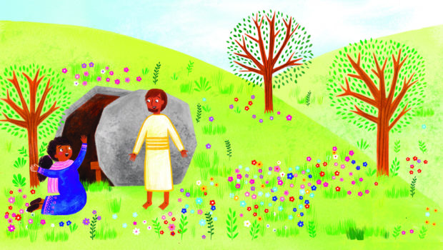

Put sticker here

if you attend
Easter Sunday!

Easter Sunday

What is it?
On Easter, we celebrate that Jesus rose from the dead, to be with us forever.

What does it mean?
Because of Easter, we know that God is stronger even than death. Everyone who follows Jesus is given a new life. We can start living that new life now, as we love one another, just like Jesus commanded the disciples on Maundy Thursday. We know that life continues even after death.

When does it happen?
The exact date of Easter changes every year. It is the first Sunday after the first full moon after the spring equinox (March 21.) It is based on the date for Passover, the Jewish holiday that Jesus and his disciples celebrated at the Last Supper.

What can I expect?
There will be lots of “Alleluias” in worship today! (Remember, those went away during Lent?) There will be lots of flowers at the front of the church, symbolizing new life. The cloths on the altar and the vestments the priests wear will be white and gold for celebration!

What else?
We will use the ancient Easter greeting: “Christ is risen! He is risen indeed!”

Easter Sunday: April 21, 9:00 and 11:00 am
Easter Egg Hunt follows 9:00 service!

Thank you for traveling with us!

Happy Easter!

Put one last sticker here

if you attend
the Easter Egg Hunt!

