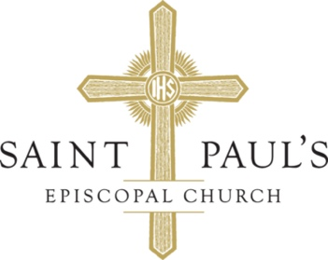

Prayer List

August 6th 2023

We pray for all those who are affected by the COVID 19 Virus.

For those who suffer in mind, body, or spirit.

Barbara Steinberg*

Brian E*

Brian Jagodnik

Charlie Prasad*

Caroline*

Chris Strum

Clare*

The Daly Family*

Dave Trietsch

Deepak Dey*

Dennis Todd

Dottie Dobbs*

Eileen and Ron

Elise and Family*

Evaleen and Bob Fisher*

Evelyn Lorence*

Jack Hart*

Jason M.

Jean, Rowan, and James*

Jesse

Jill Liberty*

John and Betty White*

Joseph Warner*

Karen Vincent*

Katherine Douglas*

Katie H.*

Magdalena Lovejoy*

Matt and Family*

Michael Quint

Morgan Rivas French

N&A *

Nick*

Nikita Johnson Gillis*

The Olson/Dulude Family*

Paul

Pat H.*

Patti Andrus *

Rick Galloway *

Rocky*

Rusty*

Sarah*

Sheila *

Sue C.*

Teresa McMurrin*

Thomas S. Douglas*

VB Family *

Viola Cleo Bradshaw

Tom Douglas

For those who have died.

Cooper
Ryan Johnston (7/7)
Jeanie Galey (7/15)

Paul Farrell (7/21)
Mary Elizabeth Parker Domejka (8/1)
Father Fred Heard (8/1)

For those serving in our armed forces.

Kyle Hein
Nathan Hanson
Patrick Caldwell
Ryan Wells
Shawn Canatsey

Tyler Conklin
Aidan Farrell

Names will remain on the prayer list for 30 days from the date they are added unless another request is made. A person’s name can be deleted at any time by contacting the church office. Prayer list is shared with parishioners and friends of St. Paul’s. To add a name, submit a Prayer Request on our website (stpaulsoregon.org) by clicking the link in the upper right corner of the homepage, or send us an email at stpauls@stpaulsoregon.org. You may also call the office (503-362-3661).
In everything by prayer and supplication with thanksgiving let your requests be made known to God.
-Paul’s Letter to the Philippians, 4:6

