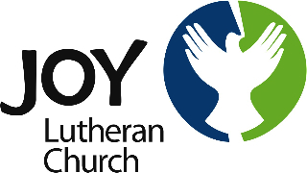

10111 East Eagle River Loop Road
Eagle River, Alaska 99577
907-694-9601
joylutheran@gmail.com

June 25, 2021

Dear Members and Friends of Joy Lutheran Church,

We have exciting news to share: our new full-time Pastor, Sean Avery, arrives here in July! We believe God’s hand has brought this to fruition and we are filled with gratitude. Pastor Avery’s first Sunday is July 11th.

Pastor Sean recently graduated from Wartburg Theological Seminary in Dubuque, Iowa and was ordained on June 11th at his home congregation in Bellingham, Washington. While Sean will infuse a youthful energy to our ministry, he also brings unique life experiences. He earned his bachelor’s degree in Human Services from Western Washington University in 2010, and his master’s degree in Organizational Development from Gonzaga University in 2014. He served as a reserve deputy sheriff for Whatcom County and communications officer for the WWU Police Department before he felt the Holy Spirit calling him to pursue the ministry.

Pastor Sean, his wife Becky and their dog Ole are excited to begin their life in Alaska, specifically Eagle River. They enjoy the outdoors and have been talking about Alaska with one another since high school. They are enthused to join us and we are over-joyed to welcome them. Together we embark on the next chapters of God’s story here at Joy Lutheran, including ministry to one another and important outreach to Eagle River and the world.

We are here if you have any particular pastoral needs, just let us know. We extend an open invitation to you to discover what God has in store for Joy Lutheran. Join us any Sunday for worship at 9:30 a.m. We would love to see you and Pastor Sean will love to get to know you.

In God’s Peace,

Sue Weimer
Council President

