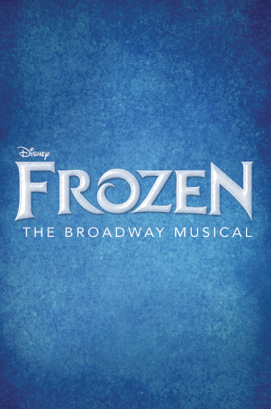
GET ‘EM WHILE THEY LAST!

Douglas County School District
Community Event with the
Denver Center for the Performing Arts

Sponsored by the
Foundation for Douglas County Schools

The Foundation for Douglas County Schools has purchased a limited number of tickets to Disney’s Frozen: The Broadway-Bound Musical coming in August to the Denver Center for the Performing Arts. The Denver debut of Frozen will feature more music, incredible stagecraft, and the epic story you love – now told as a full-length Broadway musical!

Choose between an evening performance on Thursday, September 21 at 7:30 p.m. or a matinee on Saturday, September 23 at 2:00 p.m. Tickets for the evening performance are just $40, and tickets for the matinee are $75. These great prices include all fees AND a donation to to Douglas County Schools!

To reserve and purchase your Frozen tickets - while they last - contact Stacey Briggs at stacey.briggs@dcsdk12.org or 303-387-9382.

