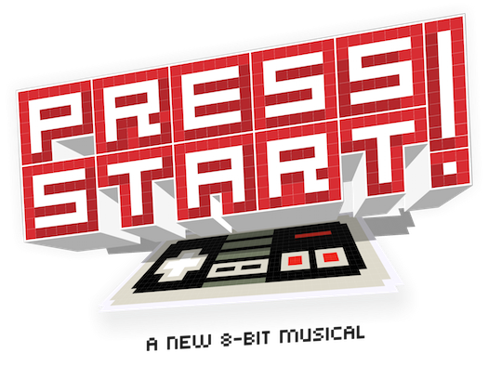
PRESS START (grades 3-8) transports us inside the bright, pixelated world of video games! When the famous characters we know and love run out of lives, they decide to put on a musical fundraiser that will help them raise gold rings and play on. Through hilarious and heartfelt musical numbers we see the heroes, villains and sidekicks like we’ve never seen them before. But when things go terribly awry, it’s the quiet sidekick Little Mushroom who must find the hero within to help save the day!

This Old Gingerbread House (grades 1 and 2) Hansel and Gretel have assumed the mortgage on the Gingerbread House in the forest. Problem is, over the years, the temptation of the tasty building materials is too much for their woodland neighbors to ignore. The house is in terrible shape! Poor Hansel and Gretel can't afford to fix up the house themselves and decide they must move out forever. But wait! Realizing that they have wronged Hansel and Gretel, the neighbors pool their resources and hire the team from "This Old Home Improvement" to come and repair the deteriorating house.
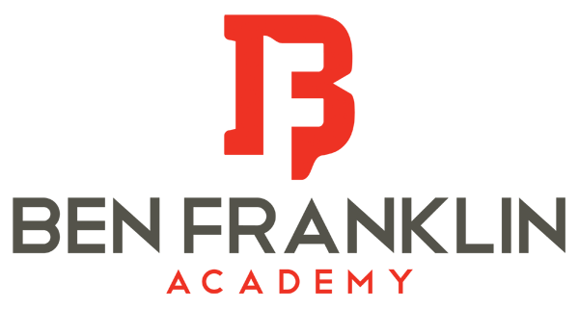

After School Music Programs
Spring 2017: Registration opens December 12th
Mondays: 1st and 2nd Grade Junior Musical Theater Mondays 3:35 to 4:10
- Musical title: This Old Gingerbread House (capped at 40 students)
- Students learn the basics of acting and singing in a musical
- Perform on May 11th at 6:30pm (call time 6)
- Start date: January 23rd

Tuesdays: :4th and up Beginning Band (flute, clarinet, sax, trumpet and percussion) Tuesdays 3:30-4
- Students focus and reading music and learn to play a band instrument of their choice
- Required material: rented instrument and “Standard of Excellence Book 1”
- Concert on May 4th, 5:30 pm at CIVIC GREEN PARK
- Start date: January 17th

Wednesdays: 3rd and up Musical Theater Wednesday 3:30 to 4:15
- Musical title: Press Start! (capped at 40 students)
- This is a class for students that enjoy the grade level musicals and want to learn the next level
  - This is NOT a riser musical. Students will learn about acting, singing and how to move on stage
- Performs on May 11th at 6:30pm (Call time 6)
- Start date: January 18th

Thursdays:4th and up Intermediate Band (already play an instrument) Thursdays 3:30 to 4
- Students focus and reading music and learn to play a band instrument of their choice
- Concert on May 4th, 5:30 pm at CIVIC GREEN PARK
- Start date: January 19th

*** To learn more about any of BFA’s music programs or to listen to the music go to: http://www.bfacademy.org/class/sixth-grade/music

To Register:
Go to bfacademy.org
Click on “make a payment”
Click on “music”
Select the class you want to register for

Questions??
Email Ms. Johnson at jjohnson@bfacademy.org

