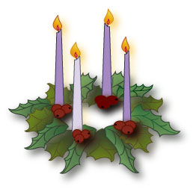 |  | 2020  Advent Calendar

Sun. | Mon. | Tue. | Wed. | Thu. | Fri. | Sat.
29 | 30 | 1 | 2 | 3 | 4 | 5
Light the first Advent candle and say a prayer for world peace | Write a prayer thanking God for all that He has given you | Be a friend to someone who needs one | Give out five compliments to those around you | Hold the door for someone who is carrying a lot of things | Encourage someone today | Do something special to show your parents/ guardians that you appreciate them
6 | 7 | 8 | 9 | 10 | 11 | 12
Light the second Advent candle and say a prayer for our St. Rose Families | Show kindness to someone who seems lonely or unhappy | Celebrate the Immaculate Conception and pray to Mary | Say a special prayer for our soldiers | Be a peacemaker at home and at school | Be Kind to Yourself Day: exercise, eat healthy, reduce stress | Pray a decade of the Rosary for a special intention
13 | 14 | 15 | 16 | 17 | 18 | 19
Light the third Advent candle and say a special prayer for those who will not be able to see their family members this Advent  Season | Say a special prayer in remembrance of the Sandy Hook victims and their families | Be positive today; no complaints or frowns allowed! | Make a special effort to be kind to those I find it hard to like | Put a smile on someone’s face today and make them laugh | Do something kind in secret to someone today | Make Christmas cards for a nursing home
20 | 21 | 22 | 23 | 24 | 25
Light the fourth Advent candle and say a prayer for our teachers | Say a prayer for all the health care workers | Call a relative you haven’t seen in a while to say ‘hello’ | Read a Scripture passage that speaks of kindness | Day of Joy and Song – Do your best to celebrate the coming of Jesus | Rejoice our Savior is born!

