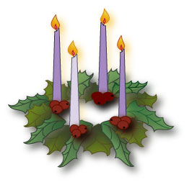 |  | December, 2018  Advent Calendar

Sun. | Mon. | Tue. | Wed. | Thu. | Fri. | Sat.
2 | 3 | 4 | 5 | 6 | 7 | 8
Light the first Advent candle and say a prayer for world peace | Receive Advent Reconciliation | Be a friend to someone who needs one | Hold the door for someone who is carrying a lot of things | Say a prayer to St. Nicholas, patron saint of children | Be a peacemaker at home and at school today | Celebrate the Immaculate Conception & pray to Mary for guidance
9 | 10 | 11 | 12 | 13 | 14 | 15
Light the second Advent candle and say a prayer for our St. Rose Families | Write a prayer thanking God for all that He has given you | Sit with someone new at lunch | Say a special prayer for our military | Show kindness to someone who seems unhappy or lonely | Say a special prayer for the Sandy Hook victims and their families | Pray a decade of the Rosary for a special intention
16 | 17 | 18 | 19 | 20 | 21 | 22
Light the third Advent candle say a prayer for those who will not be able to see their family this Advent | Encourage someone today | Be positive today; no complaints or frowns allowed! | Give out five compliments to those around you | Put a smile on someone’s face today and make them laugh | Do something kind in secret for someone today | Make Christmas cards for a nursing home
23 | 24
Light the fourth Advent candle and say a prayer for our teachers | Make a special effort to be kind to those I find it hard to like

