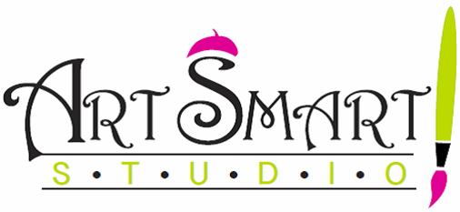
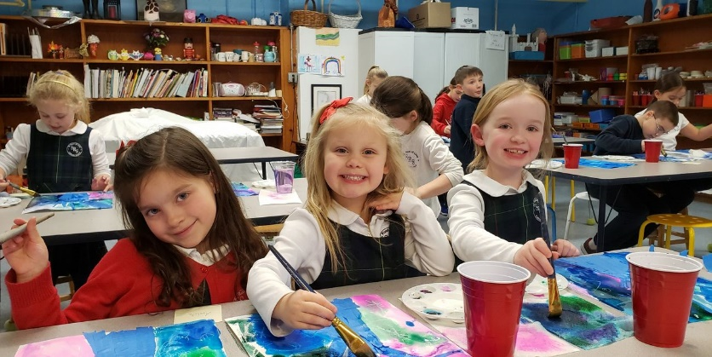

HOME is where the ART is!
SRS Monthly Home Workshop Kits
Delivered directly to St. Rose of Lima School

Welcome back! While the world socially distances, creativity flourishes!
This year, in lieu of workshops held at the school, ArtSmart! Studio will now be offering monthly HOME WORKSHOP KITS, with delivery directly to SRS.

- Multiple themes to choose from each month.
- NEW monthly “Create for A Cause” fundraiser kit option, with proceeds to benefit SRS.
- Each workshop kit will include beautiful project materials & a tutorial link… allowing young artists to create, at leisure, from home!
- Projects designed for ages 7+. Younger artists may enjoy with adult assistance.
- Online payment, with direct delivery to SRS.

To place your OCTOBER order:
- Simply visit www.artsmartstudiomonroe.com.
- Click on Home Workshop Kits & place your order by Tuesday, September 29th for delivery directly to SRS on Wednesday, October 7th.
- Kits will be sent home with your artist.

Need even more art?
Additional workshop kit themes are available through
Monroe Parks & Recreation at www.monorerec.org.
Kits ordered via MP&R by 9/29 will be eligible for the SRS delivery.
You must email me- kathy@artsmartstudiomonroe.com – to confirm your MPR kit order prior to the SRS delivery date to guarantee delivery.

