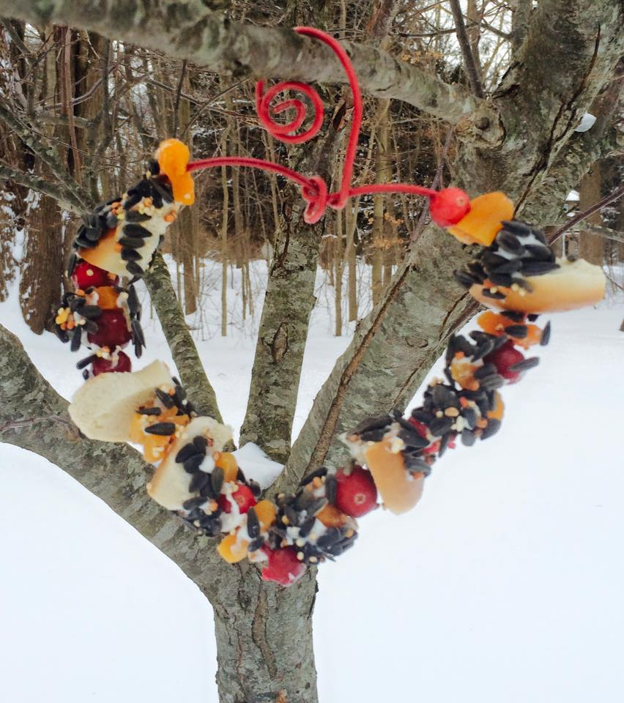

Afterschool Art @ SRS!
“Tweetheart”
Bird Feeders

KINDERGARTEN – GRADE 4 artists are invited to join Mrs. Vincent
for an afternoon of crafting to care for our feathered friends!
Valentine’s Day may have passed, but now is the time to show a little love for the birds, providing nourishment until spring arrives.
Participants will mix up a batch of (nut/nut butter free) “Bird Pudding”, then apply it to (4) simple feeders, adding a generous layer seeds & dried fruit.
All will be ready to hang in the backyard upon arrival at home!
*Each crafter will receive a copy of the recipe to bring home for future feeders.

Date Friday, February 28th Visit www.artsmartstudiomonroe.com to register
Time 3:00-4:00 at SRS Registration closes Thursday, January 27th, with a
Fee $15.00 minimum of (8) artists required to run this event.

POLICY REGARDING WORKSHOP ABSENCES: Given that materials are purchased & prepared, with seats held, based on registration, workshop fees are NOT refundable. Workshop credits are NOT issued.

Questions? Contact Kathy Vincent kathy@artsmartstudiomonroe.com
Visit Facebook - ArtSmart Studio Monroe
for recent workshops & project images
LIKE & SHARE!

