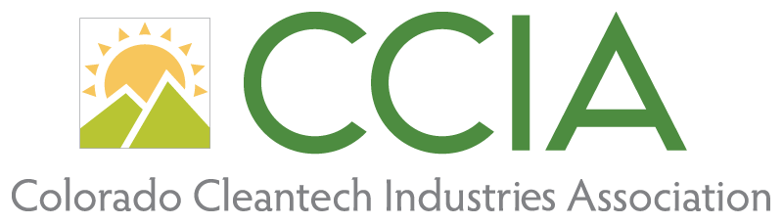

Membership Manager position description

This Membership Manager position will support the Colorado Cleantech Industries Association’s (CCIA) mission of impacting Colorado’s policies, people, products, and programs that drive expansion of a cleaner, cheaper, more efficient, and secure energy economy. Through advocacy, public policy leadership, development, and education, CCIA works to ensure that Colorado is a global cleantech leader. The ideal candidate for this role will have a strong interest in clean energy, energy innovation and building Colorado’s energy community.

In conjunction with the Partnerships Director, the Membership Manager will be responsible for the management and administration of CCIA’s member relations strategy.

Role responsibilities include all stages of the membership cycle, including organizational, administrative, scheduling, communication, CRM/database management, recruitment, retention, and renewal process functions to ensure smooth operation and continuity CCIA’s membership component.

Duties:

- Manage and maintain regular member outreach, retention, and all aspects of member relations
- Secure new CCIA members
- Develop and maintain strategies for retention and cultivation of new members, including the creation of new member benefits and regular solicitation of member feedback.
- CRM development, management, and workflow
- Manage membership accounts receivable and aspects of invoicing members
- Organization and management of members-only C-level networking events
- Represent CCIA with members, stakeholders, and in the community, including speaking publicly for the organization when needed
- Programs support as directed
- Attend meetings and programs as directed
- In concert with the Program Manager, coordinate website content and functionality to enhance membership and strategic partnership programs
- This position may require occasional work outside of normal business hours
Skills Required:
- Bachelor’s degree from an accredited four-year college or university and two years experience in membership/membership marketing and communications, economic development, and/or non-profit development
- Strong and precise verbal and written communication skills
- Ability to work with and communicate with a diverse stakeholder group, i.e. C-level executives as well as mid-to lower level company representatives
- Demonstrated ability to provide quality customer service and to lead and balance work with a variety of internal and external stakeholders
- Demonstrated ability to manage, facilitate and present to committees and groups
- Ability to support and organize meetings, webinars, and programs that engage stakeholders
- Highly organized and detail-oriented, flexible and collaborative with an ability to prioritize and manage multiple tasks simultaneously.
- Proficiency in Microsoft Office suite of applications (Excel, Word, Power Point) and Google suite
- Ability to adapt quickly to new projects, timelines, partners and direction
- Comfortable working across various social media platforms
- Excellent written and oral communication skills, and positive, can-do attitude
- Work well in a fast-paced team environment and is a dependable team player
- Personal qualities of integrity, credibility and a commitment to CCIA’s mission

Salary and Benefits:

Compensation: Annual salary and commission TBD depending on experience
Employer supported health benefits
Paid vacation time
Paid holidays
Dental and vision insurance
Professional development opportunities

