
Worship Plan for Sunday, April 20, 2025
Resurrection of Our Lord: Easter Day

The Holy Spirit calls us together as the people of God.
GATHERING
Welcome & Announcements
Prelude -Hand bells – Majestic Alleluia

Thanksgiving
Alleluia! Christ is risen.
Christ is risen indeed. Alleluia!

Just as God’s work of creation never ends,
so the gifts received in baptism are renewed every day.
Let us give thanks together for the life given in baptism.
We give you thanks, O God, for the waters of life:
for water to bathe in, water to drink,
for waters to play in and waters that inspire wonder,
for water that gives life to our planet.
We give you thanks, O God, for the waters of life.

We give you thanks, O God, for the waters of this place:
for water from our tap, for rain [and snow],
for [local water sources may be named].
We give you thanks, O God, for the waters of this place.

We give you thanks for your salvation through water:
for delivering Noah and his family through the floodwaters,
for leading your people Israel through the sea into freedom,
for preserving your prophet Elijah through the time of drought,
for guiding your people across the Jordan into a new land,
for quenching the Samaritan woman’s thirst with living water.
We give you thanks for your salvation through water.

We give you thanks for the life of all the baptized,
and for all who gather here;
for godparents and baptismal sponsors,
for children and grandchildren, for our brothers and sisters in Christ whom we have never seen but to whom we are bound.
We give you thanks for the life of all the baptized.

We give you thanks for life in Christ through your Holy Spirit:
for our entry into Jesus’ death through these waters,
for our new birth into a life of freedom and service,
for our calling to be your people, sent out for the life of the world.
We give you thanks, blessed and holy Trinity, now and forever. Amen.

Gathering Song Jesus Christ Is Risen Today ELW#365
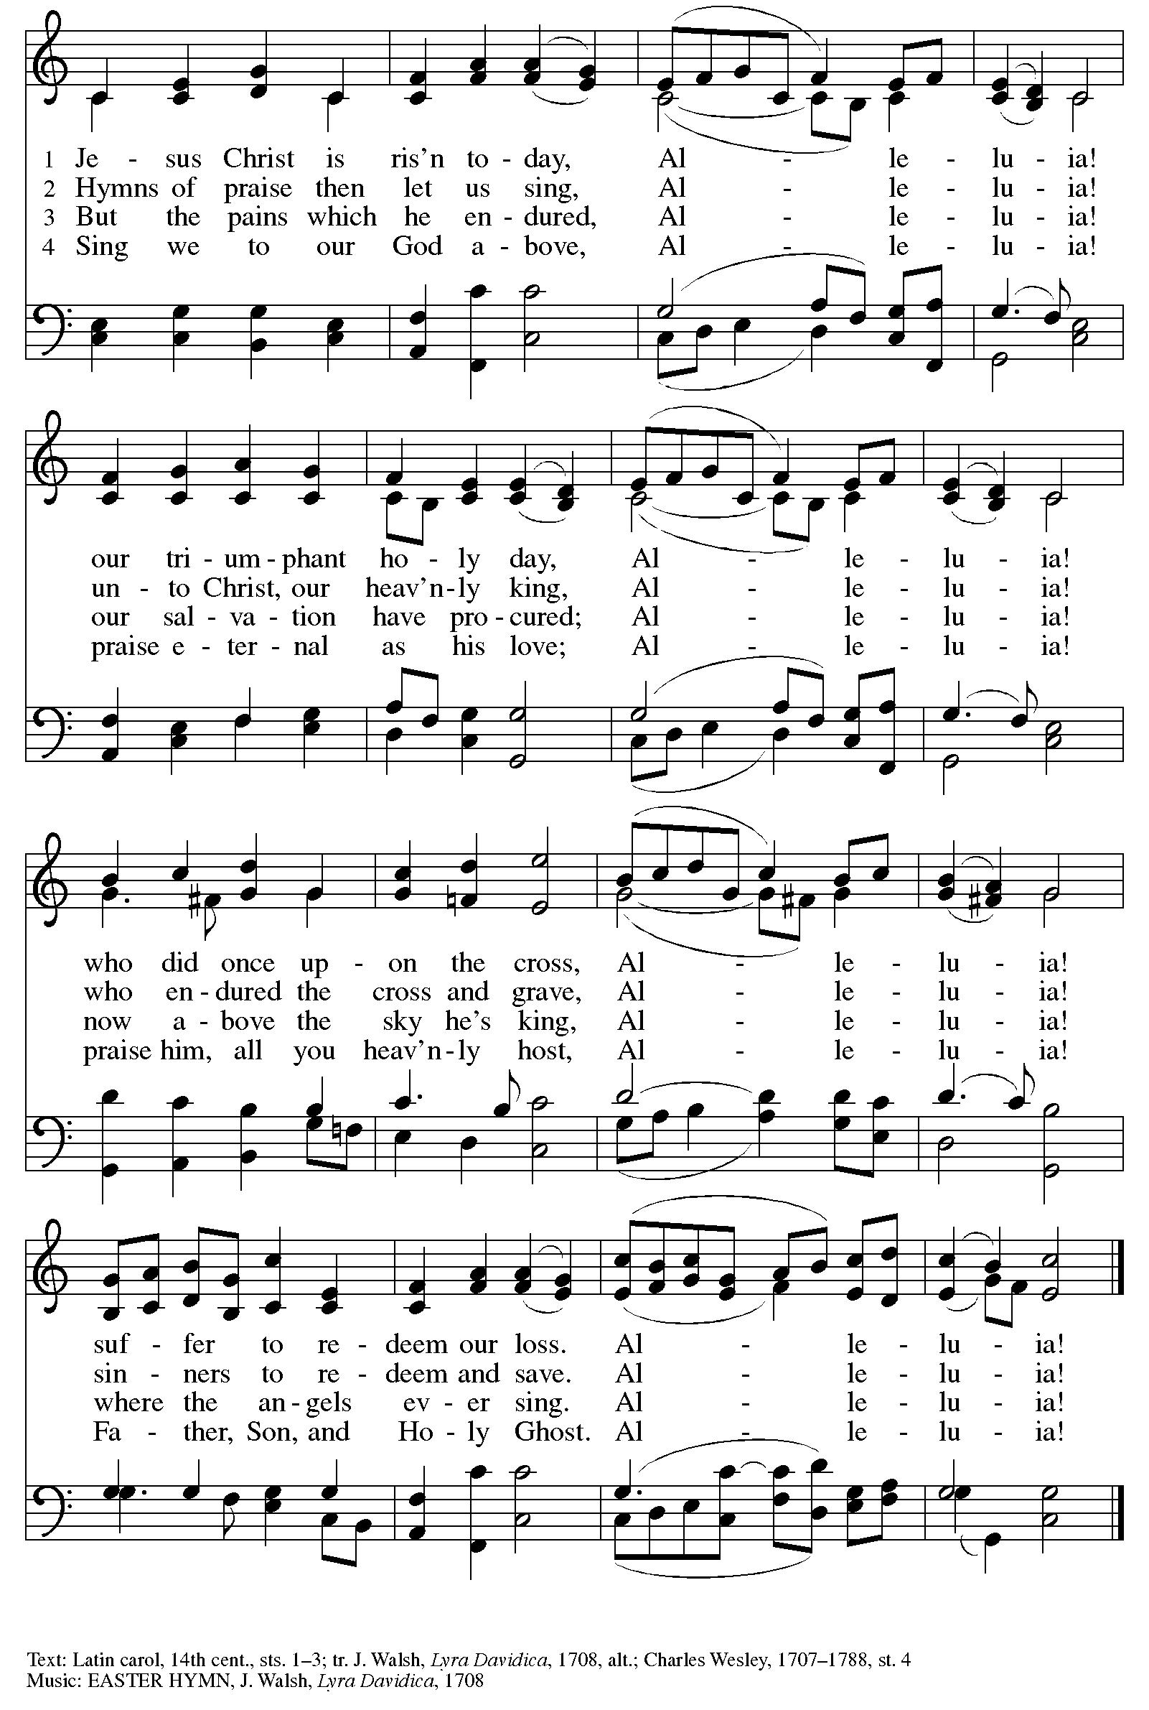

Greeting
The grace of our Lord Jesus Christ, the love of God,
and the communion of the Holy Spirit be with you all.
And also with you.

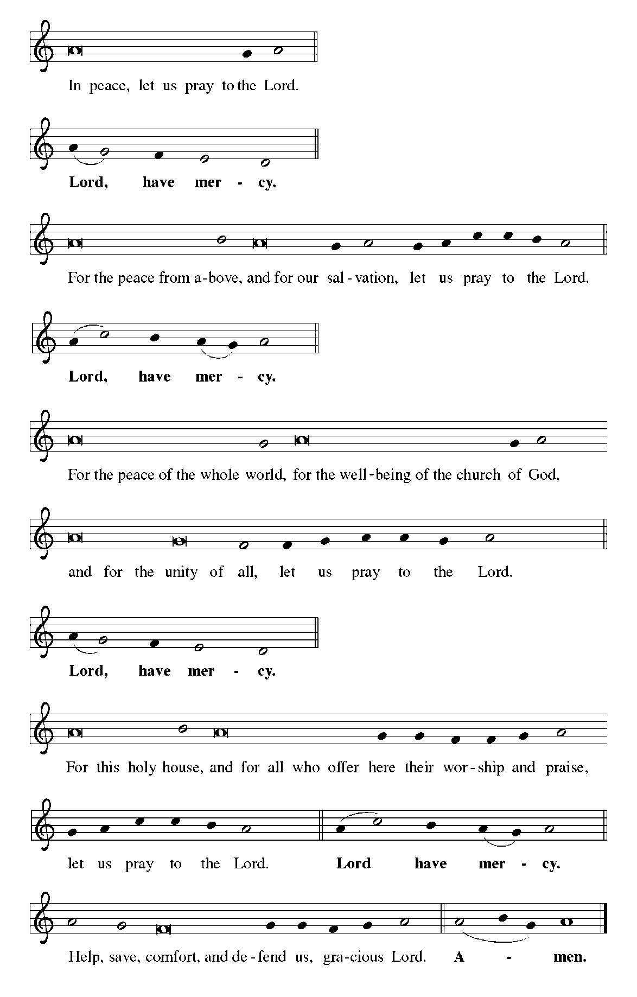
Kyrie

Canticle of Praise
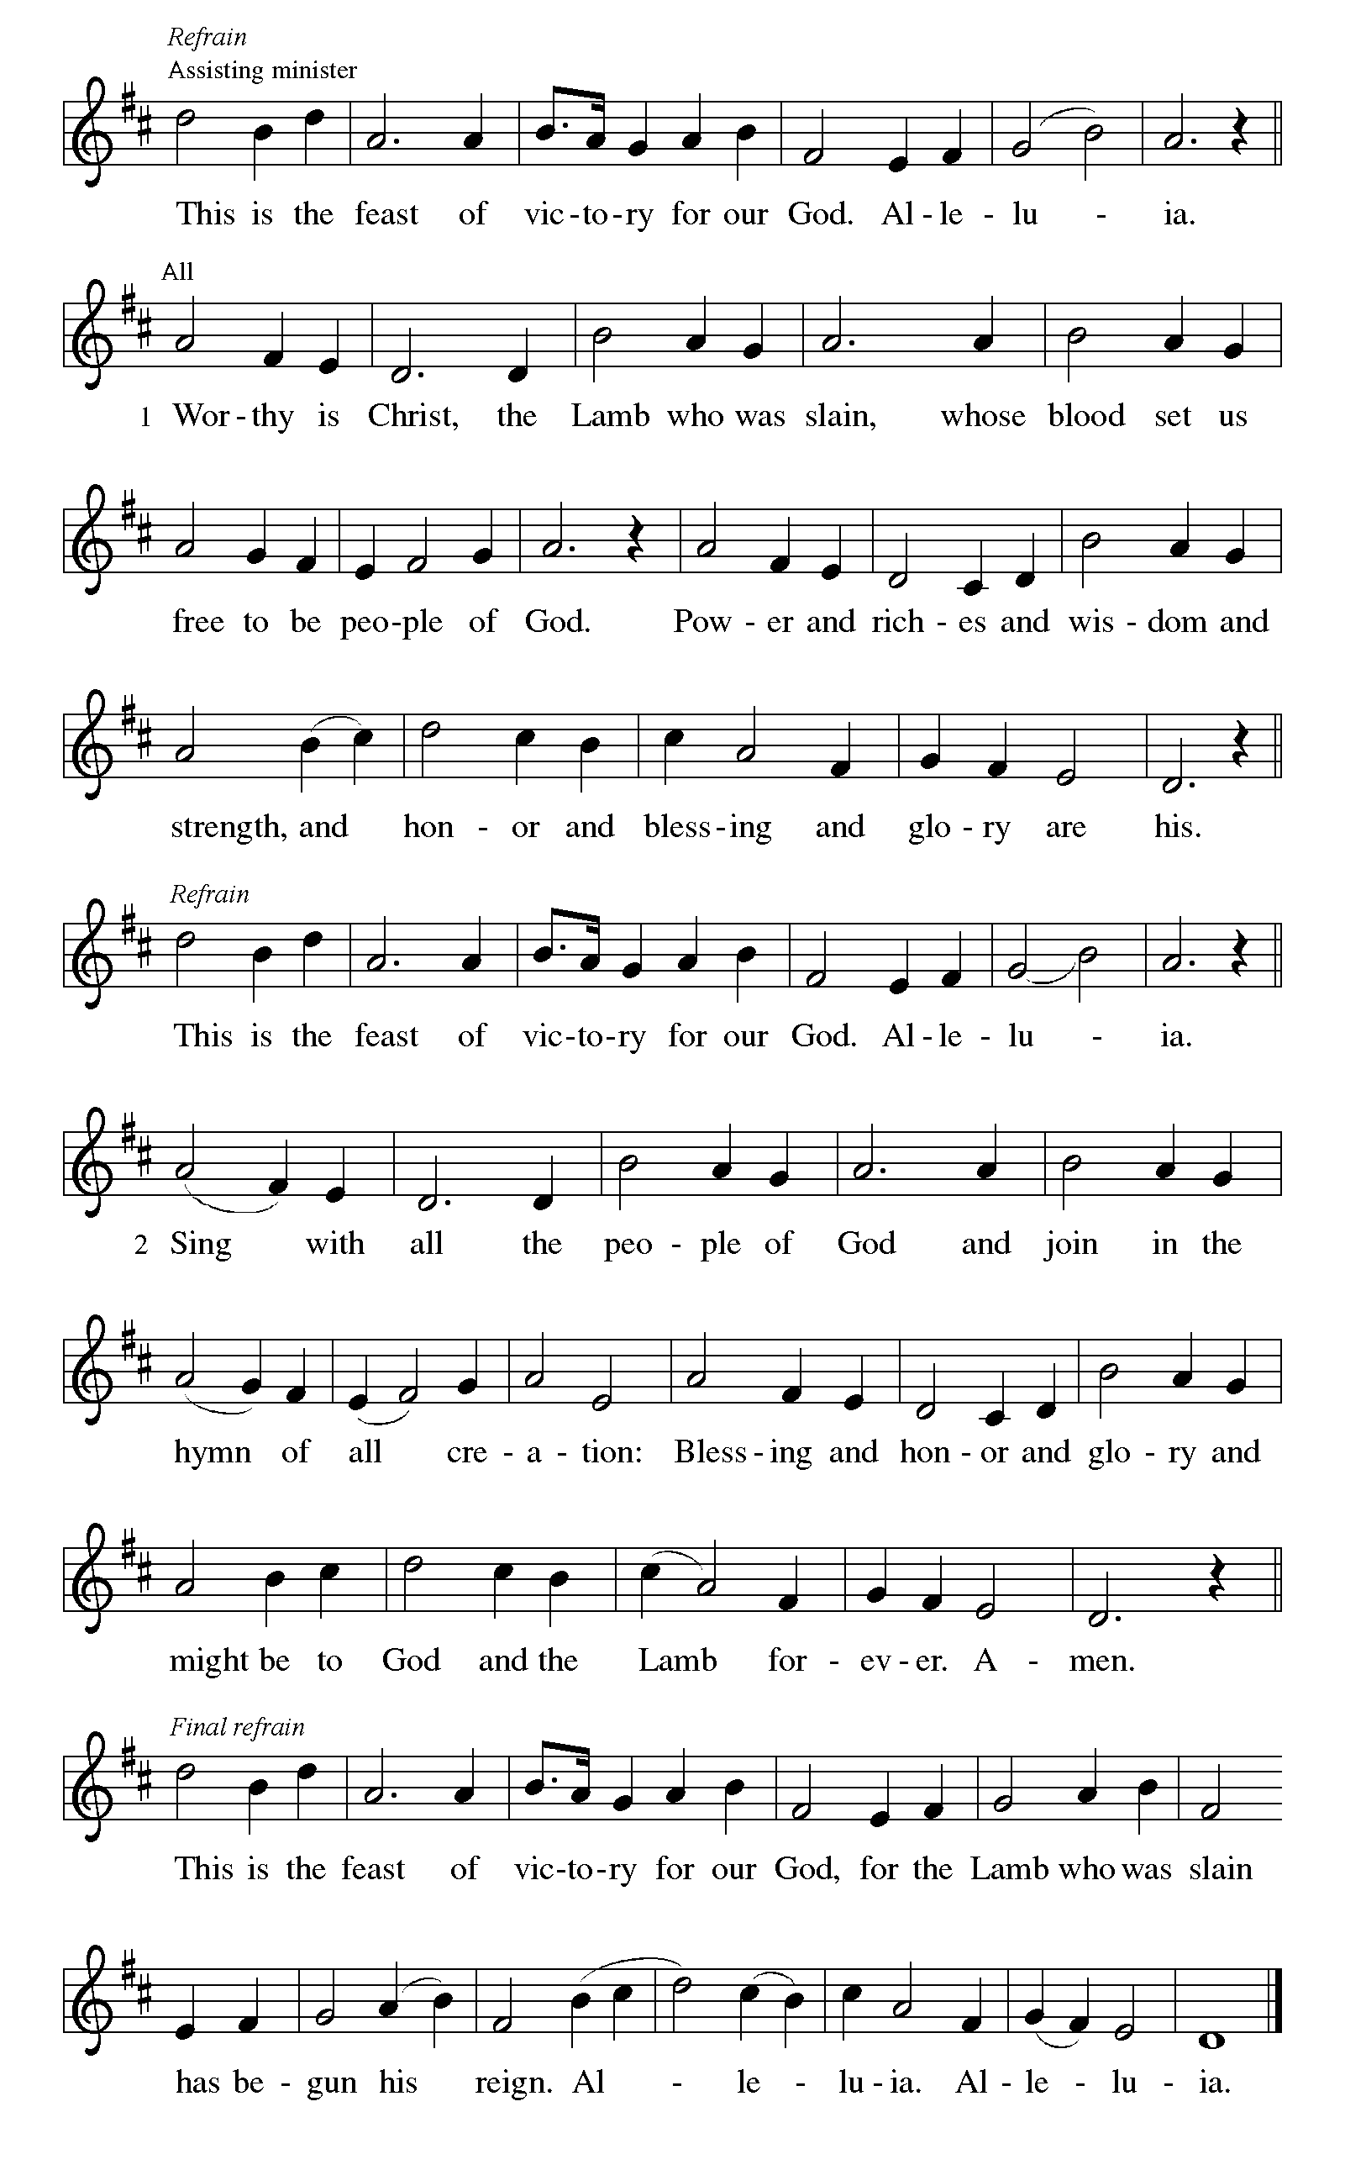

Prayer of the Day
Let us pray.
O God, you gave your only Son to suffer death on the cross for our redemption, and by his glorious resurrection you delivered us from the power of death. Make us die every day to sin, that we may live with him forever in the joy of the resurrection, through your Son, Jesus Christ our Lord, who lives and reigns with you and the Holy Spirit, one God, now and forever. Amen.

God speaks to us in scripture reading, preaching, and song.
WORD
First Reading: Acts 10:34-43
³⁴Peter began to speak to [the people]: “I truly understand that God shows no partiality, ³⁵but in every nation anyone who fears him and does what is right is acceptable to him. ³⁶You know the message he sent to the people of Israel, preaching peace by Jesus Christ—he is Lord of all. ³⁷That message spread throughout Judea, beginning in Galilee after the baptism that John announced: ³⁸how God anointed Jesus of Nazareth with the Holy Spirit and with power; how he went about doing good and healing all who were oppressed by the devil, for God was with him. ³⁹We are witnesses to all that he did both in Judea and in Jerusalem. They put him to death by hanging him on a tree; ⁴⁰but God raised him on the third day and allowed him to appear, ⁴¹not to all the people but to us who were chosen by God as witnesses, and who ate and drank with him after he rose from the dead. ⁴²He commanded us to preach to the people and to testify that he is the one ordained by God as judge of the living and the dead. ⁴³All the prophets testify about him that everyone who believes in him receives forgiveness of sins through his name.”
The word of the Lord.
Thanks be to God.

Psalm: Psalm 118:1-2, 14-24
¹Give thanks to the Lord, for the | Lord is good;
God’s mercy en- | dures forever.
²Let Israel | now declare,
“God’s mercy en- | dures forever.”
¹⁴The Lord is my strength | and my song,
and has become | my salvation.
¹⁵Shouts of rejoicing and salvation echo in the tents | of the righteous:
“The right hand of the | Lord acts valiantly!
¹⁶The right hand of the Lord| is exalted!
The right hand of the | Lord acts valiantly!”
¹⁷I shall not | die, but live,
and declare the works | of the Lord. R
¹⁸The Lord indeed pun- | ished me sorely,
but did not hand me o- | ver to death.
¹⁹Open for me the | gates of righteousness;
I will enter them and give thanks | to the Lord.
²⁰“This is the gate | of the Lord;
here the righ- | teous may enter.”
²¹I give thanks to you, for you have | answered me
and you have become | my salvation. R
²²The stone that the build- | ers rejected
has become the chief | cornerstone.
²³By the Lord has | this been done;
it is marvelous | in our eyes.
²⁴This is the day that the | Lord has made;
let us rejoice and be | glad in it. R

Second Reading: 1 Corinthians 15:19-26
A reading from 1 Corinthians.
¹⁹ If for this life only we have hoped in Christ, we are of all people most to be pitied.
²⁰ But in fact Christ has been raised from the dead, the first fruits of those who have died. ²¹ For since death came through a human being, the resurrection of the dead has also come through a human being; ²² for as all die in Adam, so all will be made alive in Christ. ²³ But each in his own order: Christ the first fruits, then at his coming those who belong to Christ. ²⁴ Then comes the end, when he hands over the kingdom to God the Father, after he has destroyed every ruler and every authority and power. ²⁵ For he must reign until he has put all his enemies under his feet. ²⁶ The last enemy to be destroyed is death.
The word of the Lord.
Thanks be to God.

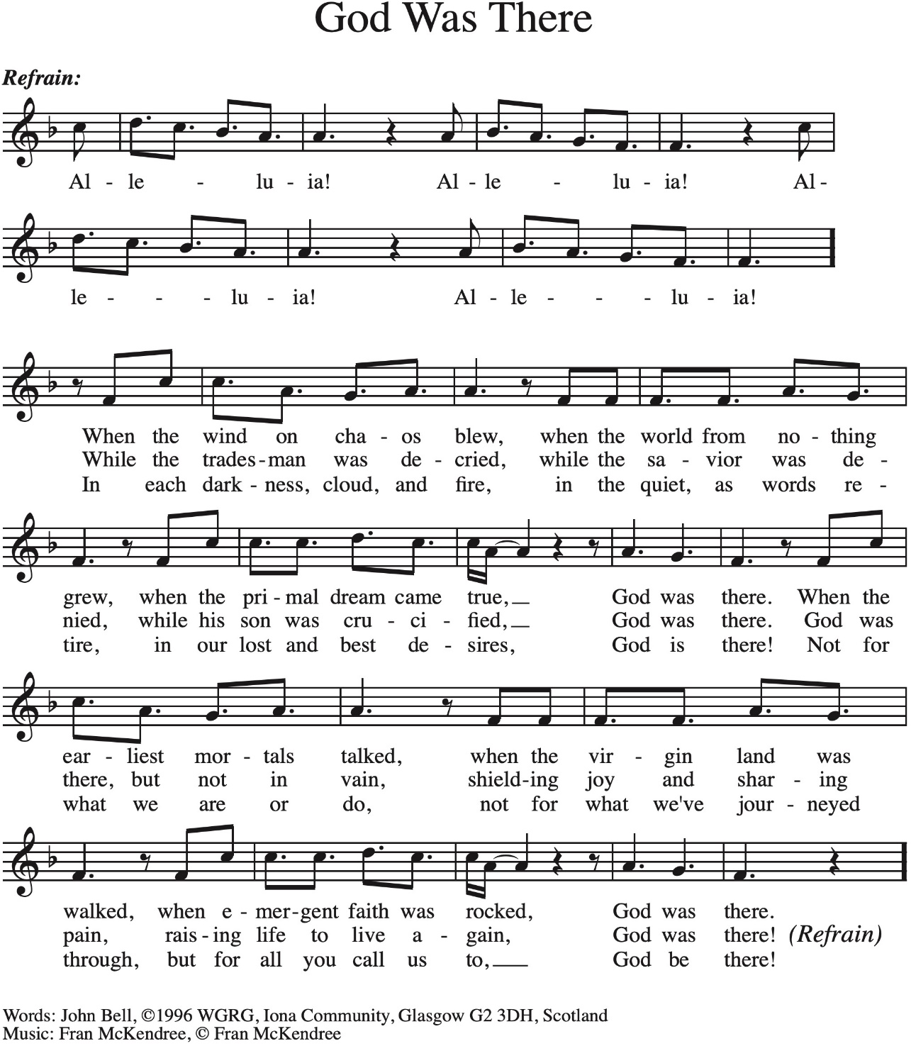
Gospel Processional God Was There - Vs 1-2

Gospel: Luke 24:1-12
The holy gospel according to Luke.
Glory to you, O Lord.
¹ On the first day of the week, at early dawn, [the women] came to the tomb, taking the spices that they had prepared. ² They found the stone rolled away from the tomb, ³ but when they went in, they did not find the body. ⁴ While they were perplexed about this, suddenly two men in dazzling clothes stood beside them. ⁵ The women were terrified and bowed their faces to the ground, but the men said to them, “Why do you look for the living among the dead? He is not here, but has risen. ⁶ Remember how he told you, while he was still in Galilee, ⁷ that the Son of Man must be handed over to sinners, and be crucified, and on the third day rise again.” ⁸ Then they remembered his words, ⁹ and returning from the tomb, they told all this to the eleven and to all the rest. ¹⁰ Now it was Mary Magdalene, Joanna, Mary the mother of James, and the other women with them who told this to the apostles. ¹¹ But these words seemed to them an idle tale, and they did not believe them. ¹² But Peter got up and ran to the tomb; stooping and looking in, he saw the linen cloths by themselves; then he went home, amazed at what had happened.
The gospel of the Lord.
Praise to you, O Christ.

Gospel Processional God Was There - Vs 3

Please be seated.
Children’s Message

Sermon
Hymn of the Day Christ Is Risen! Alleluia! ELW#382

Nicene Creed
A: Let us profess our faith to the words of the Nicene creed
We believe in one God,
the Father, the Almighty,
maker of heaven and earth,
of all that is, seen and unseen.
We believe in one Lord, Jesus Christ,
the only Son of God,
eternally begotten of the Father,
God from God, Light from Light,
true God from true God,
begotten, not made,
of one Being with the Father;
through him all things were made.
For us and for our salvation
he came down from heaven,
was incarnate of the Holy Spirit and the virgin Mary
and became truly human.
For our sake he was crucified under Pontius Pilate;
he suffered death and was buried.
On the third day he rose again
in accordance with the scriptures;
he ascended into heaven
and is seated at the right hand of the Father.
He will come again in glory to judge the living and the dead,
and his kingdom will have no end.
We believe in the Holy Spirit, the Lord, the giver of life,
who proceeds from the Father and the Son,*
who with the Father and the Son is worshiped and glorified,
who has spoken through the prophets.
We believe in one holy catholic and apostolic church.
We acknowledge one baptism for the forgiveness of sins.
We look for the resurrection of the dead,
and the life of the world to come. Amen.

Prayers of Intercession
A: God of resurrection and new life, we come before you in prayer for the church, the world, and all who are in need.
Kindle new life in your church. Encourage all who seek creative ways to share the good news of Christ’s resurrection. Bless mission developers and new ministries (local examples may be named), that their work plant seeds that flourish.
God of grace, hear our prayer.
Nourish new life in all of creation. Shower forests and grasslands, deserts, and mountains with life-giving rains. Grant us delight in your glory that shows forth in all that grows this season.
God of grace, hear our prayer.
Empower new life among the nations. As you raised Jesus from the dead, bring new hope for peace and reconciliation in places of war and strife (places or situations may be named). Raise up leaders who are steadfast in their commitment to justice and transformation.
God of grace, hear our prayer.
Bring new hope among all who are in need, especially neighbors without homes or food, and those whose housing or food supply is at risk. Bring healing to all who are fearful, ill, or grieving (especially).
God of grace, hear our prayer.
Awaken new life in this place. Open our hearts to ways you are calling us to be at work in the world and our community (communities and neighborhoods may be named). Give us courage to boldly share your love for all people beyond our walls.
God of grace, hear our prayer.
Trusting in the promises of the resurrection, we remember with thanksgiving our beloved dead. Sustain us with a living hope until we are reunited with them and all the saints at the heavenly banquet.
God of grace, hear our prayer.
We commend these and all our prayers to you, O God, trusting that you are always with us; in the name of Jesus Christ, our risen Savior.
Amen.
P: We offer to you these petitions and those we carry in our hearts, trusting in your abundant and ever-present mercy.
Amen.

Peace
The peace of Christ be with you always. And also with you.

MEAL
God feeds us with the presence of Jesus Christ.

Choral Anthem – Easter Rejoicing

Please stand.
Offertory Hymn

Offering Prayer
A: Let us pray
Gracious Provider,
You set your immense treasures among us,
opening your heart to the world.
As we prepare to feast on your beautiful love,
deepen our commitment to sharing those
treasures with others,
through our Savior, Jesus Christ.
Amen.

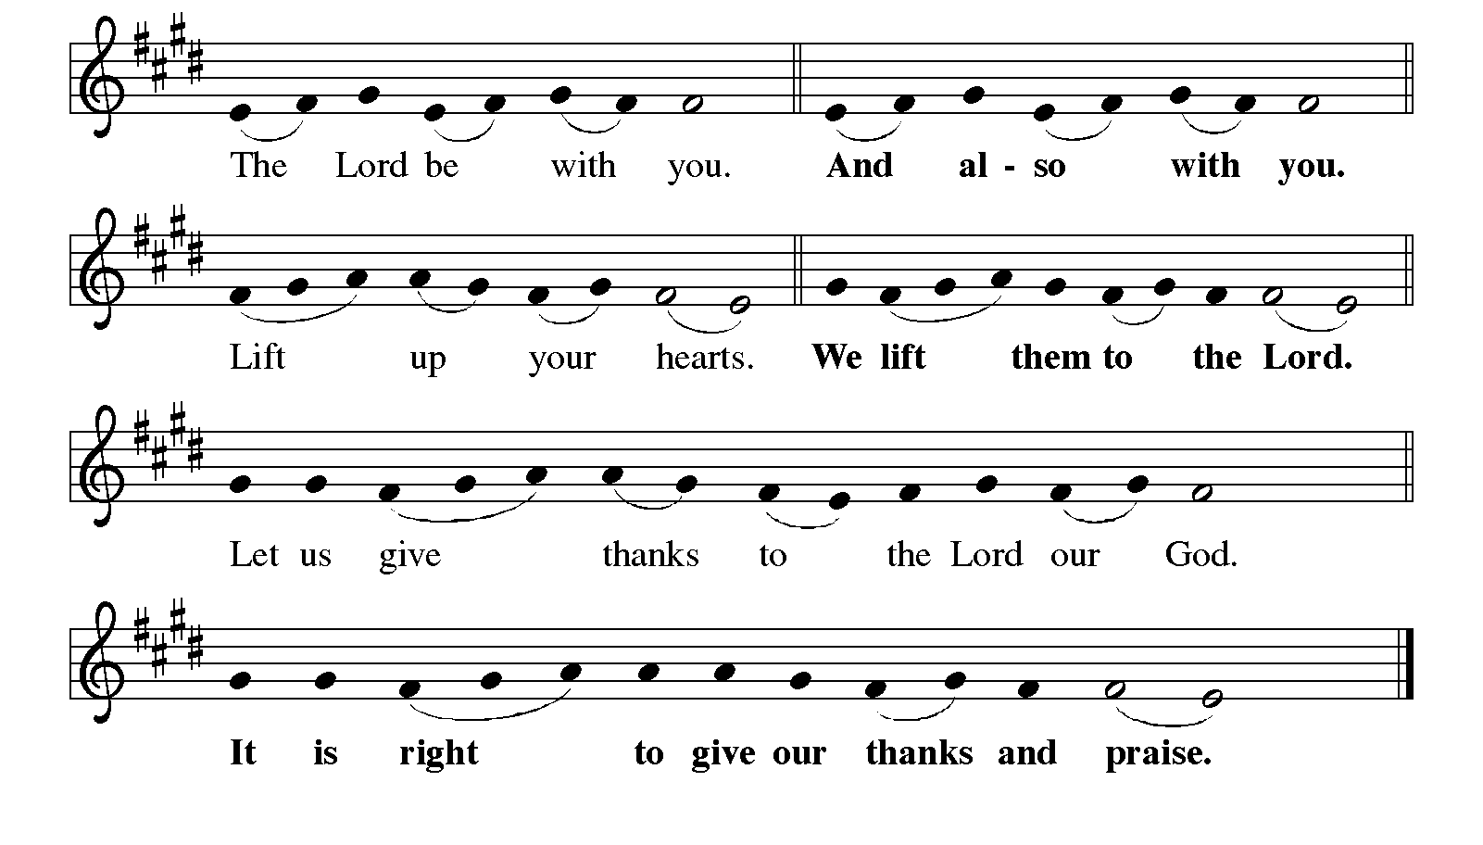
Great Thanksgiving

It is indeed right, our duty and our joy,
that we should at all times and in all places
give thanks and praise to you, almighty and merciful God,
for the glorious resurrection of our Savior Jesus Christ,
the true Paschal Lamb who gave himself to take away our sin;
who in dying has destroyed death,
and in rising has brought us to eternal life.
And so, with Mary Magdalene and Peter and all the witnesses of the resurrection,
with earth and sea and all their creatures,
and with angels and archangels, cherubim and seraphim,
we praise your name and join their unending hymn:

Eucharistic Prayer
Holy, living, and loving God,
we praise you for creating the heavens and the earth.
We bless you for bringing Noah and his family through the waters of the flood,
for freeing your people Israel from the bonds of slavery,
and for sending your Son to be our Redeemer.
We give you thanks for Jesus
who, living among us, healed the sick, fed the hungry,
and with a love stronger than death, gave his life for others.
In the night in which he was betrayed,
our Lord Jesus took bread, and gave thanks;
broke it, and gave it to his disciples, saying:
Take and eat; this is my body, given for you.
Do this for the remembrance of me.

Again, after supper, he took the cup, gave thanks,
and gave it for all to drink, saying:
This cup is the new covenant in my blood,
shed for you and for all people for the forgiveness of sin.
Do this for the remembrance of me.
Remembering, therefore,
his life-giving death and glorious resurrection,
we await your promised life for all this dying world.
Breathe your Spirit on us and on this bread and cup:
carry us in your arms from death to life,
that we may live as your chosen ones,
clothed in the righteousness of Christ.
Through him all glory and honor is yours,
Almighty Father, with the Holy Spirit,
in your holy Church,
both now and forever.
Amen

Lord’s Prayer
Our Father, who art in heaven,
hallowed be thy name, thy kingdom come,
thy will be done, on earth as it is in heaven.
Give us this day our daily bread;
and forgive us our trespasses, as we forgive those who trespass against us;
and lead us not into temptation but deliver us from evil.
For thine is the kingdom,
and the power, and the glory, forever and ever.
Amen.

Invitation to Communion
Jesus Christ, risen from the dead,
gives everyone a place at the welcome table.
Alleluia! Come to the feast.

Communion
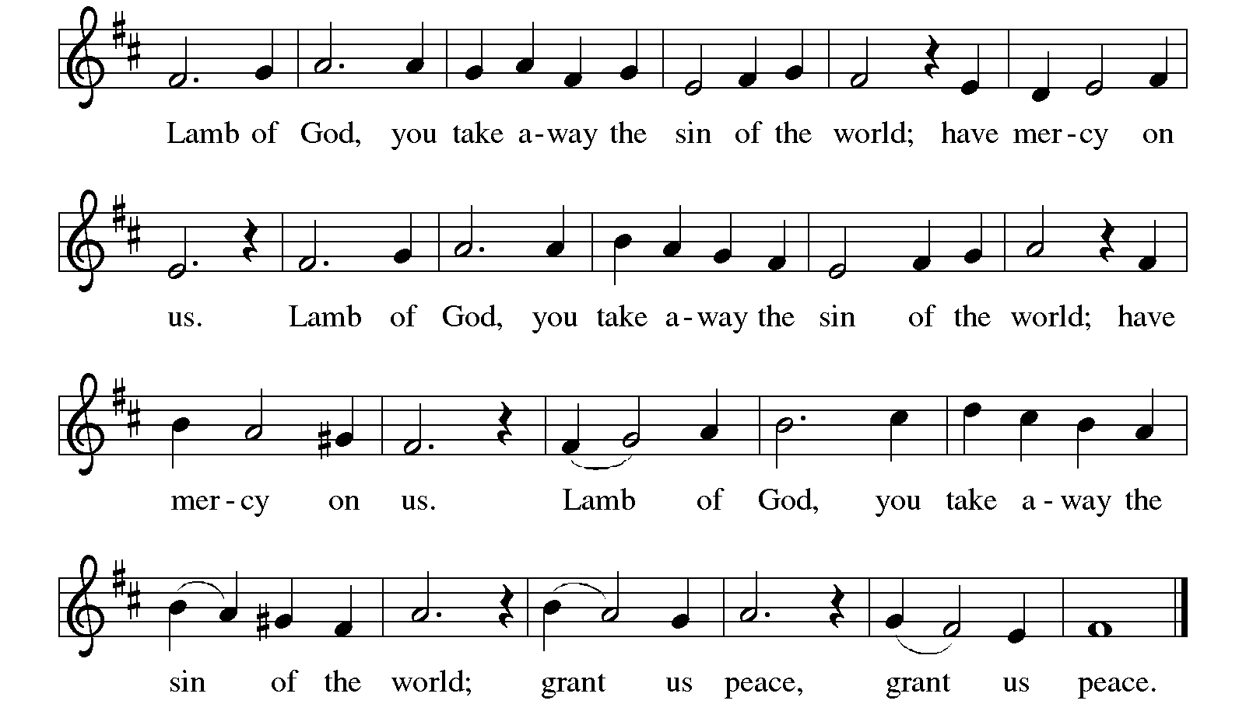

Communion Songs Christ Has Arisen, Alleluia ELW#364
Bread of Life from Heaven ELW #474
I Know that My Redeemer Lives! ELW #619

(See below)
Prayer after Communion
A: Living One,
In this feast you have made yourself known to us.
Send us now to tell of your wonders,
sing of your glory,
and proclaim your risen life
to a wounded and weary world.
Amen.
God blesses us and sends us in mission to the world.
SENDING

Blessing
Triune God,
Who was, who is and who is to come,
Sovereign, ☩ Savior, and Spirit,
Light your way with resurrection dawn,
Now and always. Amen.
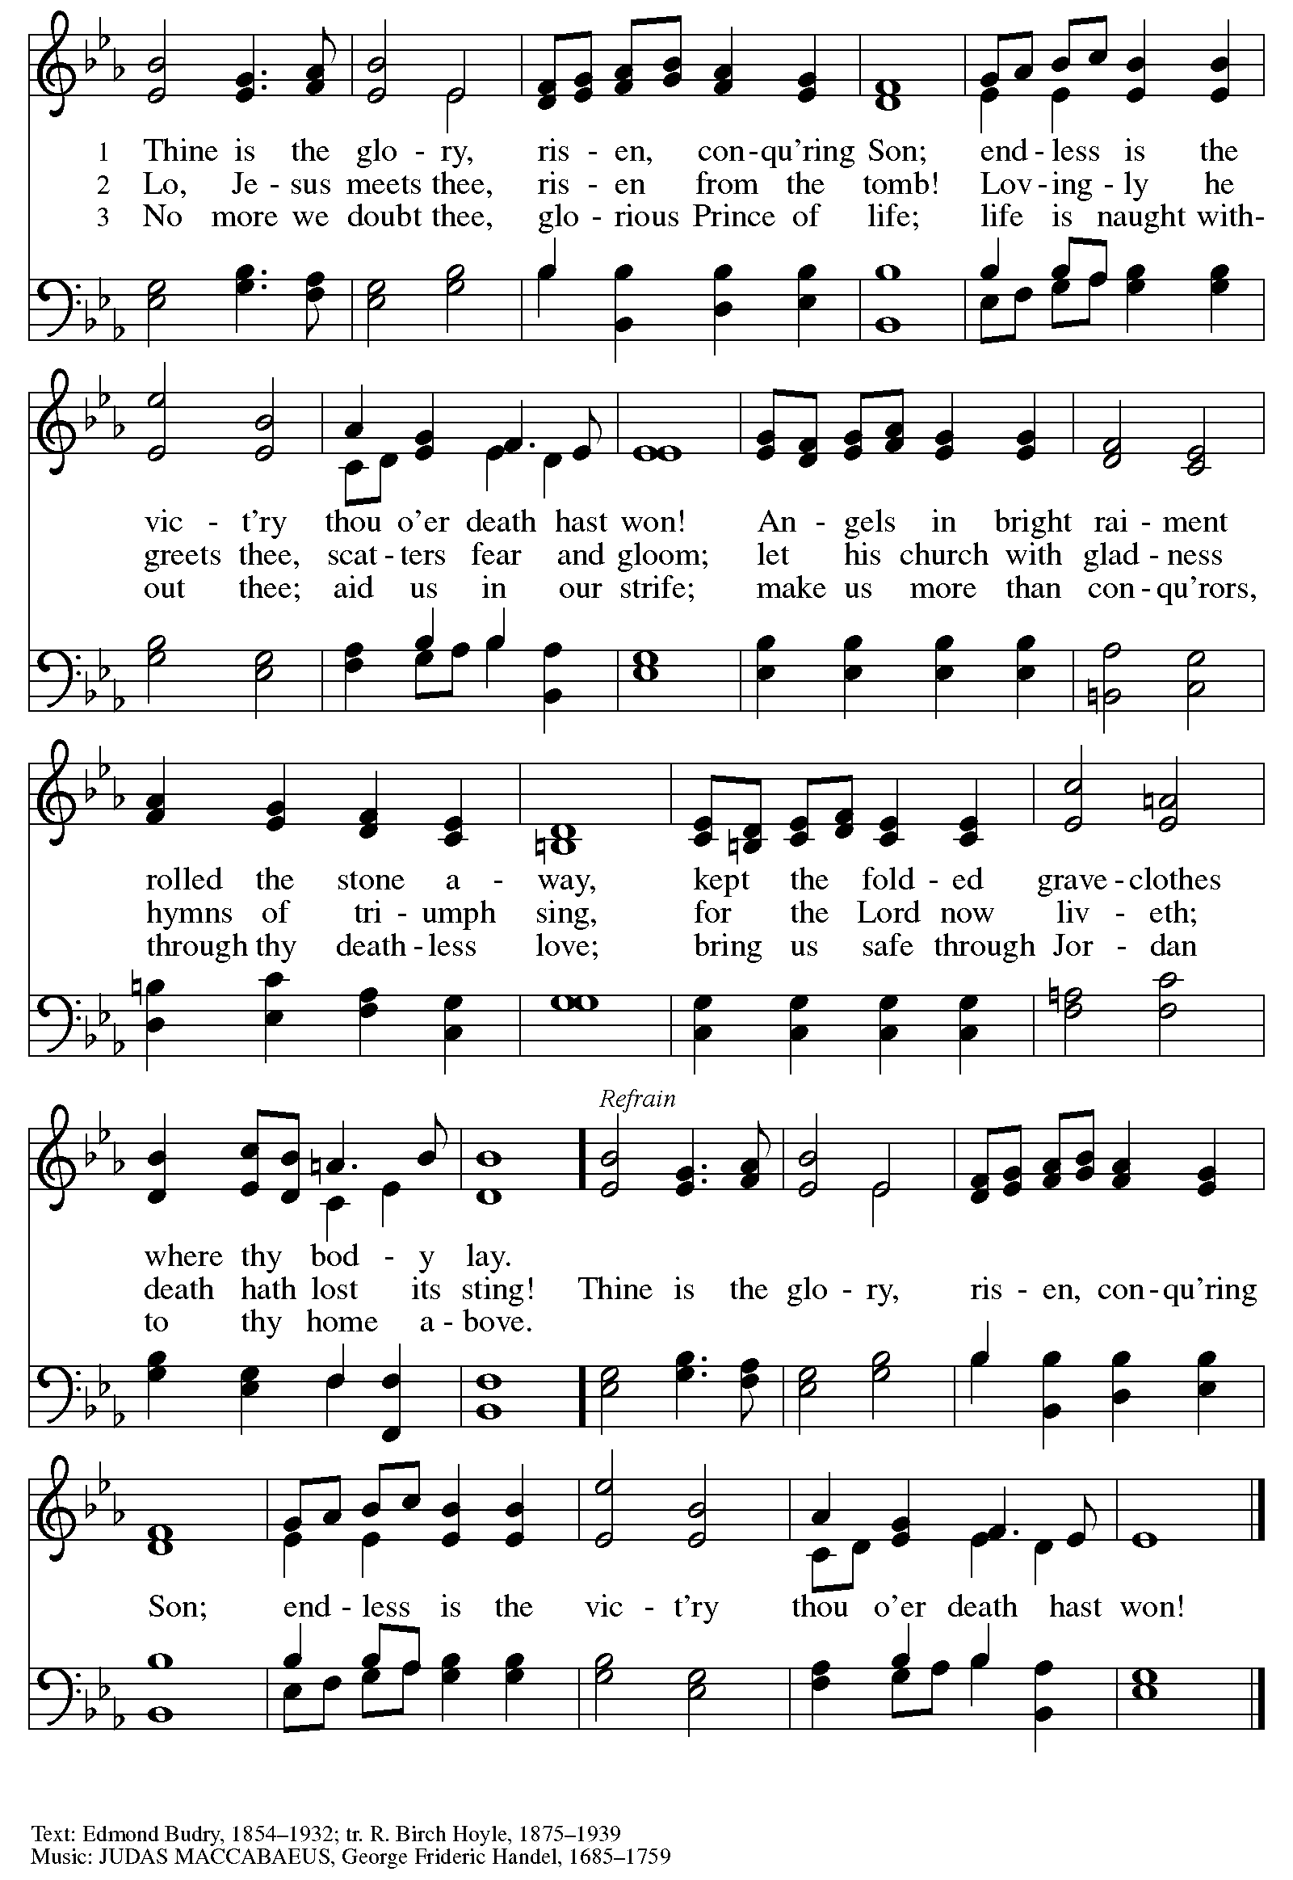
Sending Song Thine Is the Glory ELW#376

Dismissal
Alleluia. Christ is risen.
Christ is risen indeed. Alleluia.
Go in peace. In Christ you are made new. Alleluia! Alleluia!
Thanks be to God. Alleluia! Alleluia!

From sundaysandseasons.com. Copyright © 2025 Augsburg Fortress. All rights reserved.

