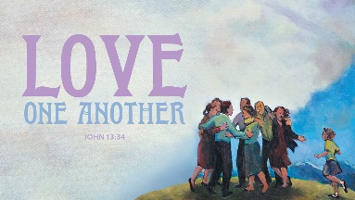
Worship Plan for Sunday, May 18, 2025
Fifth Sunday of Easter

The Holy Spirit calls us together as the people of God.
GATHERING

Prelude
Welcome/Announcements
Reflection - Preparing for Worship

Please stand.
P: Confession and Forgiveness
All make the sign of the cross, the sign that is marked at baptism, as the presiding minister begins.
Blessed be the holy Trinity, ☩ one God,
who forgives all our sin,
whose mercy endures forever. Amen.

Let us return to God, confessing our sin in the assurance of God’s abiding love.
Silence is kept for reflection.

Compassionate One,
you are slow to anger and abounding in steadfast love,
but our lives do not always reflect you
and your love for the world.
We do not show others the tender compassion
you have shown to us.
We do not welcome others with the radical hospitality
you grant to all people.
We oppress others,
even though you have set us free again and again.
We squander the abundant gifts of the earth.
Transform our lives
and guide us again in the way of the cross.
Amen.

Beloved in Christ,
God’s arms are always stretched open wide
to welcome the wandering ones home.
In ☩ Christ your sins are forgiven.
You have a place in God’s house forever.
Amen.

Gathering Song On Jordan’s Stormy Banks I Stand ELW#437

P: Greeting
The grace of our Lord Jesus Christ, the love of God
and the communion of the Holy Spirit be with you all.
And also, with you.

P: Prayer of the Day
Let us pray.
O Lord God, you teach us that without love, our actions gain nothing. Pour into our hearts your most excellent gift of love, that, made alive by your Spirit, we may know goodness and peace, through your Son, Jesus Christ, our Savior and Lord, who lives and reigns with you and the Holy Spirit, one God, now and forever.
Amen.

Please be seated.
God speaks to us in scripture reading, preaching, and song.
WORD

L: First Reading: Acts 11:1-18
A reading from Acts.
¹ Now the apostles and the believers who were in Judea heard that the Gentiles had also accepted the word of God. ² So when Peter went up to Jerusalem, the circumcised believers criticized him, ³ saying, “Why did you go to uncircumcised men and eat with them?” ⁴ Then Peter began to explain it to them, step by step, saying, ⁵ “I was in the city of Joppa praying, and in a trance I saw a vision. There was something like a large sheet coming down from heaven, being lowered by its four corners; and it came close to me. ⁶ As I looked at it closely I saw four-footed animals, beasts of prey, reptiles, and birds of the air. ⁷ I also heard a voice saying to me, ‘Get up, Peter; kill and eat.’ ⁸ But I replied, ‘By no means, Lord; for nothing profane or unclean has ever entered my mouth.’ ⁹ But a second time the voice answered from heaven, ‘What God has made clean, you must not call profane.’ ¹⁰ This happened three times; then everything was pulled up again to heaven. ¹¹ At that very moment three men, sent to me from Caesarea, arrived at the house where we were. ¹² The Spirit told me to go with them and not to make a distinction between them and us. These six brothers also accompanied me, and we entered the man’s house. ¹³ He told us how he had seen the angel standing in his house and saying, ‘Send to Joppa and bring Simon, who is called Peter; ¹⁴ he will give you a message by which you and your entire household will be saved.’ ¹⁵ And as I began to speak, the Holy Spirit fell upon them just as it had upon us at the beginning. ¹⁶ And I remembered the word of the Lord, how he had said, ‘John baptized with water, but you will be baptized with the Holy Spirit.’ ¹⁷ If then God gave them the same gift that he gave us when we believed in the Lord Jesus Christ, who was I that I could hinder God?” ¹⁸ When they heard this, they were silenced. And they praised God, saying, “Then God has given even to the Gentiles the repentance that leads to life.”
The word of the Lord.
Thanks be to God.

Psalm: Psalm 148
¹ Hallelujah! Praise the Lord | from the heavens;
praise God | in the heights.
² Praise the Lord, | all you angels;
sing praise, all you | hosts of heaven.
³ Praise the Lord, | sun and moon;
sing praise, all you | shining stars.
⁴ Praise the Lord, heav- | en of heavens,
and you waters a- | bove the heavens.
⁵ Let them praise the name | of the Lord,
who commanded, and they | were created,
⁶ who made them stand fast forev- | er and ever,
giving them a law that shall not | pass away. R
⁷ Praise the Lord | from the earth,
you sea monsters | and all deeps;
⁸ fire and hail, | snow and fog,
tempestuous wind, do- | ing God’s will;
⁹ mountains | and all hills,
fruit trees | and all cedars;
¹⁰ wild beasts | and all cattle,
creeping things and | flying birds;
¹¹ sovereigns of the earth | and all peoples,
princes and all rulers | of the world;
¹² young | men and maidens,
old and | young together. R
¹³ Let them praise the name | of the Lord,
whose name only is exalted, whose splendor is over | earth and heaven.
¹⁴ The Lord has raised up strength for the people and praise for all | faithful servants,
the children of Israel, a people who are near the Lord. | Hallelujah! R

Second Reading: Second Reading: Revelation 21:1-6
A reading from Revelation.
¹ I saw a new heaven and a new earth; for the first heaven and the first earth had passed away, and the sea was no more. ² And I saw the holy city, the new Jerusalem, coming down out of heaven from God, prepared as a bride adorned for her husband. ³ And I heard a loud voice from the throne saying,
“See, the home of God is among mortals.
He will dwell with them; they will be his peoples, and God himself will be with them;
⁴ he will wipe every tear from their eyes.
Death will be no more; mourning and crying and pain will be no more,
for the first things have passed away.”
⁵ And the one who was seated on the throne said, “See, I am making all things new.” Also he said, “Write this, for these words are trustworthy and true.” ⁶ Then he said to me, “It is done! I am the Alpha and the Omega, the beginning and the end. To the thirsty I will give water as a gift from the spring of the water of life.”
The word of the Lord. Thanks be to God.

Please stand.
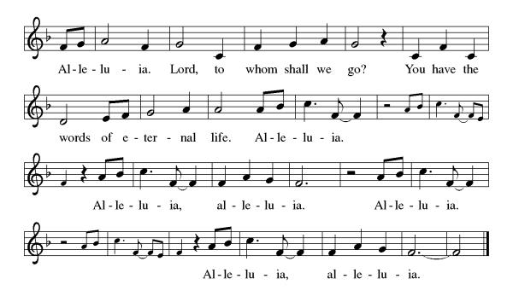
Gospel Acclamation

P: Gospel: John 13:31-35
The holy gospel according to John.
Glory to you, O Lord.
³¹ When he had gone out, Jesus said, “Now the Son of Man has been glorified, and God has been glorified in him. ³² If God has been glorified in him, God will also glorify him in himself and will glorify him at once. ³³ Little children, I am with you only a little longer. You will look for me; and as I said to the Jews so now I say to you, ‘Where I am going, you cannot come.’ ³⁴ I give you a new commandment, that you love one another. Just as I have loved you, you also should love one another. ³⁵ By this everyone will know that you are my disciples, if you have love for one another.”
The gospel of the Lord.
Praise to you, O Christ.

Please be seated.
Children’s Message

Sermon

Please stand.
Hymn of the Day God We Gather as Your People ACS#1038

A: Apostles’ Creed
Let us confess our faith to the words of the Apostles’ Creed
I believe in God, the Father almighty, creator of heaven and earth.
I believe in Jesus Christ, God’s only Son, our Lord,
who was conceived by the Holy Spirit,
born of the virgin Mary, suffered under Pontius Pilate,
was crucified, died, and was buried; he descended to the dead.
On the third day he rose again;
he ascended into heaven,
he is seated at the right hand of the Father,
and he will come to judge the living and the dead.
I believe in the Holy Spirit, the holy catholic church,
the communion of saints, the forgiveness of sins,
the resurrection of the body, and the life everlasting. Amen.

Please sit or kneel.
A: Prayers of Intercession
God of resurrection and new life, we come before you in prayer for the church, the world, and all who are in need.
Fill the church with the spirit of your redeeming love. Make us steadfast in our proclamation of your grace for all people without exceptions, especially those often overlooked in our communities.
Hear us, O God. Your mercy is great.
Awaken joy in the beauty and abundance of your creation. Show us the wonder of your presence from the smallest flower to the tallest tree. Recommit us to preservation of wild places (local or regional places may be named).
Hear us, O God. Your mercy is great.
Instruct all world leaders to protect the most vulnerable among us. Guide those in power toward equitable and just economic policies, so that all might have sufficient resources to live safely and with dignity.
Hear us, O God. Your mercy is great.
Pour out your love on all in need of care: those mourning losses, enduring trauma, experiencing broken relationships, yearning for companionship, or facing illness (especially). Wipe away every tear.
Hear us, O God. Your mercy is great.
Abide with all who are victims of racism, especially people who are doubly marginalized because of gender, sexuality, or ability. Destroy all forms of systemic oppression, and renew our commitment to healing the wounds of our collective body in this community and beyond.
Hear us, O God. Your mercy is great.
We give thanks for all the saints whose lives bear witness to your redeeming love (especially Erik, King of Sweden). Guide us by their example, until we join them in your eternal home.
Hear us, O God. Your mercy is great.
We commend these and all our prayers to you, O God, trusting that you are always with us; in the name of Jesus Christ, our risen Savior.
Amen.

P: Peace
The peace of Christ be with you always. And also, with you.
God feeds us with the presence of Jesus Christ.
MEAL

Please be seated.
Offering

Choir – I Love You Lord

Please stand.
Offertory Hymn

Offertory Prayer
A: Let us pray
Risen One, you have gathered us around your table of grace along with these gifts we bring.
Come among us again, breathe your life into us,
and enliven us with this meal, that we may live as your risen body in the world. Amen.

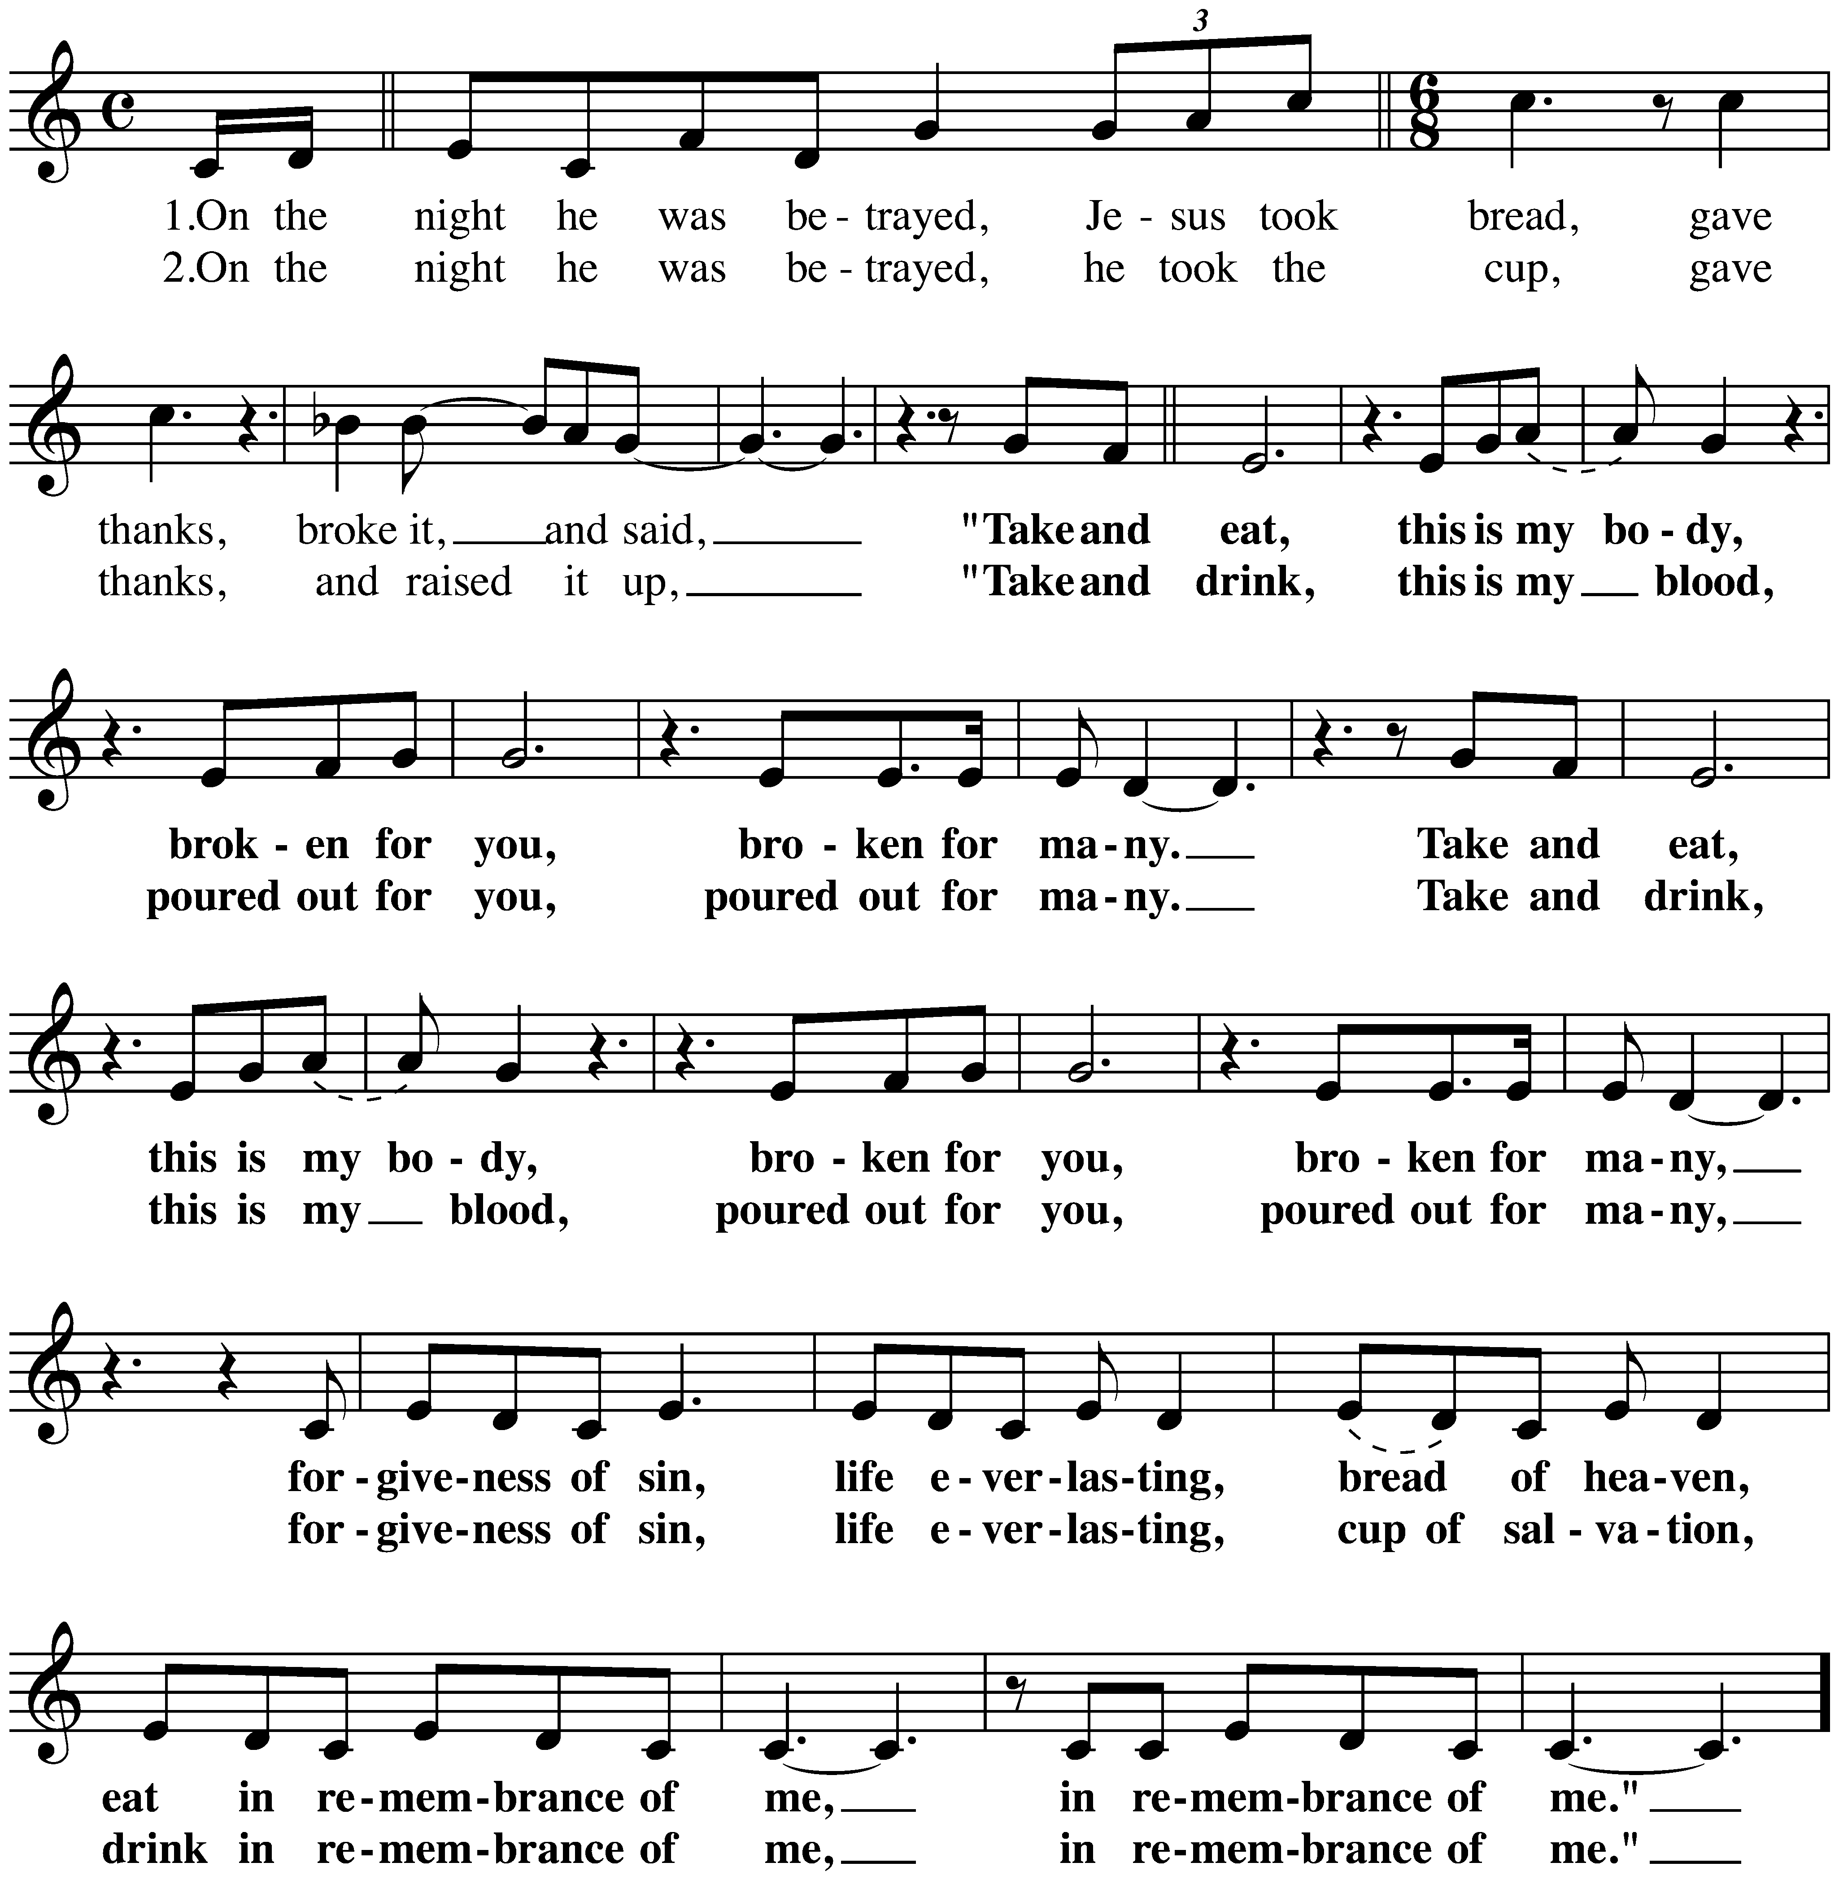
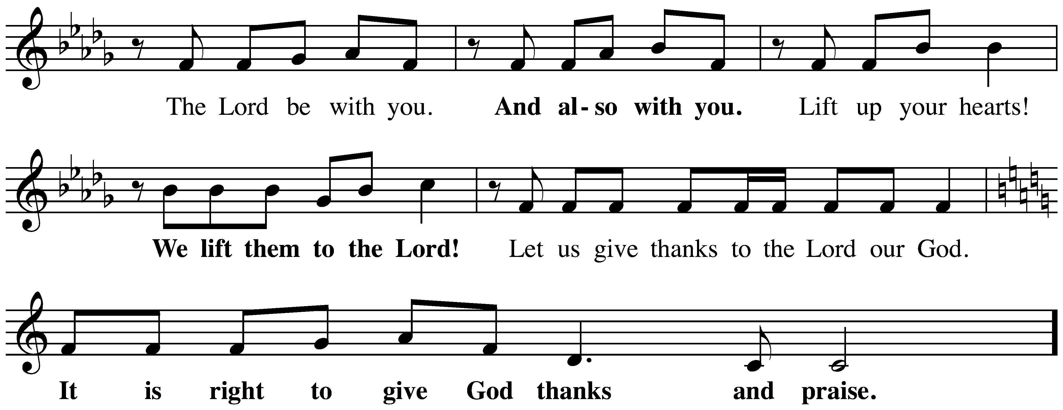
P: The Great Thanksgiving

The Lord’s Prayer

Our Father, who art in heaven,
hallowed be thy name, thy kingdom come,
thy will be done, on earth as it is in heaven.
Give us this day our daily bread;
and forgive us our trespasses, as we forgive those who trespass against us;
and lead us not into temptation but deliver us from evil.
For thine is the kingdom,
and the power, and the glory, forever and ever.
Amen.

Invitation to Communion
Come to the table of grace. Receive the gift of new life.

Please be seated.
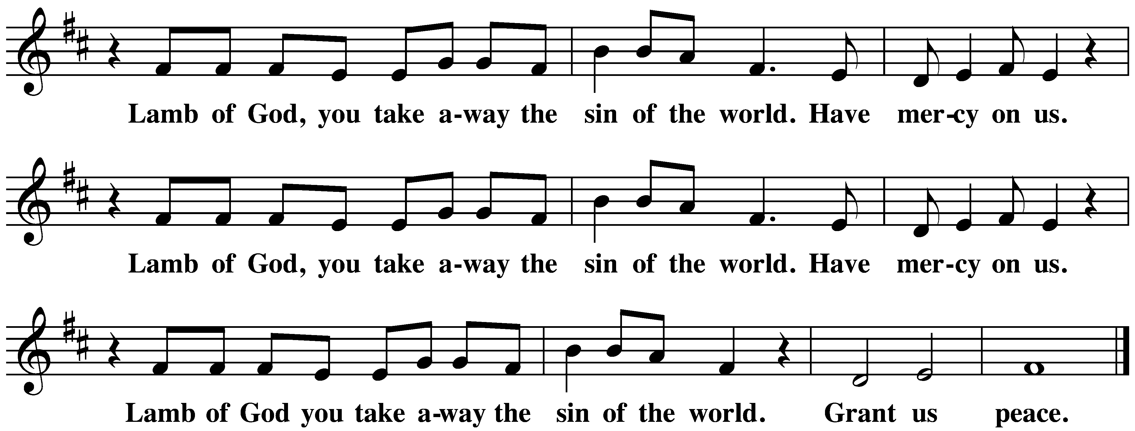
Communion Hymns

Baptized and Set Free ELW#453

Borning Cry ELW#732

A: Prayer After Communion
Living One,
in this feast you have made yourself known to us.
Send us now to tell of your wonders,
sing of your glory,
and proclaim your risen life
to a wounded and weary world.
Amen.

God blesses us and sends us in mission to the world.
SENDING

P: Blessing of the Graduates

Sending Song Hallelujah! Jesus Lives! ELW#380

Dismissal
Alleluia! Christ is risen. Christ is risen indeed. Alleluia!
Go in peace. In Christ you are made new. Alleluia! Alleluia!
Thanks be to God. Alleluia! Alleluia!

