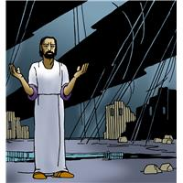
Worship Plan for Sunday, November 16, 2025
23nd Sunday after Pentecost

The Holy Spirit calls us together as the people of God.
GATHERING

Prelude
Welcome/Announcements
Reflection - Preparing for Worship

Please stand.
P: Confession and Forgiveness
All make the sign of the cross, the sign that is marked at baptism, as the presiding minister begins.
Blessed be the holy Trinity, ☩ one God,
our maker, our helper, and our keeper.
Amen.
Trusting in God’s mercy, let us confess our sin
in the presence of God and of one another.

Silence is kept for reflection.
Merciful and loving God,
we are your stiff-necked people.
We trample on the needy.
We grumble about your grace to others.
We turn away from the poor.
Have mercy on us and forgive our sins.
Rejoice over us as ones who were lost
and have been found. Amen.
Even when we are faithless, God remains faithful.
Jesus Christ came into the world to save sinners.
You who were lost have been found.
In the name of ☩ Jesus, your sins are forgiven!
Amen

Gathering Song Rise, O Sun of Righteousness ELW#657

P: Greeting
The grace of our Lord Jesus Christ, the love of God
and the communion of the Holy Spirit be with you all.
And also, with you.

P: Prayer of the Day
Let us pray.
O God, the protector of all who trust in you, without you nothing is strong, nothing is holy. Embrace us with your mercy, that with you as our ruler and guide, we may live through what is temporary without losing what is eternal, through Jesus Christ, our Savior and Lord.
Amen

Please be seated.
God speaks to us in scripture reading, preaching, and song.
WORD

L: First Reading: Malachi 4:1-2a
A reading from Malachi.
¹ See, the day is coming, burning like an oven, when all the arrogant and all evildoers will be stubble; the day that comes shall burn them up, says the Lord of hosts, so that it will leave them neither root nor branch. ^{2a} But for you who revere my name the sun of righteousness shall rise, with healing in its wings.
The word of the Lord.
Thanks be to God.

Psalm: Psalm 98
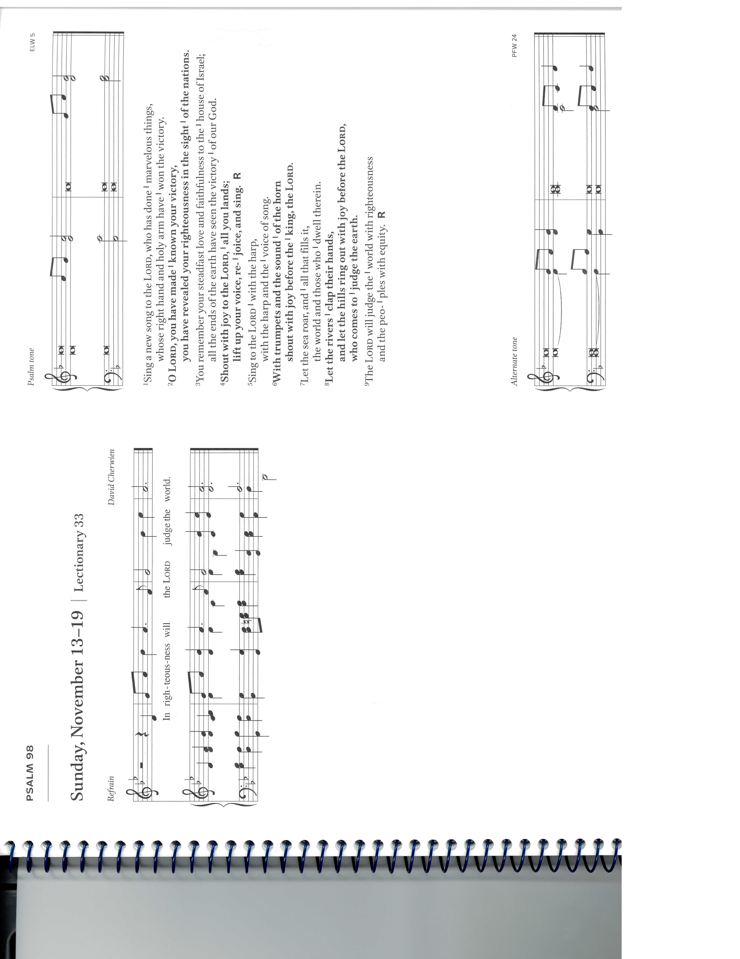
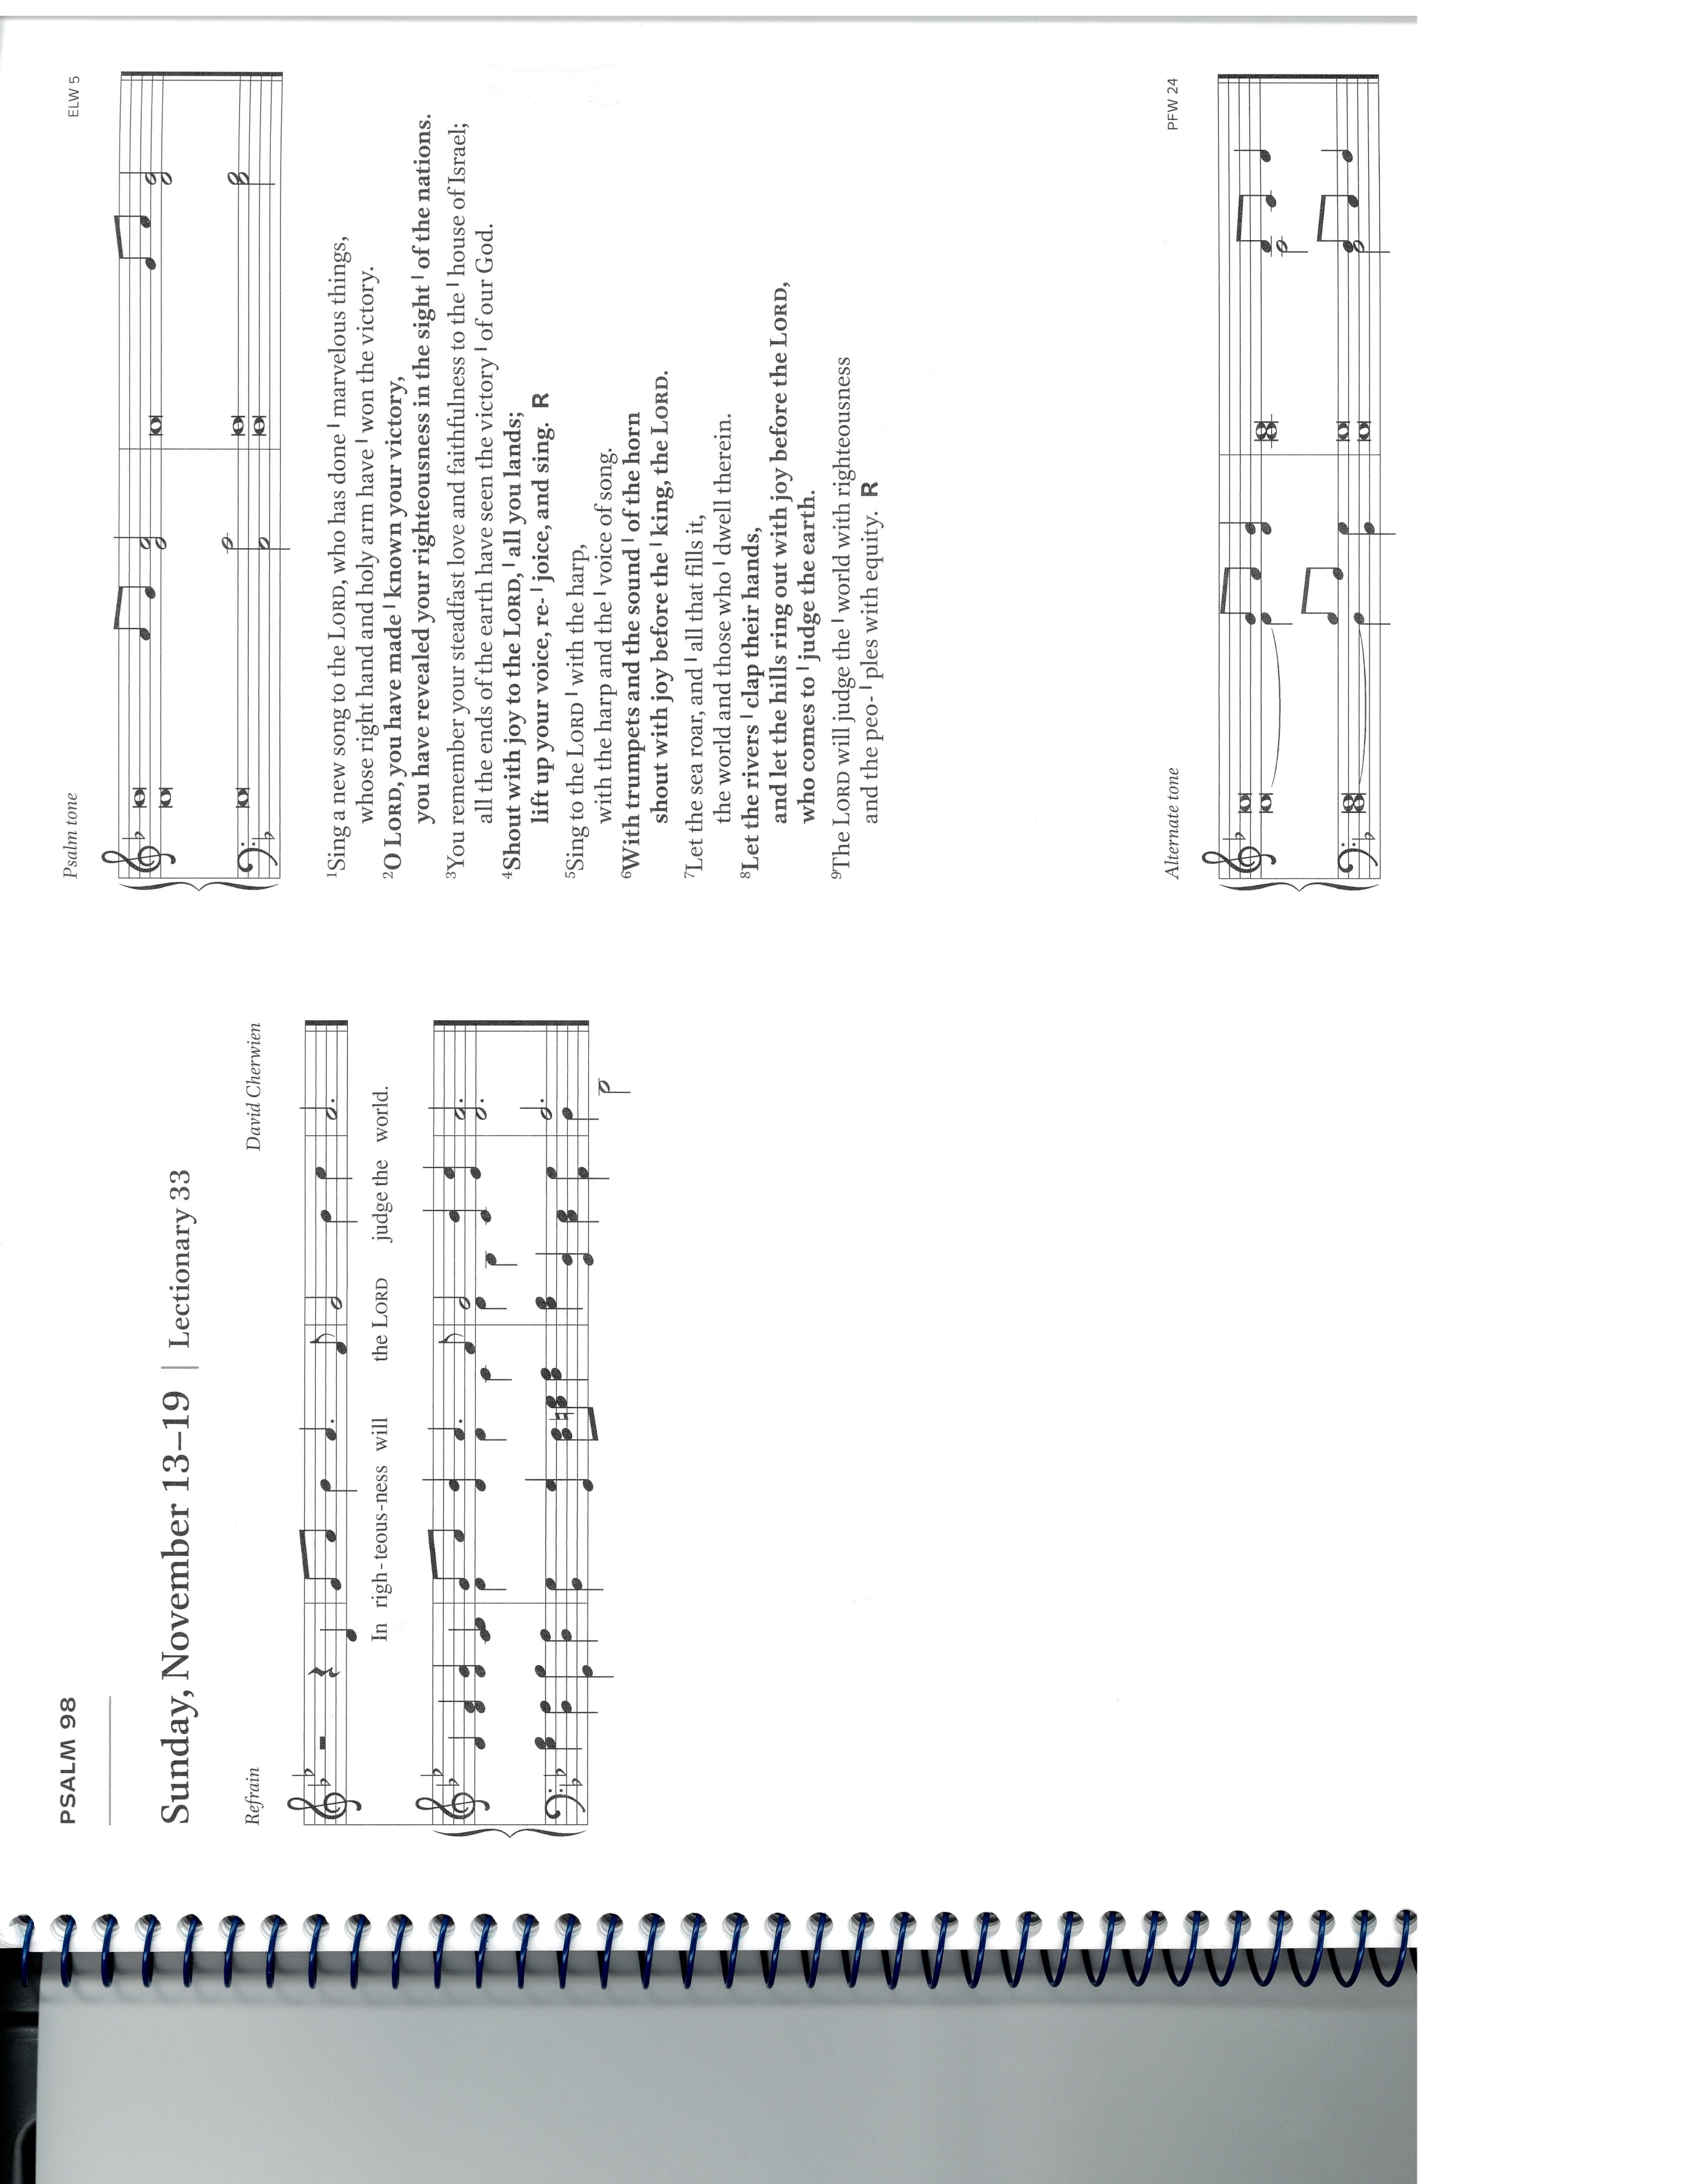
¹ Sing a new song to the Lord, who has done | marvelous things,
whose right hand and holy arm have | won the victory.
² O Lord, you have made | known your victory,
you have revealed your righteousness in the sight | of the nations.
³ You remember your steadfast love and faithfulness to the | house of Israel;
all the ends of the earth have seen the victory | of our God.
⁴ Shout with joy to the Lord, | all you lands;
lift up your voice, re- | joice, and sing. R
⁵ Sing to the Lord | with the harp,
with the harp and the | voice of song.
⁶ With trumpets and the sound | of the horn
shout with joy before the | king, the Lord.
⁷ Let the sea roar, and | all that fills it,
the world and those who | dwell therein.
⁸ Let the rivers | clap their hands,
and let the hills ring out with joy before the Lord, who comes to | judge the earth.
⁹ The Lord will judge the | world with righteousness
and the peo- | ples with equity. R

Second Reading: 2 Thessalonians 3:6-13
A reading from 2 Thessalonians.
⁶ Now we command you, brothers and sisters, in the name of our Lord Jesus Christ, to keep away from every brother or sister living irresponsibly and not according to the tradition that they received from us. ⁷ For you yourselves know how you ought to imitate us; we were not irresponsible when we were with you, ⁸ and we did not eat anyone’s bread without paying for it, but with toil and labor we worked night and day so that we might not burden any of you. ⁹ This was not because we do not have that right but in order to give you an example to imitate. ¹⁰ For even when we were with you, we gave you this command: anyone unwilling to work should not eat. ¹¹ For we hear that some of you are living irresponsibly, mere busybodies, not doing any work. ¹² Now such persons we command and exhort in the Lord Jesus Christ to do their work quietly and to earn their own living. ¹³ Brothers and sisters, do not be weary in doing what is right.
The word of the Lord.
Thanks be to God.

Please stand.
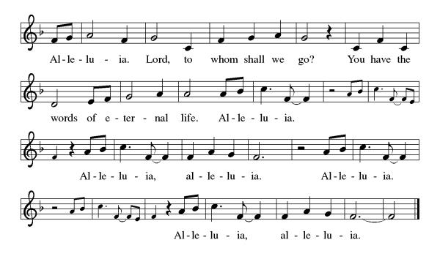
Gospel Acclamation
P: Gospel: Luke 21:5-19
The holy gospel according to Luke.
Glory to you, O Lord.
⁵ When some were speaking about the temple, how it was adorned with beautiful stones and gifts dedicated to God, [Jesus] said, ⁶ “As for these things that you see, the days will come when not one stone will be left upon another; all will be thrown down.”
⁷ They asked him, “Teacher, when will this be, and what will be the sign that this is about to take place?” ⁸ And he said, “Beware that you are not led astray, for many will come in my name and say, ‘I am he!’ and, ‘The time is near!’ Do not go after them.
⁹ “When you hear of wars and insurrections, do not be terrified, for these things must take place first, but the end will not follow immediately.” ¹⁰ Then he said to them, “Nation will rise against nation and kingdom against kingdom; ¹¹ there will be great earthquakes and in various places famines and plagues, and there will be dreadful portents and great signs from heaven.
¹² “But before all this occurs, they will arrest you and persecute you; they will hand you over to synagogues and prisons, and you will be brought before kings and governors because of my name. ¹³ This will give you an opportunity to testify. ¹⁴ So make up your minds not to prepare your defense in advance, ¹⁵ for I will give you words and a wisdom that none of your opponents will be able to withstand or contradict. ¹⁶ You will be betrayed even by parents and siblings, by relatives and friends, and they will put some of you to death. ¹⁷ You will be hated by all because of my name. ¹⁸ But not a hair of your head will perish. ¹⁹ By your endurance you will gain your souls.”
The gospel of the Lord.
Praise to you, O Christ.

Please be seated.
Children’s Message

Sermon

Please stand.
Hymn of the Day O God, of Every Nation ELW#713

A: Apostles’ Creed
Let us confess our faith to the words of the Apostles’ Creed
I believe in God, the Father almighty,
creator of heaven and earth.
I believe in Jesus Christ, God's only Son, our Lord,
who was conceived by the Holy Spirit,
born of the Virgin Mary,
suffered under Pontius Pilate,
was crucified, died, and was buried;
he descended to the dead.
On the third day he rose again;
he ascended into heaven,
he is seated at the right hand of the Father,
and he will come to judge the living and the dead.
I believe in the Holy Spirit,
the holy catholic Church,
the communion of saints,
the forgiveness of sins,
the resurrection of the body,
and the life everlasting. Amen

Please sit or kneel.
A: Prayers of Intercession
Gathered with one voice, we offer our prayers for the church, the world, and all who are in need.

God of roots and branches, defend the leaders of your church as they proclaim the gospel using discernment, wisdom, and brave testimony. Keep all the baptized on righteous paths in response to Christ’s call. Hear us, O God.
Your mercy is great.
God of roaring seas, in a world of earthquake, famine, and plague, use your mighty power to nurture the land and all that lives upon it. Restore peoples and places experiencing natural disasters (especially). Strengthen organizations who provide aid to any in crisis. Hear us, O God.
Your mercy is great.
God of victory, among quests for power, guide those in government, courts, law enforcement agencies, and the military. Turn them from war and violence to actions of care that build up the common good. Hear us, O God.
Your mercy is great.
God of healing, where injustice and exploitation result in populations that are marginalized or underserved, accompany those abandoned by friends, hurt by family, and harmed by violence or oppression. Care for all who are ill, anxious, or in pain of any kind (especially). Hear us, O God.
Your mercy is great.
God of new songs, in a congregation of faithful believers, energize us for compassionate service and delight us through worship and inspired prayer. Encourage your people in building equitable community where all are valued. Hear us, O God.
Your mercy is great.
God of every generation, we remember the saints with steadfast love and faithfulness (especially). Confident in Christ’s victory over death, may we be inspired by the example of the faithful. Hear us, O God.
Your mercy is great.
We offer these and all our prayers to you, O God, trusting in your grace and unyielding love; through Jesus Christ, our Lord.
Amen.

P: Peace
The peace of Christ be with you always. And also, with you.

MEAL
God feeds us with the presence of Jesus Christ.
Please be seated.
Offering

Choir – An Invitation to Praise

Please stand.
Offertory Hymn For the Wholeness of the Earth ACS#1067

Offertory Prayer
A: Lord of the harvest,
we return to you a portion of what you have given to us.
Turn us to set our hope not on the uncertainty of riches,
but on you, who richly provides for us.
Multiply what we have gathered
to bless all who are suffering and in need,
through Jesus Christ our Lord.
Amen.

P: The Great Thanksgiving

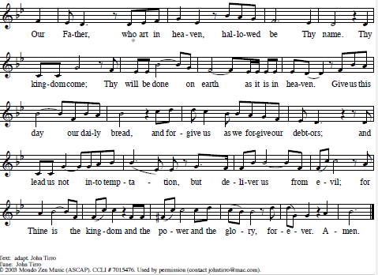
The Lord’s Prayer

Invitation to Communion
Jesus welcomes sinners and eats with them.
Come to this meal of mercy.

Please be seated.

Communion Hymns Build a Longer Table ACS#1062

God Bestows on Every Sense ACS#1069

A: Prayer After Communion
O God,
through this meal you have strengthened us
and appointed us to be your servants.
Send us to do good and to share our possessions
with all in need.
We ask this in Jesus’ name. Amen.

God blesses us and sends us in mission to the world.
SENDING

P: Blessing
The God of righteousness, who gives justice to the oppressed,
who gives food to the hungry, who sets the prisoners free,
☩ bless you now and forever. Amen.

Sending Song O God, Our Help in Ages Past ELW#632

Dismissal
Go in peace. Do not lose heart.
Thanks be to God.

