
Worship Plan for Sunday, April 12, 2026
Second Sunday of Easter

The Holy Spirit calls us together as the people of God.
GATHERING
Welcome & Announcements
Prelude
Reflection – Preparing for Worship

Please stand.
Confession and Forgiveness
The assembly stands. All may make the sign of the cross, the sign that is marked at baptism, as the presiding minister begins.

In the name of the Father,
and of the ☩ Son,
and of the Holy Spirit.
Amen.

God of all mercy and consolation, come to the help of your people, turning us from our sin to live for you alone. Give us the power of your Holy Spirit that we may confess our sin, receive your forgiveness, and grow into the fullness of Jesus Christ, our Savior and Lord.
Amen.

Let us confess our sin in the presence of God and of one another.
The assembly kneels or stands. Silence is kept for reflection.

Most merciful God,
we confess that we are captive to sin and cannot free ourselves. We have sinned against you in thought, word, and deed, by what we have done and by what we have left undone. We have not loved you with our whole heart; we have not loved our neighbors as ourselves. For the sake of your Son, Jesus Christ, have mercy on us. Forgive us, renew us, and lead us, so that we may delight in your will and walk in your ways, to the glory of your holy name.
Amen.

In the mercy of almighty God, Jesus Christ was given to die for us, and for his sake God forgives us all our sins. As a called and ordained minister of the church of Christ, and by his authority, I therefore declare to you the entire forgiveness of all your sins, in the name of the Father, and of the ☩ Son, and of the Holy Spirit.
Amen.

Gathering Song Now All the Vault of Heaven Resounds ELW 367
Greeting
The grace of our Lord Jesus Christ, the love of God,
and the communion of the Holy Spirit be with you all.
And also with you.

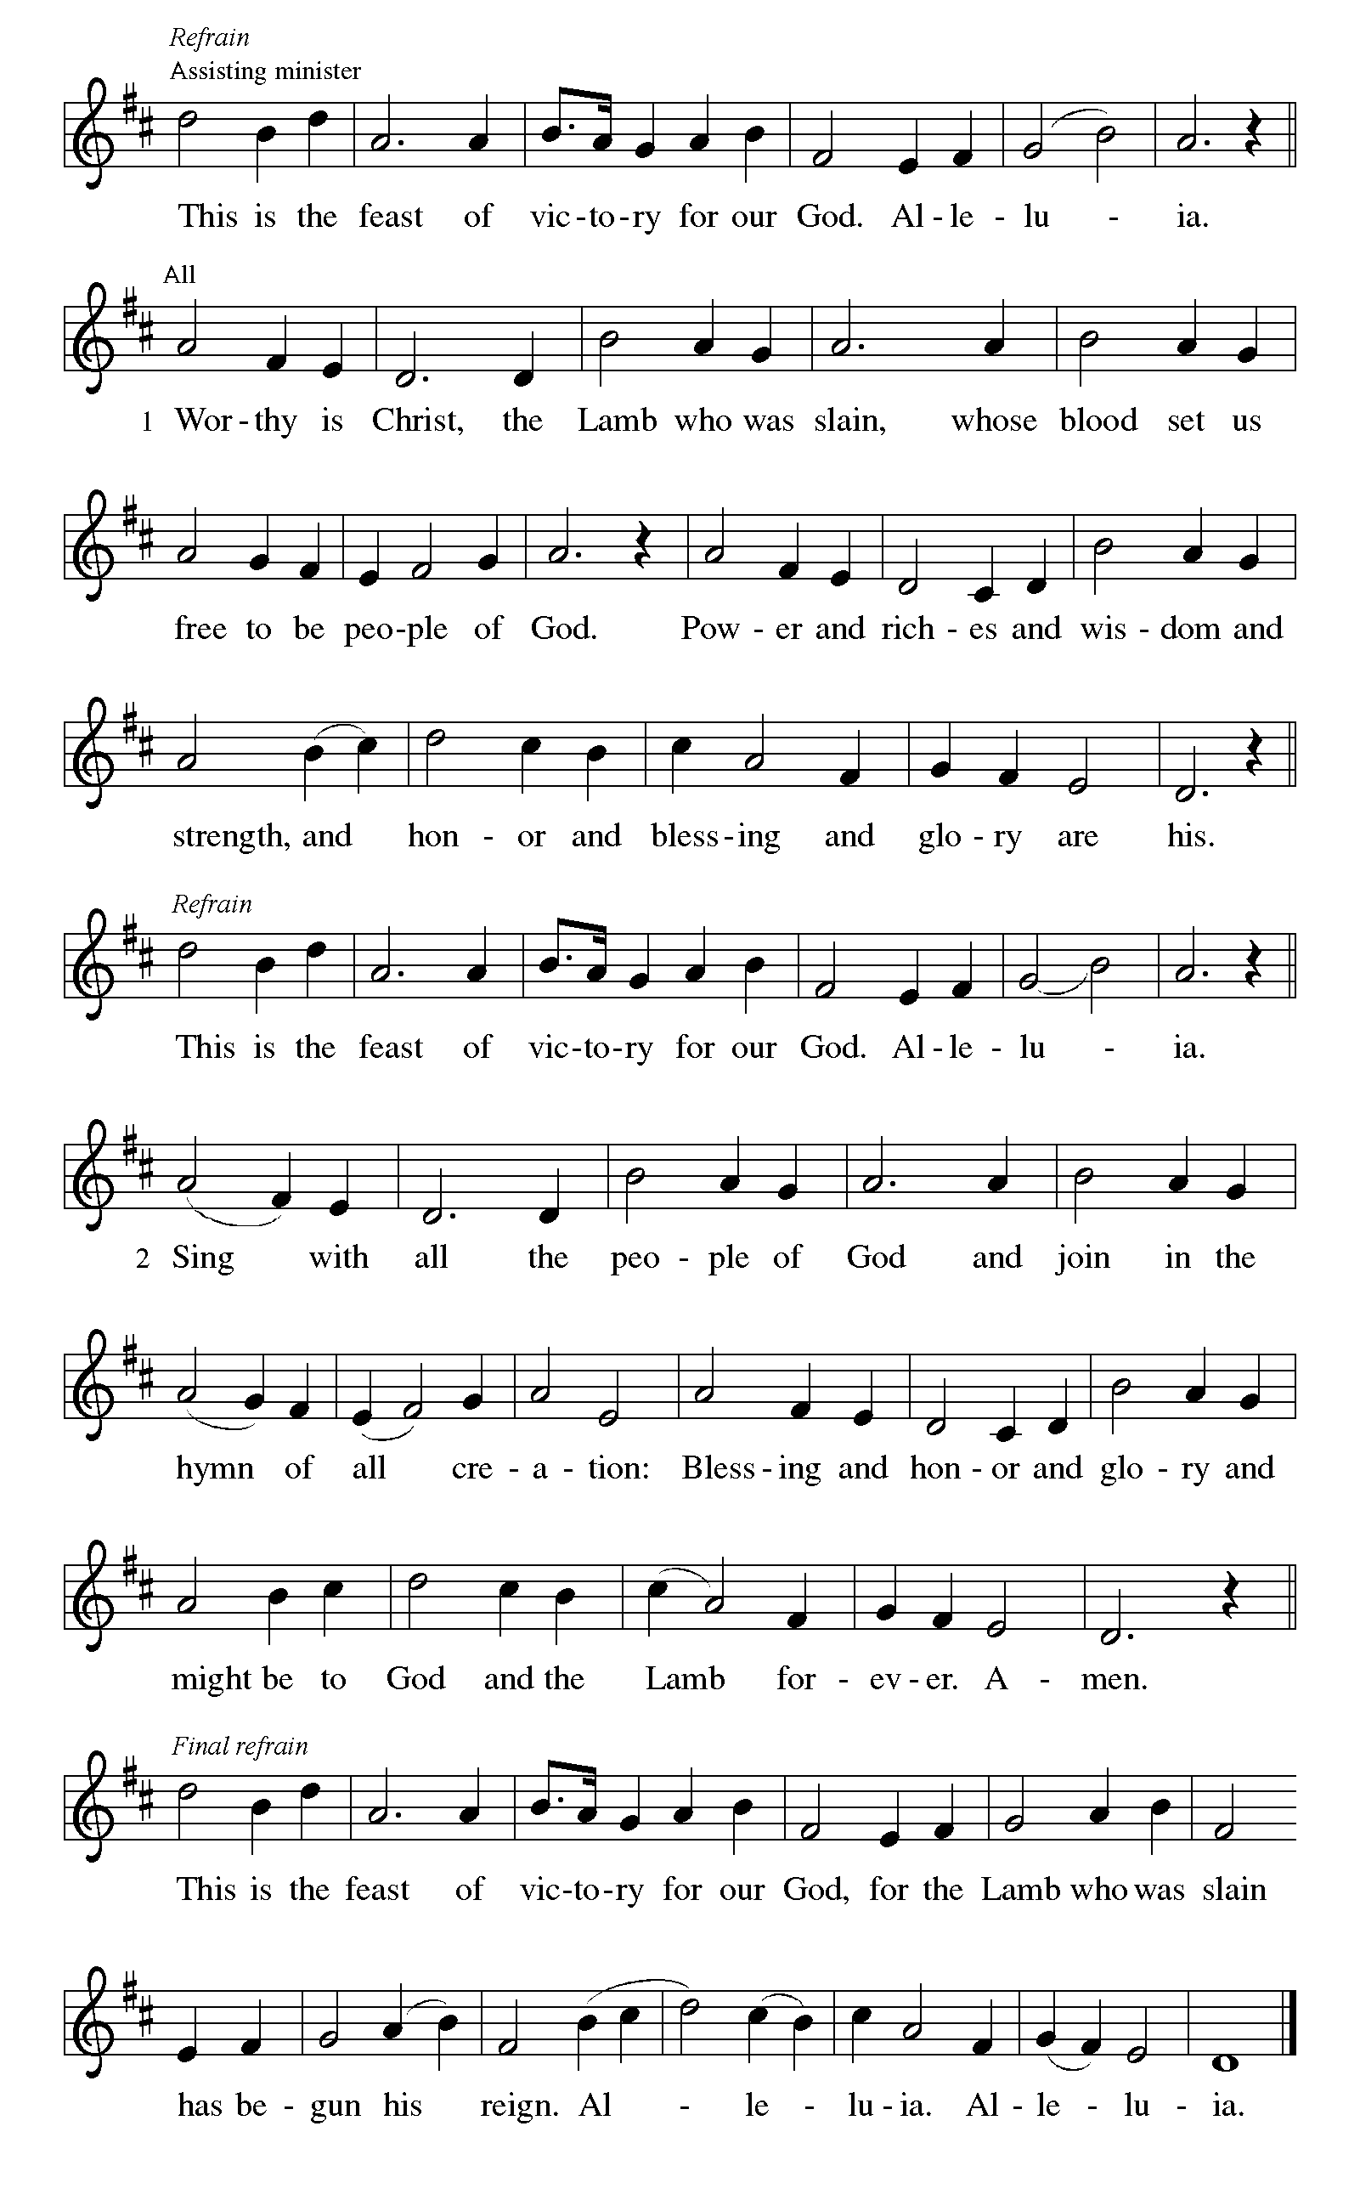
Canticle of Praise

Prayer of the Day
Let us pray.
Almighty and eternal God, the strength of those who believe and the hope of those who doubt, may we, who have not seen, have faith in you and receive the fullness of Christ’s blessing, who lives and reigns with you and the Holy Spirit, one God, now and forever.
Amen.
God speaks to us in scripture reading, preaching, and song.
WORD
First Reading: Acts 2:14a, 22-32
A reading from Acts.
^{14a} Peter, standing with the eleven, raised his voice and addressed [the crowd]: ²² “Fellow Israelites, listen to what I have to say: Jesus of Nazareth, a man attested to you by God with deeds of power, wonders, and signs that God did through him among you, as you yourselves know ²³ this man, handed over to you according to the definite plan and foreknowledge of God, you crucified and killed by the hands of those outside the law. ²⁴ But God raised him up, having released him from the agony of death, because it was impossible for him to be held in its power. ²⁵ For David says concerning him,
‘I saw the Lord always before me,
for he is at my right hand so that I will not be shaken;
²⁶ therefore my heart was glad, and my tongue rejoiced;
moreover, my flesh will live in hope.
²⁷ For you will not abandon my soul to Hades
or let your Holy One experience corruption.
²⁸ You have made known to me the ways of life;
you will make me full of gladness with your presence.’
²⁹ “Fellow Israelites, I may say to you confidently of our ancestor David that he both died and was buried, and his tomb is with us to this day. ³⁰ Since he was a prophet, he knew that God had sworn with an oath to him that he would put one of his descendants on his throne. ³¹ Foreseeing this, David spoke of the resurrection of the Messiah, saying,
‘He was not abandoned to Hades,
nor did his flesh experience corruption.’
³² “This Jesus God raised up, and of that all of us are witnesses.”
The word of the Lord.
Thanks be to God.

Psalm: Psalm 16
¹ Protect me, O God, for I take ref- | uge in you;
I have said to the Lord, “You are my Lord, my good a- | bove all other.”
² All my delight is in the godly that are | in the land,
upon those who are noble a- | mong the people.
³ But those who run after | other gods
shall have their troubles | multiplied.
⁴ I will not pour out drink offerings | to such gods,
never take their names up- | on my lips. R
⁵ O Lord, you are my portion | and my cup;
it is you who up- | hold my lot.
⁶ My boundaries enclose a | pleasant land;
indeed, I have a | rich inheritance.
⁷ I will bless the Lord who | gives me counsel;
my heart teaches me night | after night.
⁸ I have set the Lord al- | ways before me;
because God is at my right hand, I shall | not be shaken. R
⁹ My heart, therefore, is glad, and my spir- | it rejoices;
my body also shall | rest in hope.
¹⁰ For you will not abandon me | to the grave,
nor let your holy one | see the pit.
¹¹ You will show me the | path of life;
in your presence there is fullness of joy, and in your right hand are pleasures for- | evermore. R

Second Reading: 1 Peter 1:3-9
A reading from 1 Peter.
³ Blessed be the God and Father of our Lord Jesus Christ! By his great mercy he has given us a new birth into a living hope through the resurrection of Jesus Christ from the dead ⁴ and into an inheritance that is imperishable, undefiled, and unfading, kept in heaven for you, ⁵ who are being protected by the power of God through faith for a salvation ready to be revealed in the last time. ⁶ In this you rejoice, even if now for a little while you have had to suffer various trials, ⁷ so that the genuineness of your faith—being more precious than gold that, though perishable, is tested by fire—may be found to result in praise and glory and honor when Jesus Christ is revealed. ⁸ Although you have not seen him, you love him, and even though you do not see him now, you believe in him and rejoice with an indescribable and glorious joy, ⁹ for you are receiving the outcome of your faith, the salvation of your souls.
The word of the Lord.
Thanks be to God.
Gospel: John 20:19-31
The holy gospel according to John.
Glory to you, O Lord.
¹⁹ When it was evening on that day, the first day of the week, and the doors were locked where the disciples were, for fear of the Jews, Jesus came and stood among them and said, “Peace be with you.” ²⁰ After he said this, he showed them his hands and his side. Then the disciples rejoiced when they saw the Lord. ²¹ Jesus said to them again, “Peace be with you. As the Father has sent me, so I send you.” ²² When he had said this, he breathed on them and said to them, “Receive the Holy Spirit. ²³ If you forgive the sins of any, they are forgiven them; if you retain the sins of any, they are retained.”
²⁴ But Thomas (who was called the Twin), one of the twelve, was not with them when Jesus came. ²⁵ So the other disciples told him, “We have seen the Lord.” But he said to them, “Unless I see the mark of the nails in his hands and put my finger in the mark of the nails and my hand in his side, I will not believe.”
²⁶ A week later his disciples were again in the house, and Thomas was with them. Although the doors were shut, Jesus came and stood among them and said, “Peace be with you.” ²⁷ Then he said to Thomas, “Put your finger here and see my hands. Reach out your hand and put it in my side. Do not doubt but believe.” ²⁸ Thomas answered him, “My Lord and my God!” ²⁹ Jesus said to him, “Have you believed because you have seen me? Blessed are those who have not seen and yet have come to believe.”
³⁰ Now Jesus did many other signs in the presence of his disciples that are not written in this book. ³¹ But these are written so that you may continue to believe that Jesus is the Messiah, the Son of God, and that through believing you may have life in his name.
The gospel of the Lord.
Praise to you, O Christ.

Please be seated.
Children’s Message

Sermon

Hymn of the Day Touch That Soothes and Heals ACS 939
See My Hands and Feet

Nicene Creed
A: Let us profess our faith to the words of the Nicene creed
We believe in one God,
the Father, the Almighty,
maker of heaven and earth,
of all that is, seen and unseen.
We believe in one Lord, Jesus Christ,
the only Son of God,
eternally begotten of the Father,
God from God, Light from Light,
true God from true God,
begotten, not made,
of one Being with the Father;
through him all things were made.
For us and for our salvation
he came down from heaven,
was incarnate of the Holy Spirit and the virgin Mary
and became truly human.
For our sake he was crucified under Pontius Pilate;
he suffered death and was buried.
On the third day he rose again
in accordance with the scriptures;
he ascended into heaven
and is seated at the right hand of the Father.
He will come again in glory to judge the living and the dead,
and his kingdom will have no end.
We believe in the Holy Spirit, the Lord, the giver of life,
who proceeds from the Father and the Son,*
who with the Father and the Son is worshiped and glorified,
who has spoken through the prophets.
We believe in one holy catholic and apostolic church.
We acknowledge one baptism for the forgiveness of sins.
We look for the resurrection of the dead,
and the life of the world to come. Amen.

Prayers of Intercession
Trusting in the power of Christ’s resurrection to heal and redeem our broken world, let us pray for the needs of all creation.
Almighty God, you give life to the dead and call into existence things that do not exist. Breathe your Spirit upon us, that our faith may be renewed day by day. Merciful God,
receive our prayer.
Maker of heaven and earth, your mercies are new every morning. Open us to the wonders of creation, from the beauty of flowers to the complexity of subatomic particles. Merciful God,
receive our prayer.
God of peace, in every place where conflict rages, sow seeds of calm and openness to reconciliation. Strengthen the resolve of leaders and citizens to work for peace in their nations. Merciful God,
receive our prayer.
Healing God, come alongside all who are doubting, fearful, or suffering in any way (especially). Reveal to them your presence and assure them of the inheritance you have prepared for them. Merciful God,
receive our prayer.
Giver of joy, let this assembly be a place of genuine love and mutual affection. Deepen our care for one another and help us to embody your forgiving and sacrificial love. Merciful God,
receive our prayer.
Eternal One, we give thanks for saints who were faithful unto death and have joined the church triumphant. Inspire us by their witness and bring us with them into your glorious presence. Merciful God,
receive our prayer.
God of resurrection power, use us and these prayers to proclaim the good news of new life to all the world, through Jesus Christ, our risen Savior.
Amen.

Peace
The peace of Christ be with you always. And also with you.

MEAL
God feeds us with the presence of Jesus Christ.

Choral Anthem – Because He Lives!

Please stand.
Offertory Hymn Give Thanks

Offering Prayer
Merciful God,
accept the fruits of our labor, gathered to give you glory.
You have set a table before us, a glimpse of that great day
when we will hunger and thirst no more.
Nourish us with the body and blood of Jesus,
that goodness and mercy may follow us
and bless the world you love.
In the name of Jesus,
Amen.

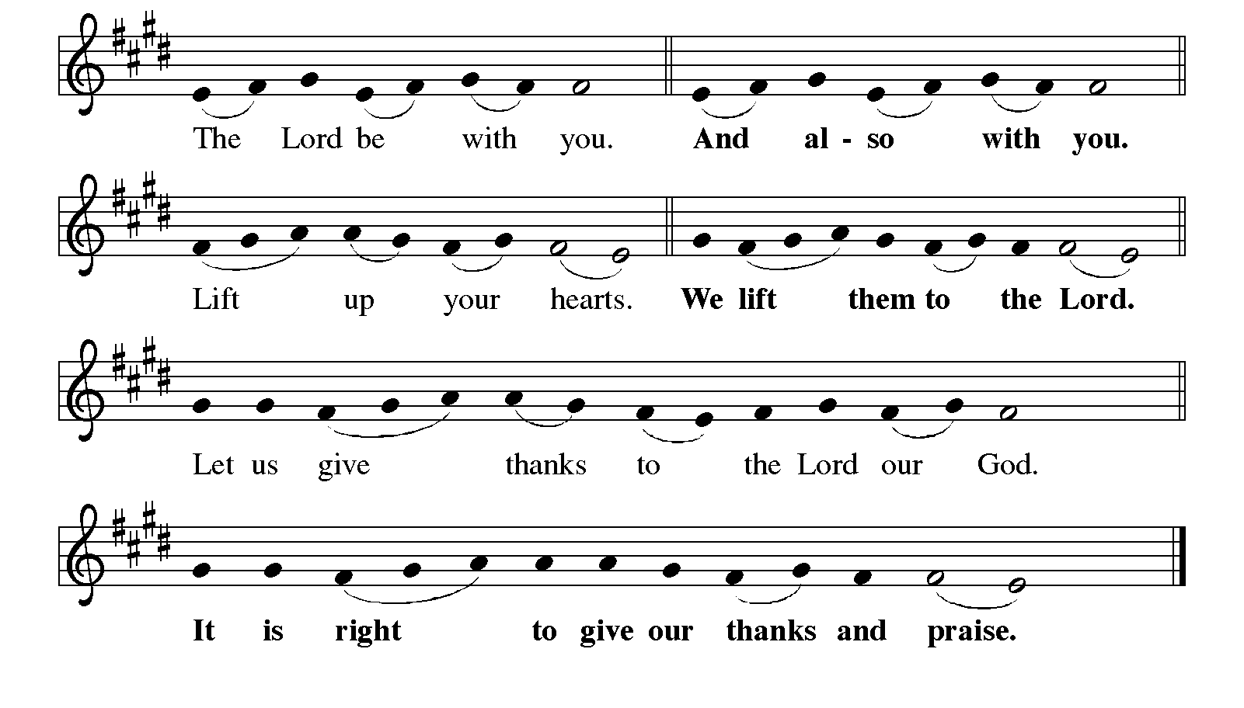
Great Thanksgiving

Eucharistic Prayer
Lord’s Prayer
Our Father, who art in heaven,
hallowed be thy name, thy kingdom come,
thy will be done, on earth as it is in heaven.
Give us this day our daily bread;
and forgive us our trespasses, as we forgive those who trespass against us;
and lead us not into temptation but deliver us from evil.
For thine is the kingdom,
and the power, and the glory, forever and ever.
Amen.

Invitation to Communion
Come to the table of new life.
Receive the risen Lord.

Communion
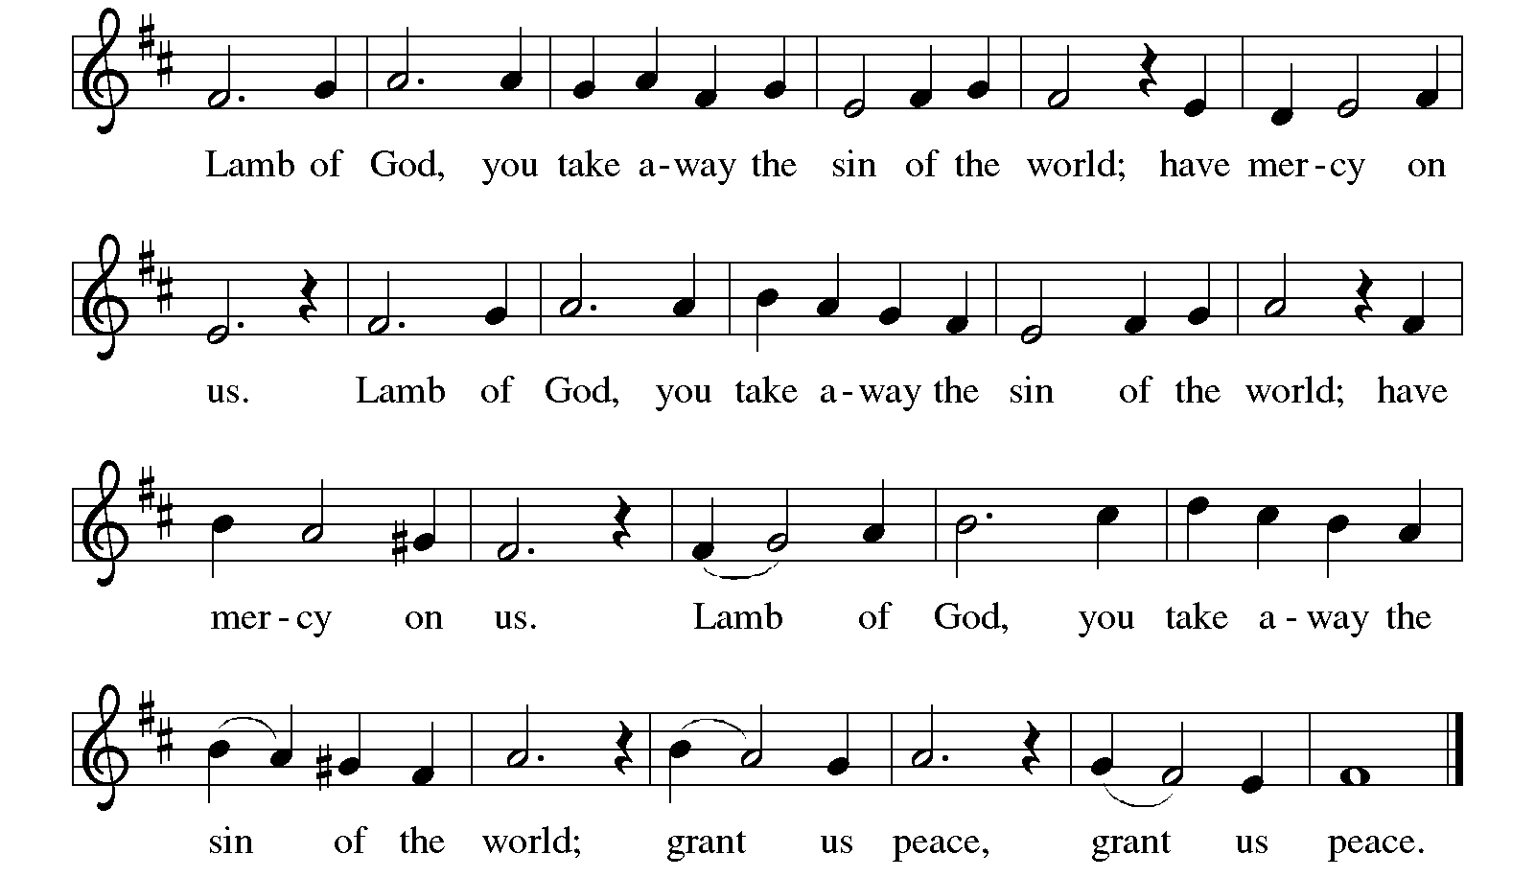

Communion Songs The Peace of the Lord ELW 646

When it Seems the Day Will End ACS 1034

Prayer after Communion
Holy One,
through this meal you have made your home among us
and are making all things new.
Send us now to speak peace to anxious hearts,
to love our enemies,
and to bring your healing to the nations.
In the name of Jesus,
Amen.

SENDING
God blesses us and sends us in mission to the world.

Blessing
God Almighty, who is the beginning and the end,
Jesus Christ, the firstborn of the dead,
and the Spirit, our advocate and peace,
☩ bless you now and forever.
Amen.
Sending Song Hallelujah! We Sing Your Praises ELW 535

Dismissal
Go in peace. Praise the Lord. Alleluia!
Thanks be to God. Alleluia!

From sundaysandseasons.com.

Copyright © 2026 Augsburg Fortress. All rights reserved.

