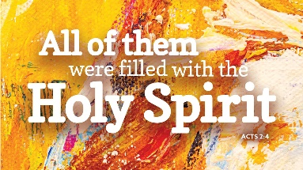
Worship Plan for Sunday, June 8, 2025
Day of Pentecost

The Holy Spirit calls us together as the people of God.
GATHERING

Prelude
Welcome/Announcements
Reflection - Preparing for Worship

Please stand.
P: Confession and Forgiveness
All make the sign of the cross, the sign that is marked at baptism, as the presiding minister begins.
Blessed be the holy Trinity, ☩ one God,
who forgives all our sin,
whose mercy endures forever. Amen.

Let us return to God, confessing our sin in the assurance of God’s abiding love.
Silence is kept for reflection.

Compassionate One,
you are slow to anger and abounding in steadfast love,
but our lives do not always reflect you
and your love for the world.
We do not show others the tender compassion
you have shown to us.
We do not welcome others with the radical hospitality
you grant to all people.
We oppress others,
even though you have set us free again and again.
We squander the abundant gifts of the earth.
Transform our lives
and guide us again in the way of the cross.
Amen.

Beloved in Christ,
God’s arms are always stretched open wide
to welcome the wandering ones home.
In ☩ Christ your sins are forgiven.
You have a place in God’s house forever.
Amen.

Gathering Song O Living Breath of God ELW#407

P: Greeting
The grace of our Lord Jesus Christ, the love of God
and the communion of the Holy Spirit be with you all.
And also, with you.

P: Prayer of the Day
Let us pray.
God our creator, the resurrection of your Son offers life to all the peoples of earth. By your Holy Spirit, kindle in us the fire of your love, empowering our lives for service and our tongues for praise, through Jesus Christ, our Savior and Lord, who lives and reigns with you and the Holy Spirit, one God, now and forever.
Amen.

Please be seated.
God speaks to us in scripture reading, preaching, and song.
WORD

L: First Reading: Genesis 11:1-9
A reading from Genesis.
¹Now the whole earth had one language and the same words. ²And as they migrated from the east, they came upon a plain in the land of Shinar and settled there. ³And they said to one another, "Come, let us make bricks, and burn them thoroughly." And they had brick for stone, and bitumen for mortar. ⁴Then they said, "Come, let us build ourselves a city, and a tower with its top in the heavens, and let us make a name for ourselves; otherwise, we shall be scattered abroad upon the face of the whole earth." ⁵The LORD came down to see the city and the tower, which mortals had built. ⁶And the LORD said, "Look, they are one people, and they have all one language; and this is only the beginning of what they will do; nothing that they propose to do will now be impossible for them. ⁷Come, let us go down, and confuse their language there, so that they will not understand one another's speech." ⁸So the LORD scattered them abroad from there over the face of all the earth, and they left off building the city. ⁹Therefore it was called Babel, because there the LORD confused the language of all the earth; and from there the LORD scattered them abroad over the face of all the earth.
The word of the Lord.
Thanks be to God.

Psalm: Psalm 104:24-34, 35b
²⁴ How manifold are your | works, O Lord!
In wisdom you have made them all; the earth is full | of your creatures.
²⁵ Yonder is the sea, great and wide, with its swarms too man- | y to number,
living things both | small and great.
²⁶ There go the ships | to and fro,
and Leviathan, which you made for the | sport of it.
²⁷ All of them | look to you
to give them their food | in due season.
²⁸ You give it to them; they | gather it;
you open your hand, and they are filled | with good things.
²⁹ When you hide your face, | they are terrified;
when you take away their breath, they die and return | to their dust.
³⁰ You send forth your Spirit, and they | are created;
and so you renew the face | of the earth.
³¹ May the glory of the Lord en- | dure forever;
O Lord, rejoice in | all your works.
³² You look at the earth | and it trembles;
you touch the mountains | and they smoke.
³³ I will sing to the Lord as long | as I live;
I will praise my God while I | have my being.
³⁴ May these words of | mine please God.
I will rejoice | in the Lord.
^{35b} Bless the Lord, | O my soul.
Hal- | lelujah!
Second Reading: Acts 2:1-21
A reading from Acts.
¹When the day of Pentecost had come, they were all together in one place. ²And suddenly from heaven there came a sound like the rush of a violent wind, and it filled the entire house where they were sitting. ³Divided tongues, as of fire, appeared among them, and a tongue rested on each of them. ⁴All of them were filled with the Holy Spirit and began to speak in other languages, as the Spirit gave them ability.
⁵Now there were devout Jews from every nation under heaven living in Jerusalem. ⁶And at this sound the crowd gathered and was bewildered, because each one heard them speaking in the native language of each. ⁷Amazed and astonished, they asked, "Are not all these who are speaking Galileans? ⁸And how is it that we hear each of us, in our own native language? ⁹Parthians, Medes, Elamites, and residents of Mesopotamia, Judea and Cappadocia, Pontus and Asia, ¹⁰Phrygia and Pamphylia, Egypt and the parts of Libya belonging to Cyrene, and visitors from Rome, both Jews and proselytes, ¹¹Cretans and Arabs — in our own languages we hear them speaking about God's deeds of power." ¹²All were amazed and perplexed, saying to one another, "What does this mean?" ¹³But others sneered and said, "They are filled with new wine."
¹⁴But Peter, standing with the eleven, raised his voice and addressed them, "Men of Judea and all who live in Jerusalem, let this be known to you, and listen to what I say. ¹⁵Indeed, these are not drunk, as you suppose, for it is only nine o'clock in the morning. ¹⁶No, this is what was spoken through the prophet Joel:
¹⁷'In the last days it will be, God declares,
that I will pour out my Spirit upon all flesh,
and your sons and your daughters shall prophesy,
and your young men shall see visions,
and your old men shall dream dreams.
¹⁸Even upon my slaves, both men and women,
in those days I will pour out my Spirit; and they shall prophesy.
¹⁹And I will show portents in the heaven above
and signs on the earth below, blood, and fire, and smoky mist.
²⁰The sun shall be turned to darkness
and the moon to blood, before the coming of the Lord's great and glorious day.
²¹Then everyone who calls on the name of the Lord shall be saved. ‘The word of the Lord.
Thanks be to God.

Please stand.
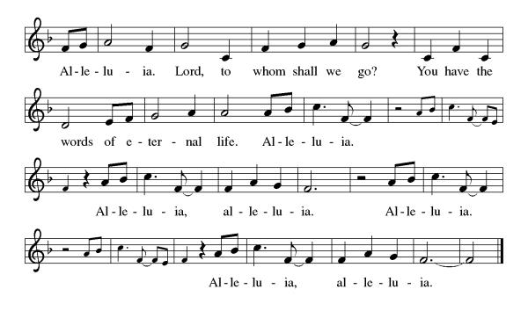
Gospel Acclamation

P: Gospel: John 14:8-17 [25-27]
The holy gospel according to John.
Glory to you, O Lord.
⁸ Philip said to [Jesus,] “Lord, show us the Father, and we will be satisfied.” ⁹ Jesus said to him, “Have I been with you all this time, Philip, and you still do not know me? Whoever has seen me has seen the Father. How can you say, ‘Show us the Father’? ¹⁰ Do you not believe that I am in the Father and the Father is in me? The words that I say to you I do not speak on my own; but the Father who dwells in me does his works. ¹¹ Believe me that I am in the Father and the Father is in me; but if you do not, then believe me because of the works themselves. ¹² Very truly, I tell you, the one who believes in me will also do the works that I do and, in fact, will do greater works than these, because I am going to the Father. ¹³ I will do whatever you ask in my name, so that the Father may be glorified in the Son. ¹⁴ If in my name you ask me for anything, I will do it.
¹⁵ “If you love me, you will keep my commandments. ¹⁶ And I will ask the Father, and he will give you another Advocate, to be with you forever. ¹⁷ This is the Spirit of truth, whom the world cannot receive, because it neither sees him nor knows him. You know him, because he abides with you, and he will be in you. [
²⁵ “I have said these things to you while I am still with you. ²⁶ But the Advocate, the Holy Spirit, whom the Father will send in my name, will teach you everything, and remind you of all that I have said to you. ²⁷ Peace I leave with you; my peace I give to you. I do not give to you as the world gives. Do not let your hearts be troubled, and do not let them be afraid.”]
The gospel of the Lord.
Praise to you, O Christ.

Please be seated.
Children’s Message

Sermon

Please stand.
Hymn of the Day As the Wind Song ACS#943
A: Apostles’ Creed
Let us confess our faith to the words of the Apostles’ Creed
I believe in God, the Father almighty, creator of heaven and earth.
I believe in Jesus Christ, God’s only Son, our Lord,
who was conceived by the Holy Spirit,
born of the virgin Mary, suffered under Pontius Pilate,
was crucified, died, and was buried; he descended to the dead.
On the third day he rose again;
he ascended into heaven,
he is seated at the right hand of the Father,
and he will come to judge the living and the dead.
I believe in the Holy Spirit, the holy catholic church,
the communion of saints, the forgiveness of sins,
the resurrection of the body, and the life everlasting. Amen.

Please sit or kneel.
A: Prayers of Intercession
God of resurrection and new life, we come before you in prayer for the church, the world, and all who are in need.
We pray for the church. Continue to inspire our sharing of the gospel and equip us to tear down the barriers we have erected. Make our welcome expansive, intentional, and open to loving challenge. Hear us, O God.
Your mercy is great.
We pray for creation. Allow fire to burn safely in habitats where it’s needed and quench flames when they threaten to run wild. Protect forests, prairies, and grasslands from destruction by natural forces or human misdeeds. Safeguard firefighters and rescuers in their dangerous work. Hear us, O God.
Your mercy is great.
We pray for courts and legislatures. Write your commandments on our hearts, and inspire all who govern to lead with love over retribution. Unite judges, lawyers, and systems of justice in a desire for reconciliation. Hear us, O God.
Your mercy is great.
We pray for the sick in body, mind, or spirit (especially). Lift up all who have been bowed low by circumstances or internal strife. Bring to wholeness those who cry out to you in need. Hear us, O God.
Your mercy is great.
We pray for this congregation (especially those affirming their baptism this day). Raise up in us a deep desire to live out our baptismal promises and to support those of all ages in our shared journey of faith. Hear us, O God.
Your mercy is great.
We offer thanks for the faithful departed who now rest in you. Let their lives encourage our own daily living. Console us with the promise of eternal life. Hear us, O God.
Your mercy is great.
We commend these and all our prayers to you, O God, trusting that you are always with us; in the name of Jesus Christ, our risen Savior.
Amen.
P: Peace
The peace of Christ be with you always. And also, with you.

God feeds us with the presence of Jesus Christ.
MEAL

Please be seated.
Offering

Flute Trio

Please stand.
Offertory Hymn
Offertory Prayer
A: Let us pray
Risen One, you have gathered us around your table of grace along with these gifts we bring.
Come among us again, breathe your life into us,
and enliven us with this meal, that we may live as your risen body in the world. Amen.

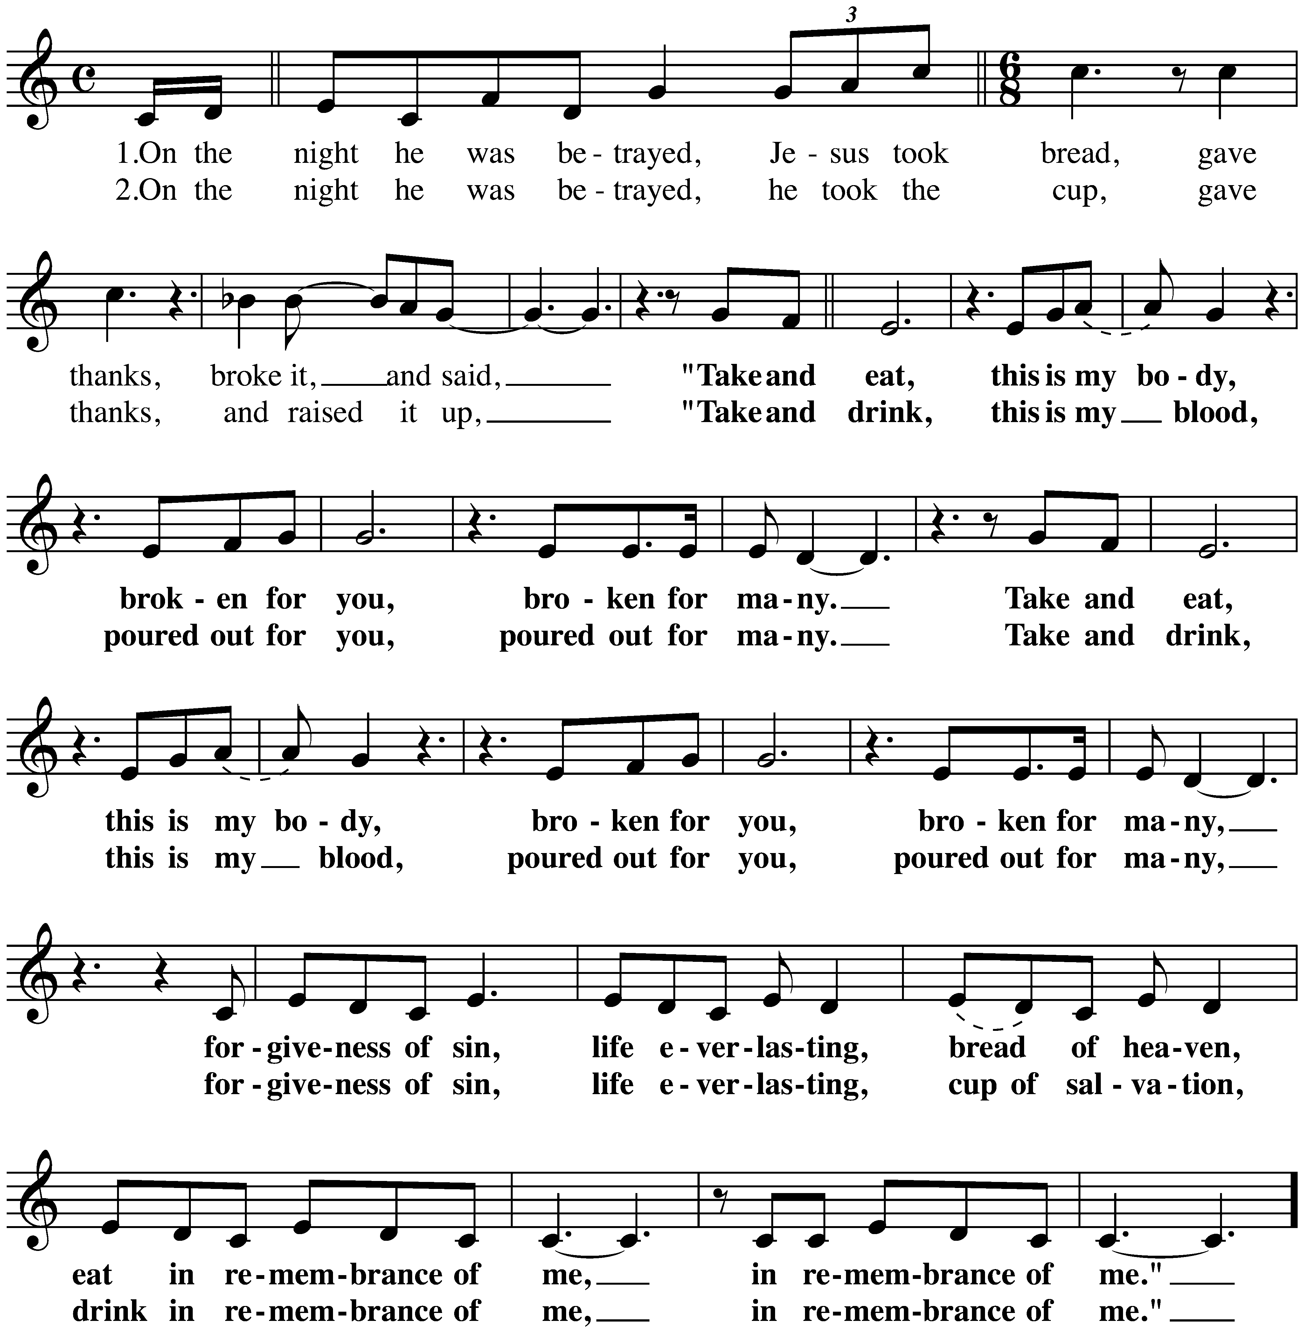
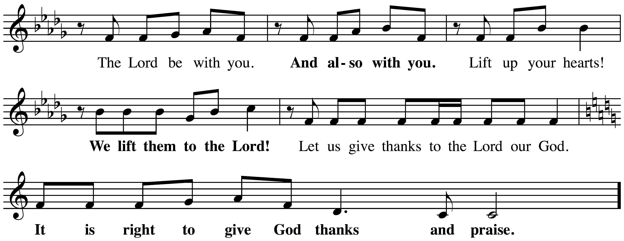
P: The Great Thanksgiving

The Lord’s Prayer

Our Father, who art in heaven,
hallowed be thy name, thy kingdom come,
thy will be done, on earth as it is in heaven.
Give us this day our daily bread;
and forgive us our trespasses, as we forgive those who trespass against us;
and lead us not into temptation but deliver us from evil.
For thine is the kingdom,
and the power, and the glory, forever and ever.
Amen.

Invitation to Communion
Come to the table of grace. Receive the gift of new life.

Please be seated.
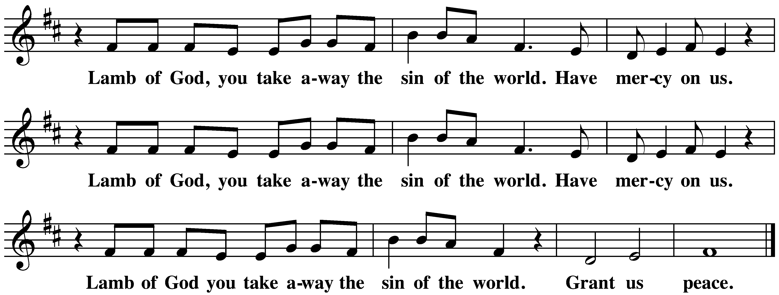
Communion Hymns

Spirit of Gentleness ELW#396

Gracious Spirit, Heed Our Pleading ELW#401

A: Prayer After Communion
Living One,
in this feast you have made yourself known to us.
Send us now to tell of your wonders,
sing of your glory,
and proclaim your risen life
to a wounded and weary world.
Amen

God blesses us and sends us in mission to the world.
SENDING

P: Blessing
The triune God, who was, who is, and who is to come,
Sovereign, ☩ Savior, and Spirit,
light your way with resurrection dawn,
now and always. Amen.
Sending Song Every Time I Feel the Spirit ACS#942

Dismissal
Alleluia! Christ is risen. Christ is risen indeed. Alleluia!
Go in peace. In Christ you are made new. Alleluia! Alleluia!
Thanks be to God. Alleluia! Alleluia!

