Reunite Palestinian Families
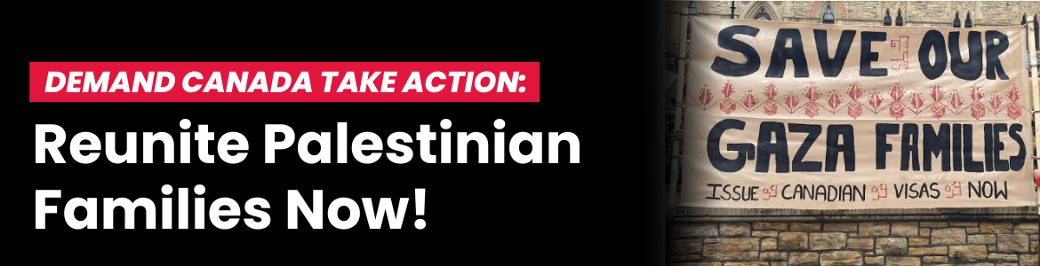
It has been over 20 months since Canada committed to evacuating 5,000 family members of Palestinian Canadians under the Gaza Temporary Resident Visa (TRV) Special Measures for Extended Family Program. Call on your leaders to live up to their commitment to reunite Palestinian families. Click here to send an email to the Ministers of Immigration, Foreign Affairs, and Public Safety.

