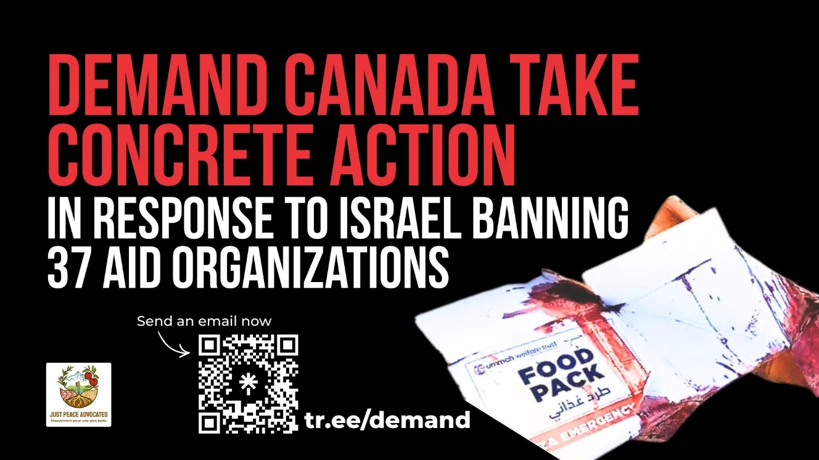

Take Action

On December 28, 2025, Israel announced it plan to bar 37 humanitarian organizations from operating in the occupied Palestinian territory (oPt). This includes Humanity & Inclusion, Doctors Without Borders, Norwegian Refugee Council, Defence for Children International Palestine, and Oxfam-Quebec. As Al-Haq noted: “The announcement follows Israel’s introduction, in March 2025, of additional registration requirements, whose aim is to consolidate its genocidal conduct in Gaza –– of which denial of access to humanitarian aid remains a central element –– to further fragment and isolate the Palestinian people from international support.”
Israel has a long-standing history of impeding access, evidenced by the nearly two decades long blockade of Gaza, all in pursuit of its settler colonial project. This is also not the first time Israel has suspended humanitarian organizations activity. In 2024, Israeli parliament banned UNRWA, “the principal provider of aid, education, health and social services to Palestinian refugees across Gaza, the occupied West Bank and neighbouring countries for decades.” Then and now, Israel accuses aid organizations of support and cover for “terrorism”; an ironic accusation from an apartheid state committing genocide and war crimes.
States, including Canada, have legal obligations to take concrete actions to hold Israel accountable and enforce international law. Read more.
Email your MP, PM Carney, and Foreign Affairs Minister Anand to demand Canada take concrete action now!

