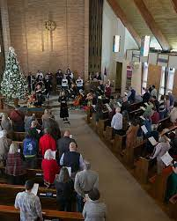The First Presbyterian Church of Troy is seeking to fill a new part-time staff position. This Spirit-led person will help us create community outreach programs, our highly-successful monthly trivia night is an example, and could support a new worship effort. We have some ideas and are excited to hear yours too. About 10 hours per week.
Contact Pastor Dan Heaton at danheatonwriter@gmail.com
https://firstprestroy.org/

