Summer Camps 2026
Session 1
Empowering People’s Independence (EPI)  https://www.epiny.org/developmental-disabilities/ | 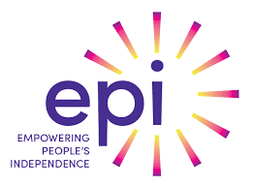
Kamp Kiwanis  https://kampkiwanis.org/ | 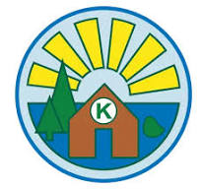
ARISE/EFR (site-based & community-based)  https://contactefr.org/ | 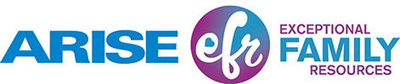
Lions Camp Badger  http://www.lionscb.org/ | 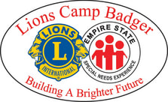
Achieve Summer Youth Program  https://www.achieveny.org/ | 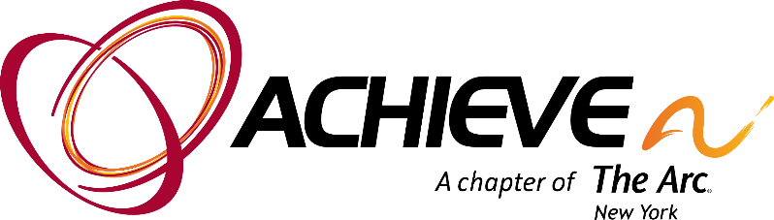

Session 2
Kelberman Kamp Connections  https://www.kelberman.org/ | 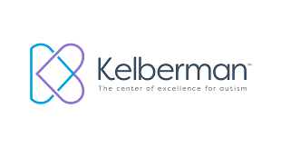
Camp Pathfinder  https://pathfindervillage.org/ | 
Arrowhead & Shepherd’s Camp  https://arrowheadbiblecamp.cloversites.com/arrowhead | 
Camp ARCO  https://www.arcofmc.org/camp-arco | 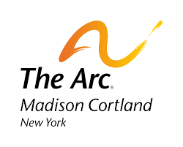
Sky Lake Camp & Retreat  https://skylakecenter.org/ | 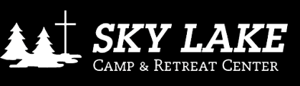
Racker FSS Funding for Camp  https://www.racker.org/ | 

