The UW-Parkside Theatre Arts Department announces
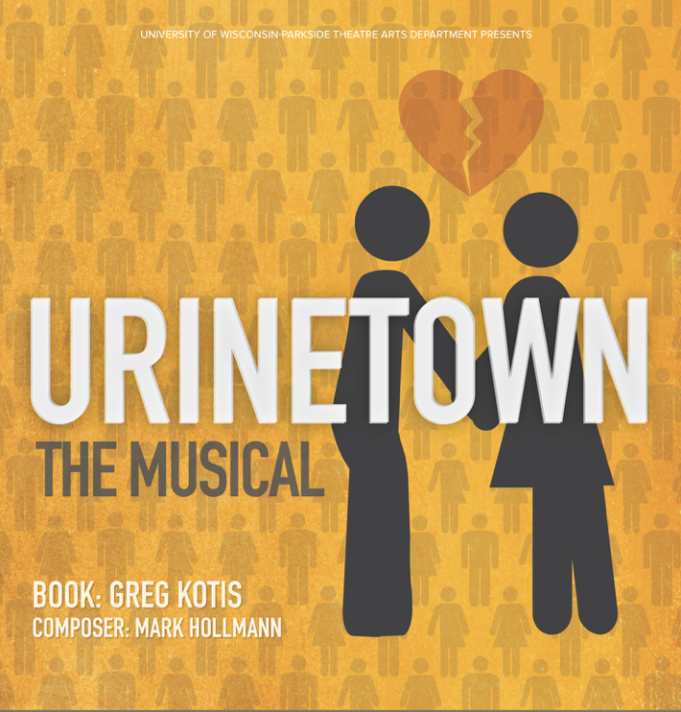
Auditions

Monday
December 3rd
From 5:00-9:00pm
Studio A, CART D132

Callbacks:
Tuesday
December 4th
From 5:30-9:30pm

Audition Details
About the show: A terrible water shortage caused by a 20-year drought has led to a ban on private toilets. People must use public amenities, regulated by a single company that profits by charging admission for one of humanity's most basic needs. Those who can’t afford the fees are ‘exiled’ to a mythic place called Urinetown, never to be seen again. One man must choose between following his heart towards love or a revolution that will lead the people to freedom. The outcome of the revolution is unknown but malevolent corporate greed meets its match in this hilarious, Tony Award-winning satire.
Audition Requirements: Please sign up for an audition time on the sheet posted outside Professor Sassaman’s door (CART 242). Auditions on Monday require a 32-Bar song (preferably contemporary, preferably comedic). Call-backs will involve learning songs from the show, choreography, and possible sides from the show as well.

- Roles for: 19 Named Characters (12M, 7W)
- Perf. Dates March 8 – 17, 2019

QUESTIONS? Contact the director: sassaman@uwp.edu

