Legal and Financial Issues in Early Childhood and Afterschool Programs
Online College Course
January 30 to April 24, 2017

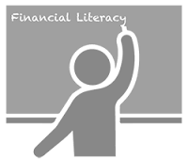
Financial Skills
- Create a real program budget
- Project cash flow one year into the future
- Identify sources of alternative funding
- Learn much more

Legal Skills
- Develop practices making regulatory agency your allies
- Determine what liability issues are putting you at risk
- Identify laws, code and regulations that could shut you down
- Learn much more

This course is a requirement of Step 2 of Vermont’s
Early Childhood and Afterschool Program Director Credential

Credits: 3 credits through Union Institute and University
Cost: $495 plus text
Location: Online through the Northern Lights e-School
Registration Deadline:
Interested Students Must Complete the Following Survey by December 30:
https://www.surveymonkey.com/r/LandF2016
Limited Spots! Priority given to those with a Step 1 Program Director Credential

For Information Contact:
Amelia Struthers, Coordinator
Northern Lights Career Development Center
amelia.struthers@ccv.edu (802) 885-8374

