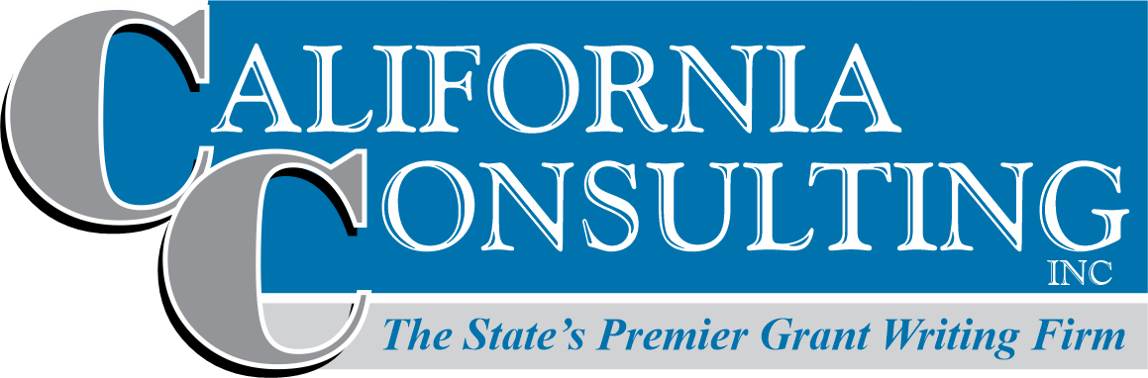
Municipal Grant Opportunities

________-Popular Opportunities

Cal OES: Hazard Mitigation Grant Program (HMGP)
Deadline: Rolling deadline for NOI, until May 31st 2025
Amount: Project max is unspecified. $150,000 for single jurisdiction plan, $250,000 for multi-jurisdiction plan.
Match: Generally, HMA funds may be used to pay up to 75% of the eligible activity costs. The remaining 25% of eligible activity costs are derived from non-Federal sources
Eligibility: States, local communities and tribal governments
https://www.caloes.ca.gov/cal-oes-divisions/recovery/disaster-mitigation-technical-support/404-hazard-mitigation-grant-program
Funding Priorities:
- Local Hazard Mitigation Plans (LHMP) updates that will expire within 24 months.
- All other LHMP updates.
- Shovel ready projects with a high level of design that can begin construction within 90 days of FEMA approval, in declared counties.
- Shovel ready projects with a high level of design that can begin constructions within 90 days of FEMA approval, in all other counties.
- Whole community risk reduction/large critical infrastructure wildfire projects.
- Whole community risk reduction/large critical infrastructure projects for other hazard types.
- Wildfire projects in any county.
- All hazard type projects in any county.
- Planning related activities.
- Five percent (5%) Initiative projects.

South Coast AQMD: MANY OPPORTUNITIES AVAILABLE
Deadline: First-Come, First-Served Basis (no application deadline; open until funds are exhausted)
Amount: Up to 85% discount will be provided, up to the funding caps listed below (whichever is less):; 20% match for fleet
Eligibility: Cities are welcome to apply as well as School Districts and licensed landscapers
http://www.aqmd.gov/home/programs
South Coast AQMD offers a broad range of programs for businesses, the community, and local government that help to achieve cleaner air quality for all. Many of these programs offer financial incentives for implementing new clean air technologies. Some provide partnerships and new ways of addressing air quality issues throughout the South Coast Basin.

San Joaquin Valley APCD: MANY OPPORTUNITIES AVAILABLE
Deadline: First Come, First Serve
Amount: Up to 100% off costs of equipment for public agencies
Match: No
Eligibility: Varies based on program
https://ww2.valleyair.org/grants
The Zero-Emission Landscaping Equipment (ZELE) Voucher Program provides incentives for San Joaquin Valley landscapers, public agencies, and businesses that perform their own landscape maintenance, to replace their old gas-powered landscape equipment with new electric options.
Amount: Small business and public agency applicants may be eligible for up to 100% of the cost of new equipment, while large businesses may be eligible for up to 85% of the cost of new equipment. Maximum funding amounts may be reduced for large businesses to ensure the 15% cost share requirement is met.
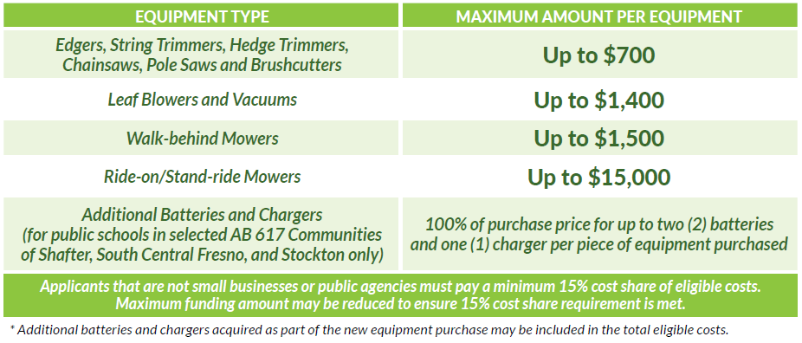
New Alternative Fuel Vehicle Purchase
This component provides funding for the purchase of new alternative fueled vehicles (Electric, Plug-In Hybrid, CNG, LNG, LPG, etc). Applications for this component are currently being accepted on a first-come, first-serve basis. For specific information about the requirements of the component, please review the program guidelines.Maximum Funding: Up to $20,000 per vehicle, with a limit of $100,000 per agency per year.
HCD: CalHome Program
Deadline: February 13, 2025
Amount: Grants vary based on program type. For example, Mortgage Assistance grants can range up to $80,000 per homebuyer, while Owner-Occupied Rehabilitation grants can reach up to $100,000 per project.
Match: No match required
Link: CalHome Program
Purpose: The program supports affordable housing development, rehabilitation, and assistance for low-income households .
Mortgage Assistance:
- Financial support for first-time low-income homebuyers.
- Provides up to $80,000 per homebuyer to assist with down payments or closing costs.
Owner-Occupied Rehabilitation:
- Funds for the rehabilitation of owner-occupied homes for low-income residents.
- Provides up to $100,000 per project for necessary repairs or improvements.
Accessory Dwelling Units (ADUs):
- Funding for the creation or rehabilitation of ADUs to increase affordable housing stock.
Homeownership Development Projects:
- Financial support for organizations to develop affordable single-family homes.
Manufactured Housing Assistance:
- Support for purchasing and/or rehabilitating manufactured homes.
Homebuyer Counseling and Education:
- Programs to educate low-income households on homeownership, financial literacy, and the home-buying process.
Self-Help Housing Projects:
- Support for low-income families building their own homes through mutual self-help programs.

FHWA: Promoting Resilient Operations for Transformative, Efficient, and Cost-Saving Transportation (PROTECT) Program
Deadline: February 24, 2025
Amount: Planning: $100,000 min, no max, Implementation: $500,000-no max
Match: 0-20%, depending on project
Link: https://www.grants.gov/search-results-detail/356840
Purpose: The purpose of the PROTECT Program is to provide grants on a competitive basis for projects that seek to strengthen surface transportation to be more resilient to natural hazards, including climate change, sea level rise, heat waves, flooding, extreme weather events, and other natural disasters through support of planning activities, resilience improvements, community resilience and evacuation routes, and at-risk coastal infrastructure.

USDA: Community Wildfire Defense
Deadline: February 28, 2025
Amount:The maximum amount of Federal funding awarded to any one community or Tribe via this competitive process is:
- $250,000 for the creation or updating of a Community Wildfire Protection Plan.
- $10 million for a project described within a Community Wildfire Protection Plan less than 10 years old.
- For planning purposes, the total Federal funding available through the CWDG competitive process could be up to $250 million for this second round.
Eligibility: Entities eligible to apply for at-risk communities for funding under the CWDG include:
- Units of local governments representing communities located in an area with a risk of wildfires,
- Indian Tribes (please apply through either the Indian Tribes/Alaska Native Corporations specific notice or the applicable regional notice),
- Non-profit organizations including homeowner associations that assist such communities,
- State forestry agencies (including U.S. territories and interests), and
- Alaska Native Corporations (please apply through either the Indian Tribes/Alaska Native Corporations specific notice or the applicable regional notice).
Match: Yes 10% for CWPPs, 25% for implementation
https://www.fs.usda.gov/managing-land/fire/grants
This program, which was authorized by the Bipartisan Infrastructure Law, prioritizes at-risk communities in an area identified as having high or very high wildfire hazard potential, are low-income, or have been impacted by a severe disaster that affects the risk of wildfire. More details on these three priorities can be found in the Notices of Funding Opportunity (NOFOs) below.
The program provides funding to communities for two primary purposes:
- Develop and revise Community Wildfire Protection Plans (CWPP).
- Implement projects described in a Community Wildfire Protection Plan that is less than ten years old.
The Community Wildfire Defense Grant Program also helps communities in the wildland urban interface (WUI) implement the three goals of the National Cohesive Wildland Fire Management Strategy.
Restore and Maintain Landscapes: Landscapes across all jurisdictions are resilient to fire-related disturbances, in accordance with management objectives.
Create Fire Adapted Communities: Human populations and infrastructure can better withstand a wildfire without loss of life and property.
Improve Wildfire Response: All jurisdictions participate in making and implementing safe, effective, efficient risk-based wildfire management decisions.

HCD: Homekey+ Program
Deadline: Applications accepted after January 30th, Gap Financing projects due March 14th, all other project application types due May 30th or until funds exhausted
Amount: Proposition 1 allocates approximately $2 billion, with $1 billion specifically designated for veterans.
Eligibility: Local public entities (cities, counties, and public housing authorities), Tribal entities, Housing developers
Match Requirements: No match required.
Link: https://www.hcd.ca.gov/grants-and-funding/homekey-plus
Summary:
Homekey+ is part of the Behavioral Health Infrastructure Bond Act (Proposition 1) passed in March 2024. This program aims to develop permanent affordable housing paired with supportive services, specifically for veterans and individuals with mental health or substance use challenges who are homeless or at risk of homelessness. Projects should focus on the acquisition and rehabilitation of existing buildings, new construction, or other innovative housing solutions.
Eligible Uses:
Acquisition and rehabilitation of existing properties (e.g., hotels, motels, apartments)
Conversion of commercial properties
New construction for permanent housing
Master leasing of properties
Purchase of affordability covenants
Population Served:
Veterans and individuals with behavioral health challenges who are at risk of, or experiencing, homelessness.
Funding Priorities:
Projects demonstrating readiness and the capacity to begin quickly (within 12 months)
Applications with commitments to sustainable long-term funding for services (especially using MHSA and BHSA funds)
Projects that address regional targets and needs in coordination with local Continuum of Care (CoC) and mental health departments
Program Contact:
For more information, visit Homekey+.
Email: homekey@hcd.ca.gov

HCD: Emergency Solutions Grant Program
Deadline: March 28th, 2025
Amount: $75,000-$200,000
Match: Yes
Link: https://www.hcd.ca.gov/grants-and-funding/programs-active/emergency-solutions-grants#undefined
Description: The ESG program does not fund individuals or families directly. The ESG program provides grant funding to approved units of general-purpose local government and federally recognized non-profit organizations.

These ESG funds are used to:
- Engage homeless individuals and families living on the street;
- Rapidly re-house homeless individuals and families;
- Help operate and provide essential services in emergency shelters for homeless individuals and families; and
- Prevent individuals and families from becoming homeless.

Cal Parks: Outdoor Recreation Legacy Partnership Program (ORLP)
Deadline: May 30, 2025
Amount: Maximum: $15 million per application, Minimum: $300,000 per application
Match: 50%
Eligibility: Cities, Counties, State agencies, Federally recognized Native American Tribes
Joint Powers Authorities where all members are otherwise eligible under LWCF.
Park districts, and special districts with authority to acquire, operate and maintain public park and recreation areas
https://www.parks.ca.gov/?page_id=30578
ORLP focuses on communities with little to no access to publicly available outdoor recreation opportunities. ORLP funds the acquisition and/or development of new parks, or substantial renovations to parks in economically disadvantaged cities or towns of at least 30,000 people.
- Projects must be located in incorporated cities and towns with at least 30,000 people.
- Projects must be located within a Census tract that is determined to be disadvantaged per the Climate and Environmental Justice Screening Tool at https://screeningtool.geoplatform.gov.
- Projects must involve land acquisition or development for outdoor recreation.
- Projects must be outdoor recreation areas and facilities open to the general public and not limited to special groups.
- Projects cannot be within a park/site that has LWCF or ORLP grant funding within the last seven years.

CPUC: Cal Advanced Services Broadband Adoption Account
Deadline: July 1st 2025
Amount: The CASF Adoption Account is authorized $20.024 million for fiscal year 2023-2024 to provide grants to increase publicly available or after-school broadband access and digital inclusion.
Match: Yes, 15%
Link: https://www.cpuc.ca.gov/industries-and-topics/internet-and-phone/california-advanced-services-fund/casf-adoption-account
Purpose: Pursuant to Public Utilities (Pub. Util.) Code section 281, moneys in the CASF Adoption Account are available to the Commission to award grants to increase publicly available or after-school broadband access and digital inclusion, such as grants for digital literacy training programs and public education to communities with limited broadband adoption. The Commission is required to give preference to programs and projects in communities with demonstrated low broadband access, including low-income communities, senior citizen communities, and communities facing socioeconomic barriers to broadband adoption.

USBR: WaterSmart Small-Scale WEE Grant:
Deadline: 7/8/2025
Amount: up to $100,000
Match: Yes 50%
Link: https://www.usbr.gov/watersmart/swep/index.html
Through the WaterSMART Small-Scale Water Efficiency Projects Reclamation provides 50/50 cost share funding to irrigation and water districts, tribes, states and other entities with water or power delivery authority for small water efficiency improvements that have been identified through previous planning efforts. Projects eligible for funding include installation of flow measurement or automation in a specific part of a water delivery system, lining of a section of a canal to address seepage, or other similar projects that are limited in scope.

California Department of Parks and Recreation: Land and Water Conservation Fund (LWCF)
Deadline: August 5, 2025
Amount: Up to $6 million
Match: Yes - 50%
Eligibility: Cities, counties, tribal governments, JPAs, park districts, and special districts with authority to acquire, operate and maintain public park and recreation areas
URL: https://www.parks.ca.gov/?page_id=21360
Acquisition of lands, wetlands, and waters for public outdoor recreation, including new areas or additions to existing parks, forests, wildlife management areas, beaches, and other similar areas dedicated to public outdoor recreation, as well as physical connections among them (e.g., trails, waterways, land between recreation areas, wildlife habitat corridors) may be eligible for assistance.
Development should encompass essential public outdoor recreation activities and the necessary support facilities for public use. Projects could involve a combination of land acquisition and site development. These projects can cater to a diverse range of public outdoor recreation activities and facilities required to enhance the use and enjoyment for the public. These include, and are not limited to:
• Community Parks
• Campgrounds
• Playgrounds
• Sport fields and Courts
• Picnic Areas and Open-air Pavilions
• Trails and Tracks for Hiking, Walking, Skating, or Biking
• Water based Recreation Facilities for Swimming or Boating
• Fishing and Hunting Facilities
• Pools and Splash Pads
• Publicly Accessible Nature Preserves or Conservation Areas
• Community Gardens
• Spectator Facilities such as Amphitheaters or Bandstands
• Renovations of Existing Facilities
• Interpretive Signage

Economic Development Administration (EDA): PWEAA
Due: Rolling basis, no deadline.
Amount: $100,000 to $3,000,000
Match: No
Eligibility:
City or township governments
Native American tribal governments (Federally recognized)
Public and State controlled institutions of higher education
Nonprofits that do not have a 501(c)(3) status with the IRS, other than institutions of higher education
Nonprofits having a 501(c)(3) status with the IRS, other than institutions of higher education
Private institutions of higher education
State governments
County governments
Special district governments
Link: https://www.eda.gov/funding/funding-opportunities
Purpose: EDA has authority to provide grants to meet the full range of communities’ and regions’ economic development needs from planning and technical assistance to construction of infrastructure. These grants are made through a series of Notices of Funding Opportunity (NOFOs) that can be found on EDA’s website at https://www.eda.gov/funding/funding-opportunities and are designed to support the economic development activities most useful to a community based on its needs and circumstances. EDA funds community or regionally generated ideas and assists communities to advance to the next level of economic development.
This NOFO, which supersedes the FY20 PWEAA NOFO, sets out EDA’s application submission and review procedures for two of EDA’s core economic development programs authorized under the Public Works and Economic Development Act of 1965, as amended (42 U.S.C. § 3121 et seq.) (PWEDA): (1) Public Works and Economic Development Facilities (Public Works) and (2) Economic Adjustment Assistance (EAA).
EDA supports bottom-up strategies that build on regional assets to spur economic growth and resiliency. EDA encourages its grantees throughout the country to develop initiatives that present new ideas and creative approaches to advance economic prosperity in distressed communities.
Through this NOFO EDA intends to advance general economic development in accordance with EDA’s investment priorities, but also to pursue projects that, where practicable, incorporate specific priorities related to equity, workforce development, and climate change resiliency so that investments can benefit everyone for decades to come.
***CEDS (Comprehensive Economic Development Strategy) needed for EDA grants

SRF Programs
Deadline: Ongoing
Amount: Varies Depending on Project
Match: Low Cost Loan with PF option
Link: https://www.waterboards.ca.gov/water_issues/programs/
Purpose: Funding for Drinkingwater, Wastewater, and Stormwater projects.

