Advocus  LOCATION: 85 W. Algonquin Road – Arlington Hts, IL 60005  TIME: 9:00 AM – 11:00 AM  DATE: Saturday May 3, 2025 | 
LOCAL NUMBER: (708) 263-4292
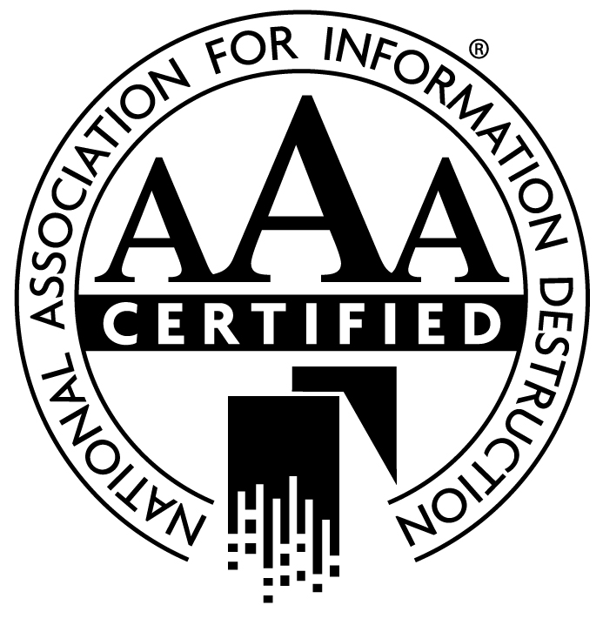  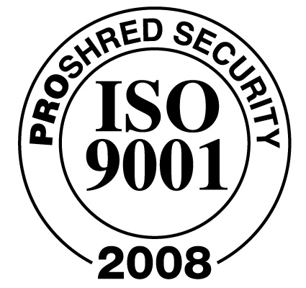  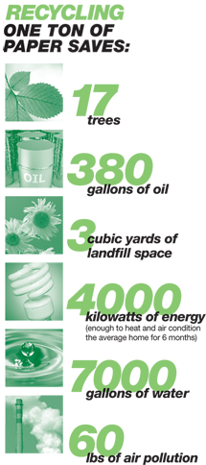 | 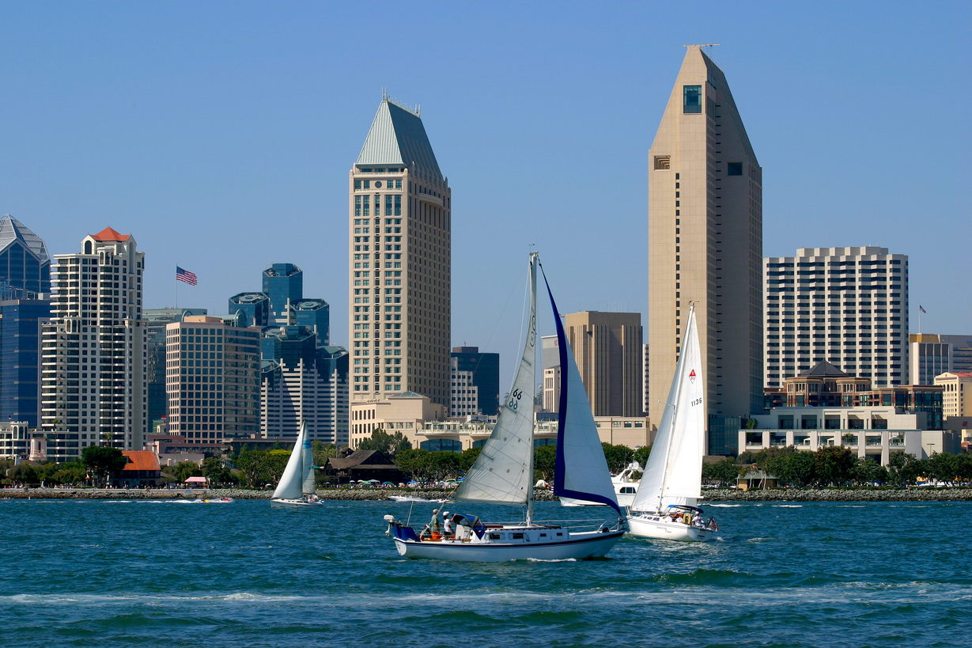
 | TO SHRED  - all paper  - file folders  - hanging files  - computer files  - computer paper  - notepads  - envelopes |  | NOT TO SHRED  - cans/bottles  - food/wrappers  - thick metal  - copier/printer cartridges  - corrugated cardboard  - non-recyclable materials  - large quantities of plastic  - biohazard materials  - medical waste
 | NO NEED TO REMOVE STAPLES, PAPERCLIPS AND FASTENERS, RUBBER BANDS
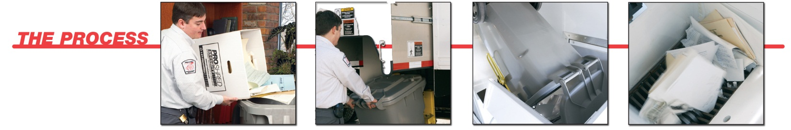
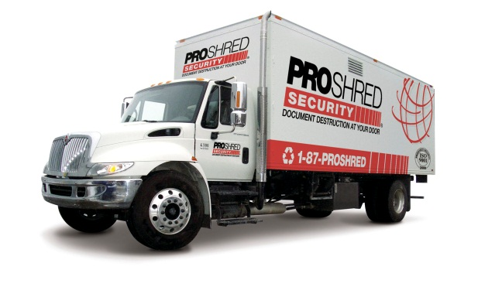


ABOUT US
PROSHRED® is a customer service and security focused shredding company, providing the most secure on-site document shredding and recycling services available in America for safeguarding private information, maintaining legislative compliance and protecting public image.
www.proshred.com


