

Real Estate Needs Real Attorneys
Social Content
February 6, 2025

Batch 4 - Post #7

From explaining closing terms and documents to ensuring the title is clear, real estate attorneys assist your clients in understanding their full legal rights related to the property. #RealEstateBrokers #RealEstateAttorney #LegalProtection

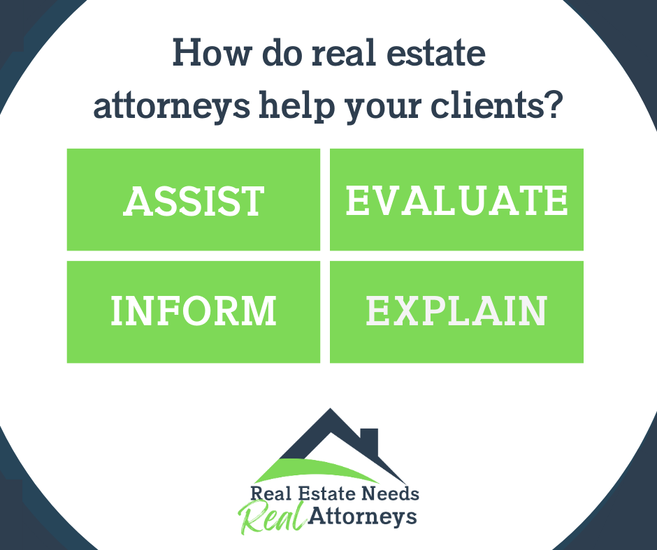

Basic steps for posting:

- Select the text above, right-click, select Copy.

- Open Facebook, LinkedIn, or Instagram: Place cursor in posting field and right click, select Paste to insert the copied text.

- Return to this document, right click the image, select Copy.

- Repeat step 2 to paste image.

- Click Post – and you’re done!

Need more detail? See our step-by-step guide, or contact Advocus, we are happy to help!

