@e®@li
ENTREPRENEURSHIP CENTER

'M/:11®
_Eg.-.. RSVP Today to
-.'·· . save your spot!

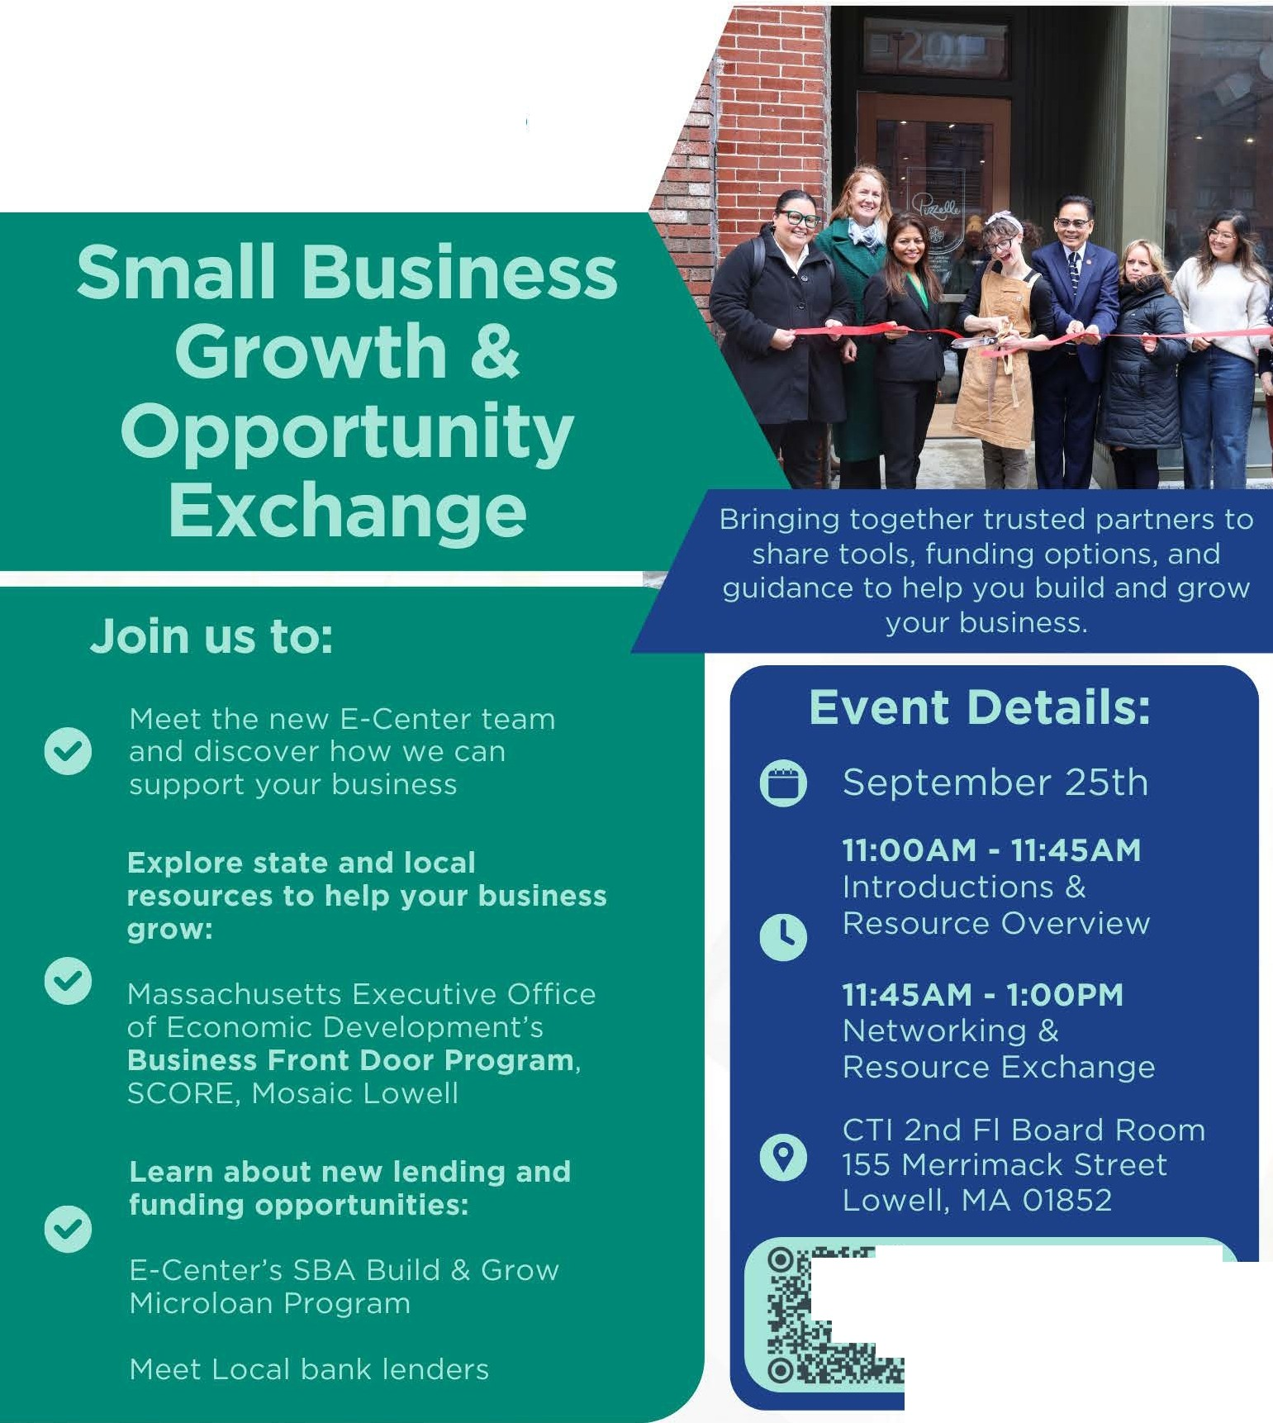
Connect with the Entrepreneurship Center!


'- 978-654-5731
O business@co mmteam.org
This event is sponsored by:
ACCatalyst tor Cihange  U.S. Smal18uslness


Adm inistration

