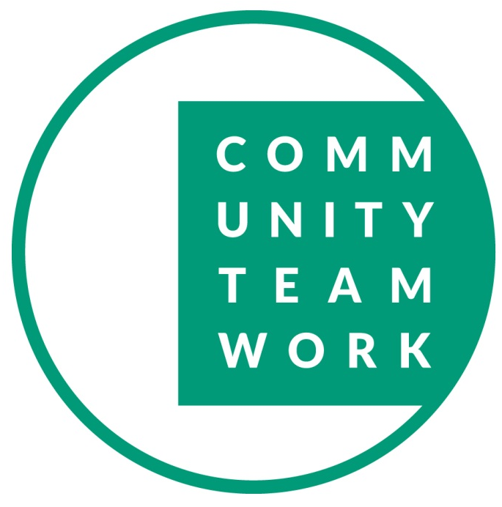

FOR IMMEDIATE RELEASE
July 14, 2026

Community Teamwork Announces CEO Leadership Transition
LOWELL, MA — Community Teamwork announced today Chief Executive Officer Carl Howell will step down from his role effective September 11, 2026, to pursue another leadership opportunity.
The Community Teamwork Board of Directors has begun a leadership transition process, including the appointment of an Interim Chief Executive Officer while a search is conducted for the organization’s next CEO.
“We are grateful to Carl for his leadership, vision, and unwavering commitment to Community Teamwork’s mission,” said Sheila Och, President of the Community Teamwork Board of Directors. “Under his leadership, Community Teamwork has strengthened its impact throughout the Greater Lowell region, expanded critical services, and positioned the organization for continued success. While we are sorry to see him leave, we are excited for him as he embarks on this next chapter of his career.”
Howell informed the Board in advance of his departure, allowing the organization to take a thoughtful and deliberate transition that will ensure continuity of leadership and operations.
“Leaving Community Teamwork is one of the most difficult professional decisions I have ever made,” Howell said. “This organization has been much more than a workplace—it has been a mission and a community that I have been honored to serve. I am deeply grateful to our Board, leadership team, employees, partners, and supporters for their dedication and commitment to improving lives every day.”
He added, “I leave knowing Community Teamwork is in an exceptionally strong position. We have an outstanding leadership team, an extraordinary staff, and a dedicated Board of Directors. I am confident they will continue advancing the mission and delivering the high-quality programs and services our communities depend upon.”
The Board emphasized that Community Teamwork’s operations, strategic initiatives, and community partnerships will continue without interruption throughout the transition.
“Community Teamwork has successfully served our region for more than six decades because of the strength of its people and its mission,” Och said. “Our experienced leadership team, together with our dedicated staff across the organization, will continue advancing Community Team’s mission and supporting the individuals, families, and communities we serve throughout this transition. As the Board appoints interim leadership and conducts a search for the next Chief Executive Officer, we move forward with confidence in the strength, commitment and collective leadership of the entire Community Teamwork team.”
Community Teamwork is one of Massachusetts’ largest Community Action Agencies, serving tens of thousands of residents each year through programs that promote economic opportunity, housing stability, early education, workforce development, energy assistance, and family well-being throughout Greater Lowell and the surrounding region.
Additional information regarding interim leadership and the CEO search process will be shared as it becomes available.

Media Contact:
Kathleen Plath, VP Communications and External Affairs
Community Teamwork
508-561-9220
kplath@commteam.org

About Community Teamwork
Established in 1965, Community Teamwork is a non-profit Community Action Agency (CAA) serving more than 55,000 individuals and families in the City of Lowell and the seven surrounding towns of Billerica, Chelmsford, Dracut, Dunstable, Tewksbury, Tyngsboro, and Westford. Community Teamwork also serves as a Community Development Corporation and as the Regional Housing Agency for the Merrimack Valley and the rest of the Northeastern Massachusetts, including 72 cities and towns inclusive of the North Shore and Cape Ann. Community Teamwork is a catalyst for social change. We strengthen communities and reduce poverty by delivering vital services and collaborating with key stakeholders to create housing, education and economic opportunities. Our vision is a community whose institutions, systems, and people support everyone’s opportunity to thrive. Community Teamwork | Greater Lowell’s Community Action Agency

