How do I protect my Zoom sessions from AI Bots?
What are they?
They’re third-party services like OtterPilot (from otter.ai), fireflies.ai, and read.ai that offer AI based note-taking services by recording meetings. These external third-party services are not supported by UIS.
How do they work?
Someone signed up for their service. It doesn’t really matter who, it just matters that you invited them to a meeting. The service watches for that person to be scheduled for a meeting and joins that meeting. When the meeting is over, it sends out notifications to other participants that a transcript is available. To get the transcript, you have to sign up for their service, at which point it starts doing the same thing with all of your meetings.
Why shouldn’t I use them?
HealthWest does not have any contract terms with these services to ensure protected or sensitive data is not misused.
Furthermore, the use of unsupported AI assistants in meetings with PII could result in a HIPAA violation.
How can I protect my meetings from these services?
Limit a Meeting to Authenticated Users Only
1. Log in to the healthwest.zoom.us website and schedule a meeting as usual. In the Security options, select Require Authentication to join.
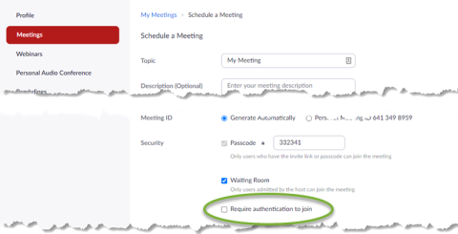
2. After you do so, Select HealthWest and Muskegon County Users in the dropdown menu.
Enable “Waiting Room” security for your meeting
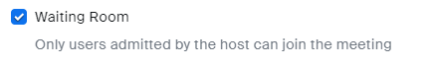
Blocking AI bots from your meetings
1. Go to your Zoom Settings.
2. In the meeting tab, search "Block users in specific domains from joining meetings and webinars" and enable the slider
3. Click the pencil icon to edit the list and include the domains of the AI accounts that may be attempting to join (example: "otter.ai, read.ai")
4. Click Save
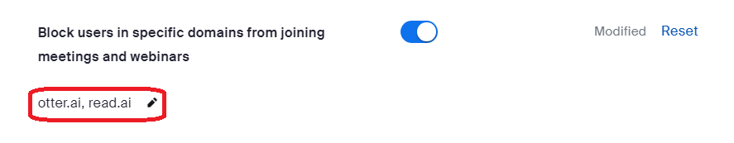
NOTE: This is not a complete list of domains to block
Remove a Bot from a Zoom meeting
Should a bot manage to join a meeting despite security settings, use the same methods to remove it as you would for an unwanted human attendee. These actions include:
- Remove a Participant from a Zoom Meeting or Webinar
Click Participants, click More beside the unwanted bot user, then click Remove.
- Lock Your Session
This prevents additional users from joining. Click Security, then click Lock Meeting. Repeat to unlock the meeting.
- Suspend Participant Activities
This will suspend all participants' screen sharing, video, audio, and breakout rooms, and locks the meeting. Click Security, then the red Suspend Participant Activities link.

NOTE: Keep in mind that after you have removed the unwanted AI bot from your meeting, you may wish to undo the “Suspend Participant Activities” feature, as it affects all attendees and will interfere with screen sharing and other common attendee activities.

Another approach is to turn on the Captcha for guests.
- Go to healthwest.zoom.us/profile/setting
- Enable the Show a "Join from your browser" link option.
- Check the Require solving a CAPTCHA for guest users (users who are not signed in) option.

