Responsibility vs Irresponsibility
Is it your natural inclination to take responsibility for other people who refuse to take responsibility for themselves?
-----------------------------------------------------------------------------------------------------------------
In what ways could you take less responsibility for others to encourage them to step up and start taking more responsibility for themselves?
------------------------------------------------------------------------------------------------------------------------------------------------------------------------------------------------------------------------------------------
What would change in your life if you started to take less responsibility for other people’s problems?
------------------------------------------------------------------------------------------------------------------------------------------------------------------------------------------------------------------------------------------

Humility and Honesty vs Arrogance and Pride
Are there times where you have not taken responsibility for the role you have played in a situation and the outcomes that followed?
---------------------------------------------------------------------------------------------------------------------
How do you think the outcome would have changed had you taken responsibility?
------------------------------------------------------------------------------------------------------------------------------------------------------------------------------------------------------------------------------------------
In what ways do you think your life would change if you took responsibility for your imperfections?
------------------------------------------------------------------------------------------------------------------------------------------------------------------------------------------------------------------------------------------

Slow to Anger vs Easily Angered
Can you recall the last time you were angry?
---------------------------------------------------------------------------------------------------------------------

Write down what triggered your anger and how you handled your anger; how was your anger expressed and were you proud of how it was expressed?
------------------------------------------------------------------------------------------------------------------------------------------------------------------------------------------------------------------------------------------
Ideally, how do you wish you had responded? What would you have done differently?
------------------------------------------------------------------------------------------------------------------------------------------------------------------------------------------------------------------------------------------

Faith for Future vs Fear of the Future
What fears are you holding onto which are preventing you from having faith in the decisions you are making?
------------------------------------------------------------------------------------------------------------------------------------------------------------------------------------------------------------------------------------------
Do you take risks with the faith that things will work out for the best, or do you tend to ‘play it safe’ due to the fear of making mistakes?
---------------------------------------------------------------------------------------------------------------------

How much more could you achieve with your life if you were to stop exercising fear and start exercising more faith?
------------------------------------------------------------------------------------------------------------------------------------------------------------------------------------------------------------------------------------------

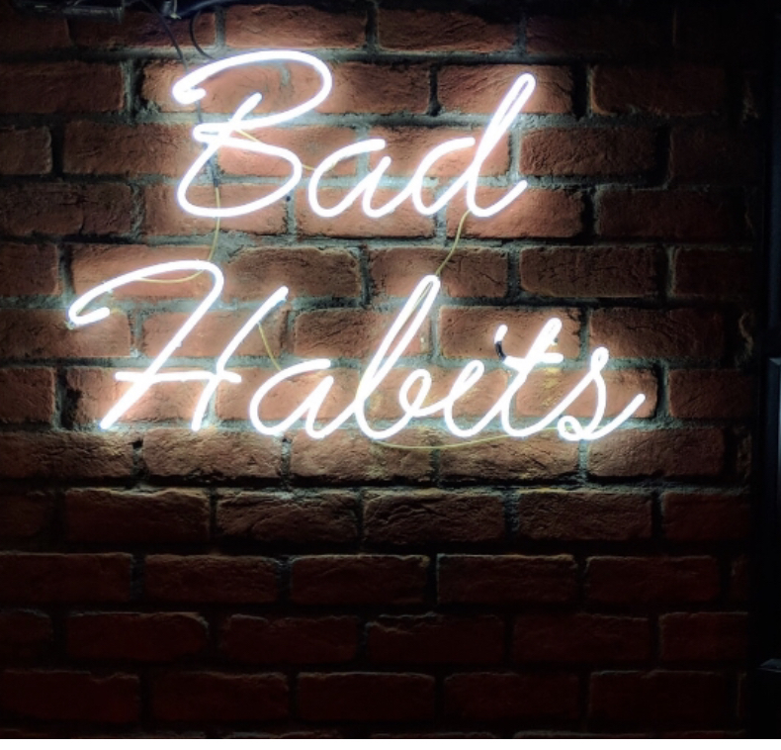
Promoter of Unity vs Promoter of Disunity
What are your feelings towards these words?
WORDS  Sexy  Jesus  Bitch  Queer  Black  Slavery  Religion  Fuck  Trump  Atheist  Bipolar | FEELINGS

Are you committed to working with and understanding other people, or are you more interested in doing things your own way?
--------------------------------------------------------------------------------------------------------------------
What changes can you begin making today to better understand others and begin working with other people?
---------------------------------------------------------------------------------------------------------------------------------------------------------------------------------------------------------------------------------------------------------------------------------------------------------------------------------------------------------------

Decisiveness and Progress Driven vs Indecisiveness and Double Minded
What are the limiting beliefs preventing you from deciding?
------------------------------------------------------------------------------------------------------------------------------------------------------------------------------------------------------------------------------------------
How different would your life be if you let go of these limiting beliefs and trusted in your own decision-making abilities?
------------------------------------------------------------------------------------------------------------------------------------------------------------------------------------------------------------------------------------------
Do you embrace challenges and look for ways to grow and develop yourself, or do you shy away from change?
------------------------------------------------------------------------------------------------------------------------------------------------------------------------------------------------------------------------------------------
What areas of your life could you start improving in today which would prioritize growth over pleasure?
------------------------------------------------------------------------------------------------------------------------------------------------------------------------------------------------------------------------------------------

Governed by Fear vs Governed by Feelings
Being honest with yourself, how many social, work and intimate relationships do you have in your life that are based upon facts?
----------------------------------------------------------------------------------------------------------------
How do you feel the quality of your relationships would change if you chose to be transparent and honest in them?
------------------------------------------------------------------------------------------------------------------------------------------------------------------------------------------------------------------------------------------
Often, we do not say things because we do not want to hurt the other person’s feelings. But by not speaking up, we are not being honest, and this can also end up hurting the other person and causing strain on the relationship.

Think of someone that you can reach out to and be completely honest about a concern you have in your relationship with them. Write one or more names down then reach out to them and have that conversation.
------------------------------------------------------------------------------------------------------------------------------------------------------------------------------------------------------------------------------------------


Desire for Growth and Development vs a Desire to Feel Happy and Constantly Gratified
Consider situations in your life where you have chosen to resist growth through the desire for pleasure or instant gratification?
Reflect on times when you were aware of what you ‘should’ be doing but maybe chose to spend time doing something more enjoyable or fun.
In those situations, how did you feel about your decision to do something for pleasure as opposed to committing to your own personal growth?
------------------------------------------------------------------------------------------------------------------------------------------------------------------------------------------------------------------------------------------
Consider how you felt before making the decision during and afterwards. Often tricking ourselves into experiencing something enjoyable in the short term can lead us to us feeling sad or unfulfilled later.
Let us reverse the same scenario. Consider a time where you made a sacrifice and decided to focus on doing something that was going to help you progress in life?
--------------------------------------------------------------------------------------------------------------------
Think of as many experiences as you can and write them down. They do not always have to be a big decision. It could be a little thing like working later instead of going out with friends or choosing to go to sleep earlier because you know rest is important.
The next time you are finding yourself resisting growth and embracing the desire for pleasure, what is one action step you can take to get yourself back on track?
------------------------------------------------------------------------------------------------------------------------------------------------------------------------------------------------------------------------------------------

NOTE: This does not mean you cannot have downtime and enjoy yourself. This is about taking responsibility for the times we procrastinate or resist growing as individuals often through fear.

